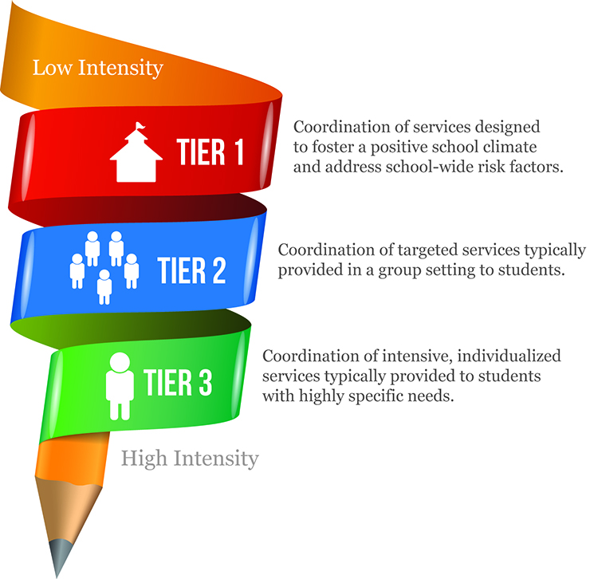

**Shallegra Moye and Bryan McCarthy**, the Site Coordinators in SRSD, will work with school staff to implement a school plan & coordinate resources, delivering support across the 3 Tiers.

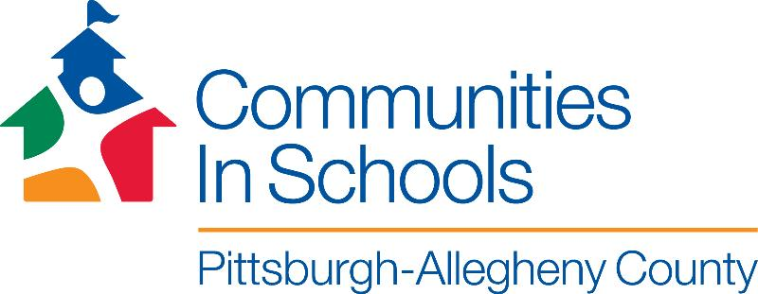

Many children face challenges both inside and outside the classroom. Through a school-based site coordinator, Communities In Schools strategically aligns and delivers needed resources so that students can focus on learning.

**Resources at SRSD that can be provided to students & families:**

* Academic Assistance
* Adult Literacy
* Basic Needs – food, clothing, etc.
* Behavioral Interventions
* Bullying Prevention
* Enrichment
* Family Engagement
* Leadership Development
* Life Skills
* Mental Health Services
* Mentoring
* Parenting Classes
* Physical Health
* Violence Prevention

**What is a community school for StoRox School District?**

**It’s the heart of the community!**

A community school provides a holistic approach to academics, health and human services, community development and engagement. CIS surrounds students with a community of support, empowering them to stay in school and achieve in life by coordinating resources to improve student learning, build stronger families and healthier communities.

**For more information, please contact**

**Shallegra Moye smoye@cispac.org**