Sto-Rox Jr./Sr. High School Presents Career Night!

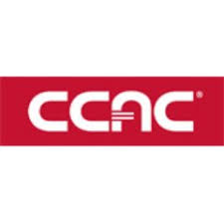

Students and their families in grades 9-12 are invited to the Jr. /Sr. High School Auditorium on Wednesday February 13th from 6-8pm to hear information from Parkway West Career and Technical Center, CCAC-Allegheny Campus and the building Trades, including applying for employment and training

Students and families will learn about the application process, earning potential of high demand jobs and be able to ask questions of potential employers

Light refreshments will be served!

