Name: _____________________________________

TOPIC 2: Cells and Cellular Organization
Please use the Khan Academy Parts of a Cell video to guide you

- What structure defines a cell?
- What do we call an organism that does have a nucleus?
What do we call an organism that does not have a nucleus?
- What are two examples of prokaryotes?

- What are three types of eukaryotes?
- Ribosomes help to make ___________ for the cell.

- The fluid in the cells is called the ______________ (aka cytoplasm)
- The Endoplasmic reticulum connects to the __________ Bodies
- The section of the Endoplasmic Reticulum with attached ribosomes is called the _____________ ER
The section of the Endoplasmic Reticulum without ribosomes is called the ______________ ER
- When a protein leaves the Golgi Bodies, what does it take with it? __________________________________
This piece will help it float around in the cell and fuse with the cell membrane.
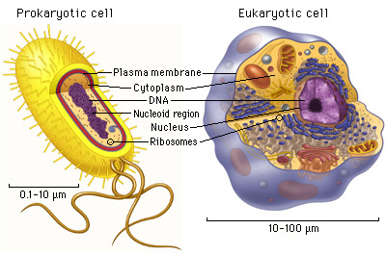
- What items could be stored in a vesicle?
- Lysosomes and lytic vacuoles do what?
- What is an organelle?
- Where do we turn sugars into ATP?

- What do plants use for photosynthesis?
- What do filaments do?

