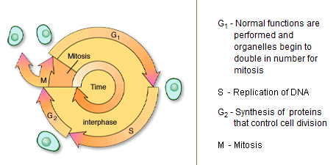Topic 4: Cell Division

Introduction
Mitosis is one of the stages in the life cycle of a cell. It refers to the division of the nucleus.
- Mitosis - Type of cell division in which daughter cells receive the exact chromosome and genetic makeup of the parent cell; occurs during growth and repair.
- Nuclei - Cell organelles containing most of the genetic material of the cell; collection of nerve cell bodies within the central nervous system; center of an atom consisting of protons and neutrons.

Stages of Mitosis
Mitosis is the process by which the contents of the eukaryotic nucleus are separated into 2 genetically identical packages. Chromosomes replicate prior to the beginning of mitosis. As mitosis begins they condense and become visible under a light microscope. They appear as sister chromatids joined at the centromere. Mitosis is divided into 4 stages. During prophase, the nuclear envelope disintegrates and a spindle of microtubules forms. Centrioles may help organize the spindle as in this animal cell. The chromosomes begin to move toward the midplane of the spindle. When they are on the midplane with centromeres attached to spindle fibers, the second stage, metaphase has been reached. Metaphase yields to anaphase as the centromeres separate and the sister chromatids, now termed chromosomes, are pulled toward opposite poles of the spindle. During the final stage, telophase, a nuclear envelope forms around each set of chromosomes, the spindle disappears and the chromosomes decondense. The result is 2 nuclei, each with an identical set of chromosomes. Cytokinesis is the division of the cell contents outside of the nucleus. It occurs with both mitosis and meiosis. In cells without walls, it is accomplished by pinching of the cell. In plant cells, the wall prevents pinching; instead vesicles line up along the middle of the cell. As they fuse they form the separation between daughter cells.
- Eukaryotic Cell - Cell that possesses a nucleus and the other membranous organelles characteristic of complex cells.
- Chromosome - Rodlike structure in the nucleus seen during cell division; contains the hereditary units, or genes.
- Sister Chromatid - One of two genetically identical chromosomal units that are the result of DNA replication and are attached to each other at the centromere.
- Centromere - Constricted region of a chromosome where sister chromatids are attached to one another and where the chromosome attaches to a spindle fiber.
- Prophase - Mitosis phase during which chromatin condenses so that chromosomes appear.
- Microtubule - Organelle composed of 13 rows of globular proteins; found in multiple units within other organelles, such as the centriole, cilia, flagella, as well as spindle fibers.
- Centriole - Short, cylindrical organelle in animal cells that contains microtubules in a 9 1 0 pattern; present in a centrosome and associated with the formation of basal bodies.
- Metaphase - Mitosis phase during which chromosomes are aligned at the metaphase plate (equator) of the mitotic spindle.
- Telophase - Mitosis phase during which the diploid number of daughter chromosomes are located at each pole.

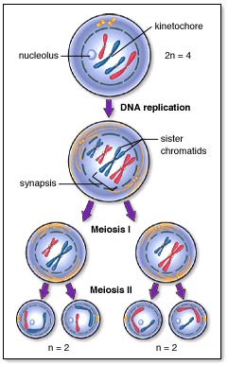
Meiosis
The ultimate goal of the process of meiosis is to reduce the number of chromosomes by half. This must occur prior to sexual reproduction. The cell at the top contains two homologous pairs of chromosomes, for a total of four chromosomes. The final products of meiosis, four daughter cells, each contain one chromatid from each original homologous pair, for a total of two chromosomes. There are two stages of meiosis to accomplish this task
- Sexual Reproduction -Reproduction that occurs through fusion of two gametes

Meiosis I reduces the chromosome number in half, but each chromosomes contains two sister chromatids. Meiosis II
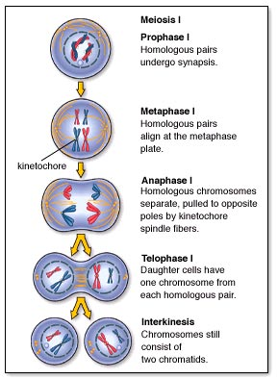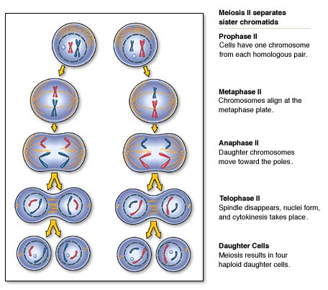
Meiosis is the process by which a diploid nucleus divides twice to produce 4 haploid nuclei. The divisions are called meiosis I and meiosis II. In the life cycles of diploid organisms meiosis precedes sexual reproduction. Among animals, the products of meiosis are gametes-eggs or sperm. DNA is replicated prior to the start of meiosis. The identical sister chromatids are joined at the centromere as in mitosis. Unlike in mitosis, homologous chromosomes pair with one another. These pairs intertwine during early prophase of the first meiotic division and may exchange segments. This exchange is called crossing over. During prophase I, the nuclear envelope disappears and the spindle forms. The homologous pairs lie side by side as they reach the midplane of the spindle and attach to spindle fibers in Metaphase I. Metaphase ends and Anaphase I begins as the partners in each pair of homologous chromosomes separate as they are pulled toward opposite poles of the spindle. These chromosomes still consist of sister chromatids joined at their centromeres. During Telophase I the spindle disappears, nuclear membranes may re-form and the 2 nuclei, each containing a haploid set of chromosomes, are separated as cytokinesis divides the cytoplasm. Prophase II begins with the formation of a spindle and the still duplicated chromosomes move toward its mid-plane. At Metaphase II they are lined up and attached to spindle fibers. Anaphase II begins when centromeres separate and sister chromatids, now considered chromosomes, begin moving in opposite directions. During Telophase II the nuclear membrane re-forms, the spindle disappears and cytokinesis divides the cytoplasm. The result is 4 haploid cells.

