Name: _____________________________________

TOPIC 6: DNA and its processes
Please use the Council Rock Video Podcast to guide you
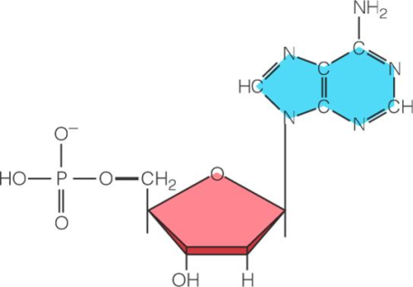
- Label the three parts of a nucleotide to the right.
- DNA has ______ strands and the bases ___denine, ___ymine, ___tosine, and ___uanine.
- RNA has _____ strand and the base ___racil instead of thymine.
- What are the functions of
mRNA? tRNA? rRNA?
- What are the three different processes that nucleic acid can do?

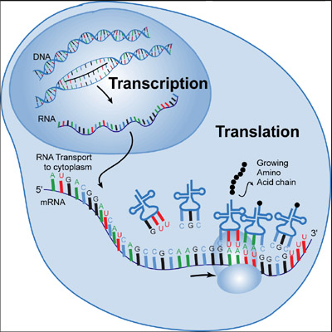

- What happens during replication?
- What happens during transcription?
- What does AUG code for? ____________________
- What do UGA, UAA, and UAG code for? ______________________
- What happens during translation?
- What is the biology definition of a mutation?
- What happens during
  - Substitution mutation
  - Insertion point mutation
  - Deletion point mutation
  - Duplication chromosomal mutation
  - Deletion chromosomal mutation
  - Inversion chromosomal mutation
  - Translocation chromosomal mutation

