Name: _____________________________________

TOPIC 8: Evolution
Please use the Council Rock Video Podcast to guide you

- A process in which new species develop from pre-existing species is known as __________________.
- TRUE or FALSE: There are always enough resources to support all organisms: ___________________
- What happens to the species that have the advantageous traits?
  - b.
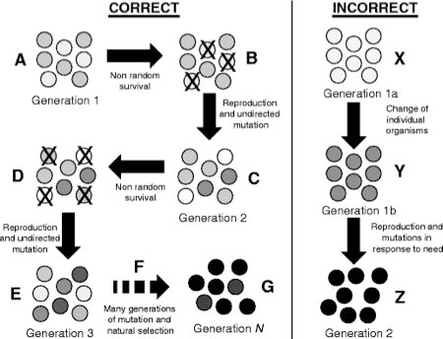
- What happens to the species that do NOT have advantageous traits?
- Explain why the INCORRECT section on the right IS incorrect
- What are the three different types of isolating mechanisms?

- A decrease in genetic variation caused by the formation of a new population by a small number of individuals from a larger population is known as ________________________________________.

- Describe the following pieces of evidence for evolution
  - Fossils:
  - Homologous structures:
  - Analogous structures:
  - Embryology:
  - Biochemistry:

- What happens during gradualism? ___________________________________________________________
- What happens during punctuated equilibrium? _________________________________________________
- Give an example of
  - Selective breeding: ______________________________________________________
  - Inbreeding: ____________________________________________________________
  - Hybridization: __________________________________________________________

