Topic 9: Ecology
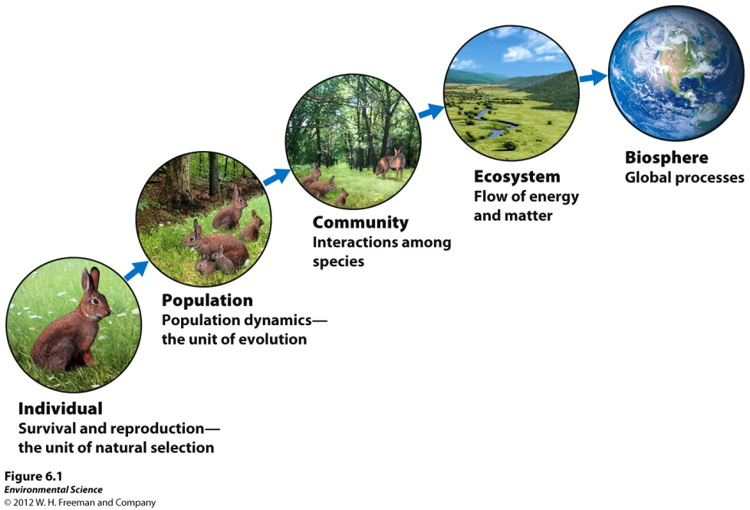
Ecosystems have both living components (biotic factors such as the trees, birds, and fish) and nonliving components (abiotic factors such as how much rain or sun an area gets). All ecosystems need energy, and the most basic form of energy comes from the sun. Producers (also known as autotrophs) are able to make their own food. These are eaten by consumers (also known as heterotrophs). We can track the flow of energy linearly using a food chain or look at a more detailed flow of energy using a food web.
Ecology is the study of how organisms interact with their environment. There are many different levels of ecology. The diagram to the left shows all of the different levels

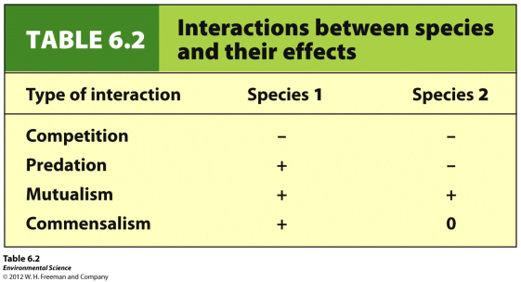
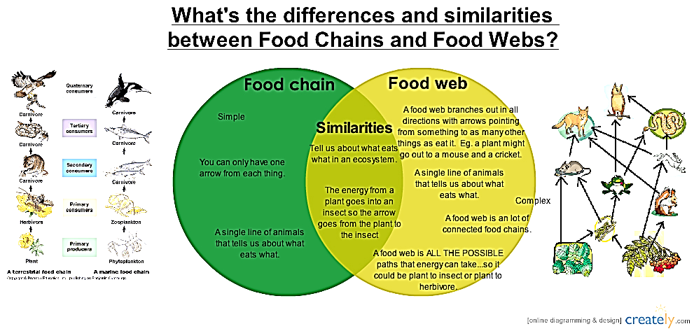
Organisms can interact with each other in many different ways. Symbiosis is the general term for organisms that closely interact with each other. There are three different types of Symbiosis: parasitism, mutualism, and commensalism. The table to the right shows some of the different ways different organisms can interact with each other.

A limiting factor is some sort of factor (biotic or abiotic) that is going to limit the population’s growth. It could be an important nutrient that is cycled through the ecosystem (such as water, nitrogen, carbon, or phosphorus), or it could be a food source or predator. A great example of limiting factors are predator-prey graphs. It is easy to see how the size of the population is affected.

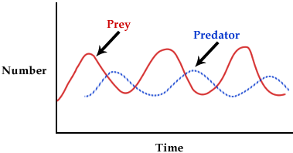
Here, the size of the populations depends on the number or prey and predators. The predator population peaks after the prey population because of the lag time in reproduction. When the predator population is at its highest, the prey is at its lowest. With limited food, the population size of the predator decreases. This allows the prey population to increase, and the cycle continues again…

Nutrient Cycles
Important nutrients such as carbon, nitrogen, phosphorus, and water are cycled through living things and the environment through biogeochemical cycles. The following pictures are overviews of the carbon, phosphours, and nitrogen cycles.
Carbon Cycle
Nitrogen Cycle
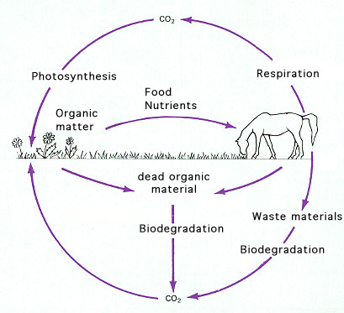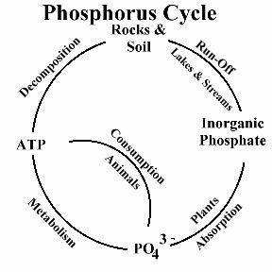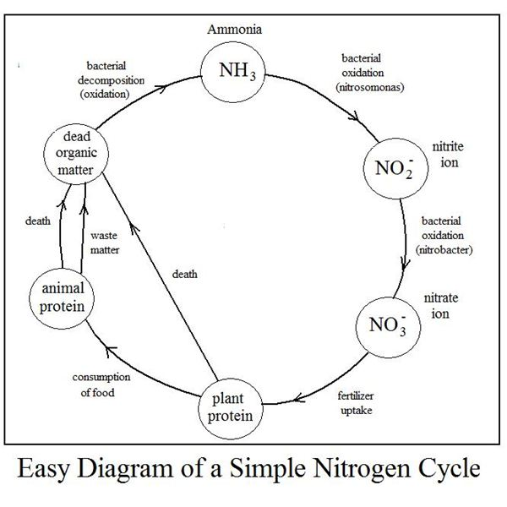

These natural processes are affected by human involvement. The table below shows how humans change the cycles:

Cycle Disturbance/problem | Ecosystem Effect
Hydrologic /deforestation and paving | ↓ evapotranspiration, ↑ runoff, ↑ erosion, ↑ flooding
Carbon/fossil fuel combustion and deforestation | ↑ CO₂ levels, ↑ atmospheric heat retention, ↑ global warming
Nitrogen/excess (fertilizers, pig farms) | ↑ Atmospheric N₂, change of diversity (eutrophication)
Phosphorus/excess (fertilizers, detergents, bird/bat guano) | Algal bloom, change of diversity

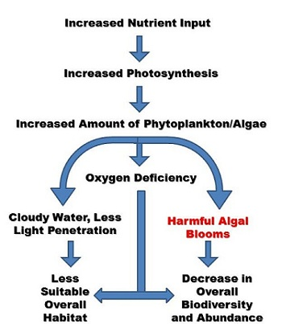

Eutrophication is a term that demonstrates how changing nutrient levels affect the organisms in an ecosystem. For eutrophication, and increase of nutrients (usually nitrogen and phosphorus because they are limiting nutrients) is added. This increases photosynthesis (sometimes called an algal bloom because the algae covers the top of the body of water), and as these producers die, the decomposers come in to feed off of them. These decomposers are going through respiration and lower the oxygen available to all organisms that can cause many to die.

