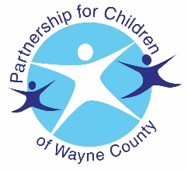
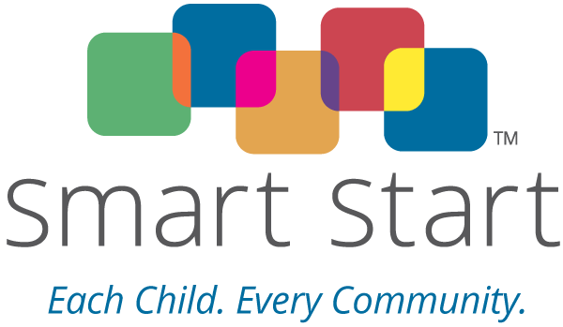
INCREDIBLE YEARS
Parenting series

Does your child exhibit

CHALLENGING BEHAVIORS?

A FREE parenting program dedicated to supporting and strengthening families, and preparing them to handle misbehaviors and learn preventive approaches

3-6 year old program
- Free child care
- Free meals for the whole family
- Evening classes offered Monday and Tuesday nights
- Gas cards for participation
- Classes last a minimum of 15 weeks

If you are interested and would like to register, contact the Partnership for Children of Wayne County at (919) 735-3371 Ext. 237 Angela, Ext 238 Nancy (Spanish), or Ext. 222 Delaine

Spanish Classes will begin January 14th, 2019
English Classes will begin January 15th, 2019

* Participants completing the Incredible Years Series will receive a $50.00 gift!!

Proven Positive Outcomes for Families:

- Reduces aggressive and disruptive behavior
- Increases positive family communication and problem-solving
- Promotes self-control

Slots are limited. Must call to register.

