they



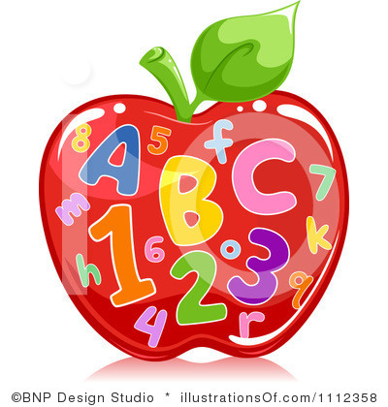

The class will be working on numbers 1-5. By the end of Lesson 5, students will be able to count and make sets to 5, they will be able to print numbers to 5, they will be able to count sets to 5 that are displayed in a variety of formats, and they will be able to match numerals to the word form for 1-5.

In math, we will also use a variety of learning tools to re-enforce each lesson. Students will have folder game activities, hands on practice, and assessments to measure their understanding and growth at the end of the week.

School begins at 7:00, tardy bell rings at 7:30. We begin releasing at 2:30.

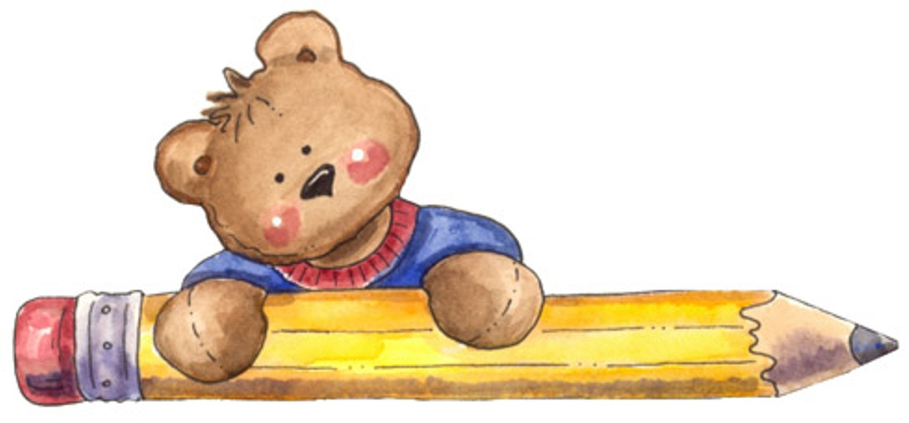

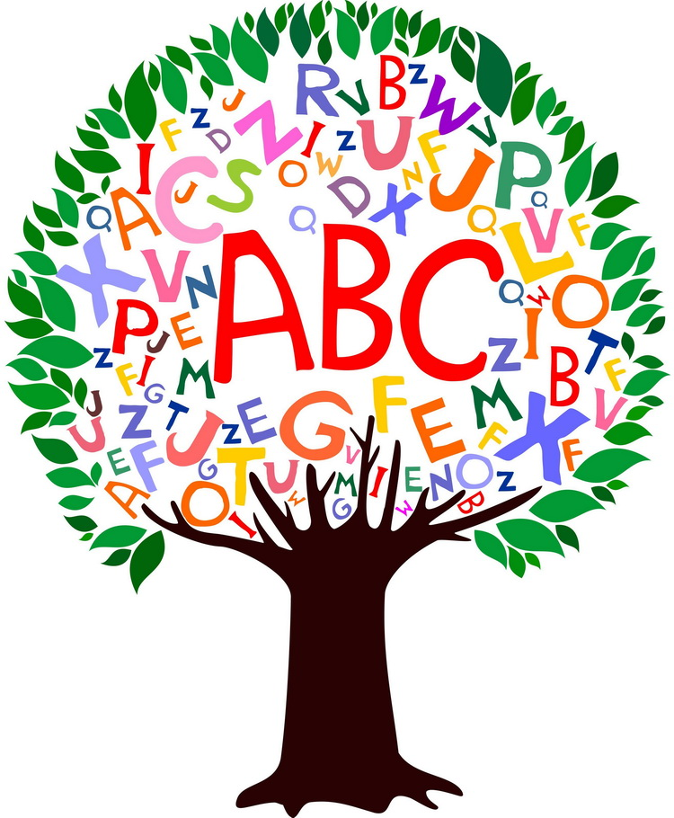

Sept. 5th- Scouting Night @6:30 in Cafeteria

Sept. 16th- Fall Pictures

Sept. 27th- Back to School Dance 1st-4th ONLY. (2:45-4:15)

**Monday-Music**

**Tuesday-PE**

**Wednesday-Computer (B week)**

**Guidance (A week)**

**Thursday-Art**

**Friday-PE**

Our Daily Specials

**Science and Social Studies**

These two subjects will be incorporated into our reading and math. When we have these lessons; I will have them in a block like this for both. I will also have an explanation of what the class is learning and the activities we are doing to help students understand these standards.

Homework folders will have the weekly newsletter, students high-frequency words for kindergarten, and their words to learn for the week/month. Homework will be in the back pocket for each night. Important information papers will be in the front pocket.

Please make sure that you go through this folder every night for important papers, home, and information. I want you and I to be partners in this 1st very important year of school. We can make this a fun, rewarding, and important learning experience.

This folder will help you keep informed of school and class events and information. Here are my numbers if you have questions or concerns:

Mrs. Holland hm# 919-689-3653

Cell# 919-920-9523

School# 919-658-7330

Homework Folders

This week the students are working on many new things: their names, letters A-E using ABC Bootcamp, activities with sight words, and recognizing the front, back, and title page of books.

The children will also do hands on activities with centers. These are educational games that re-enforce what has been taught.

We will also do independent work to assess their understanding.

**Language/Reading**

Tiger News for September

Math

**Mrs. Holland’s**

**Newsletter Kindergarten**