Vanleer Elementary School was built in 1940-1941. The building consisted of four classrooms, an auditorium with stage, an office, a library and cafeteria in basement. In 1950-1951, four more classrooms and restrooms were added. The gym was also added that year.

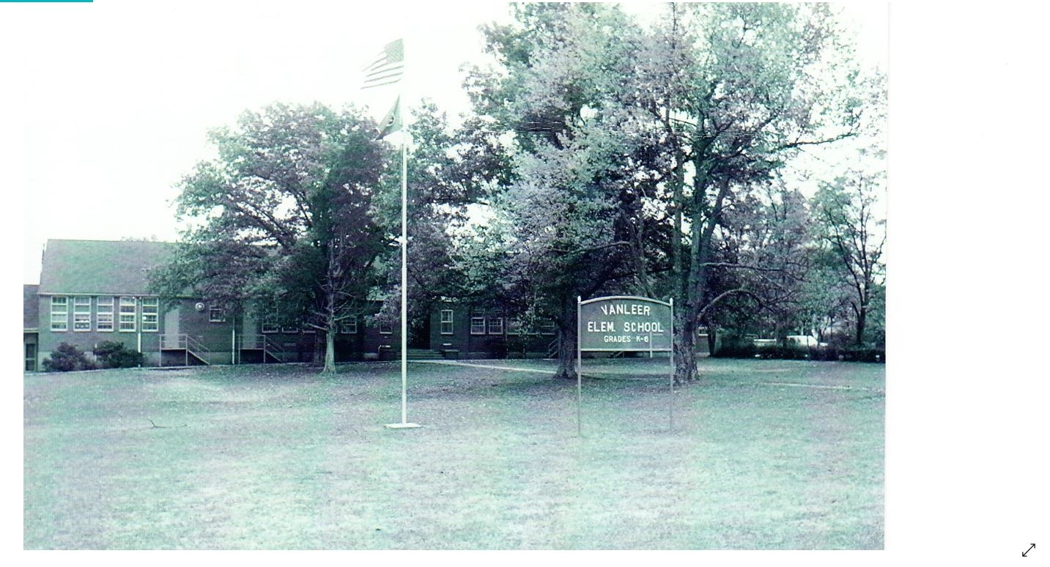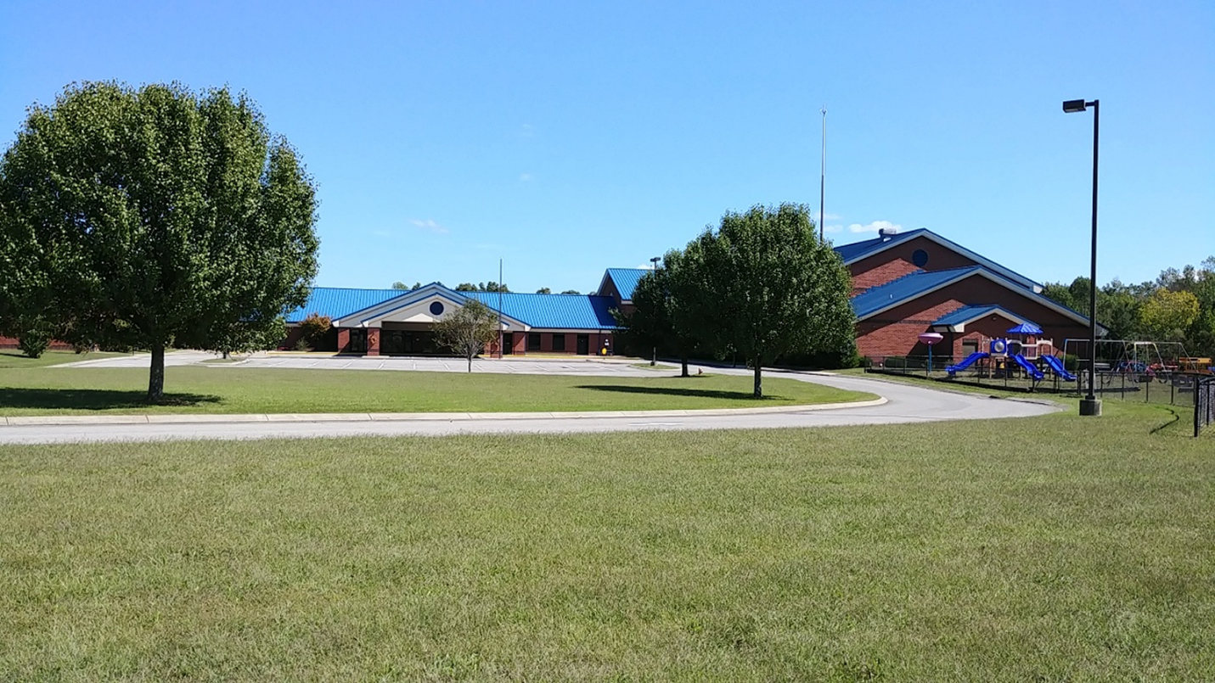
We moved into our new building in 2003.

