Behavioral Intervention Guidebook
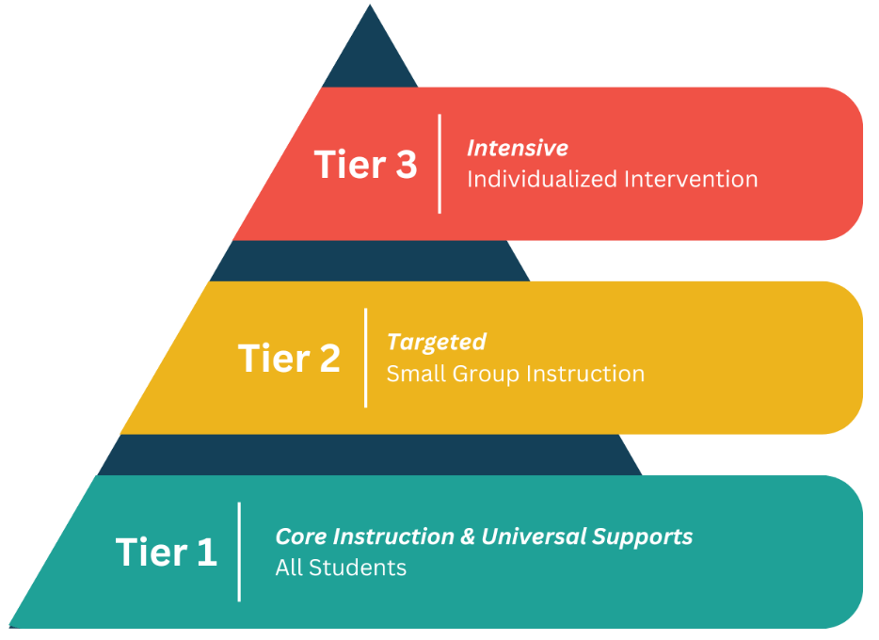

Introduction
Hello, my name is Janelle Patterson. I am an instructional support specialist for Behavior with BOCES 2. Prior to this position I was a special education teacher in behavioral classroom settings for ten years. I have learned through my current and previous position that behavior is not one size fits all. Behaviors look different for every student, and two students can share similar behaviors but use them for different functions. The key is trial and error and to figure out the function of the behavior and replace it. Different interventions should be tried until you find the right one for the student and the teacher.
The need for behavior support in schools as well as interventions and strategies has increased across the country. This guidebook can assist you in navigating the MTSS process for behavior as well as providing you with resources for different interventions that you can try in your school or in your classroom.

What is the process?
All students should always be receiving Tier 1 interventions in the classroom setting. Tier 1 interventions refer to universal, school-wide practices and strategies designed to support the behavioral and academic success of all students. It is the first level of a multi-Tiered system of support or MTSS and it is proactive rather than reactive. If a student is struggling with appropriate behavior in the classroom setting, Tier 1 interventions that are in place should be documented and behaviors that take place should be tracked. Once you have tried a variety of Tier 1 interventions and the student is still struggling with behavior the student should then move to Tier 2 interventions and repeat the process before moving on to Tier 3 interventions if necessary.

Table of Contents:
Definitions……………………………………. Page 4
EATS/ Behavior functions……………………. Page 6
Data tracking…………………………………. Page 7
Tier 1 interventions……………………………Page 11
Tier 2 interventions……………………………Page 14
Tier 3 interventions……………………………Page 16
Intervention examples……………………….... Page 18
ABC Model fundamentals……………………. Page 23
Sensory input…………………………………. Page 25
Resources………………………………………Page 27

Definitions: Terms to Know
Screening: A school wide assessment of student performance in specific skill areas given three times per year; administered by the assessment team.
Progress Monitoring: Frequent assessment to track specific student goals; administered weekly or bi-weekly (depending on Tier) to determine whether the intervention is working as planned; administered by the person responsible for the delivery of the intervention.
Diagnostic Assessment: Assessments that are diagnostic in nature provide greater detail about individual students’ skills and instructional needs. They are typically administered to students who fall significantly behind a benchmark or when students have not demonstrated sufficient progress (Center on Teaching and Learning, n.d.). These assessments can provide valuable insight into a student’s current level of performance, including strengths and areas in need of improvement.
Functional Behavioral Assessment: The process of determining why a student engages in behaviors that impede learning and how the student’s behavior relates to the environment. An FBA must provide a baseline of the student’s problem behaviors, across activities, settings, people, and times of the day, regarding:
● Frequency
● Duration
● Intensity
Parent/Guardian consent is needed for an FBA. The FBA includes the information necessary to develop a behavioral intervention plan (BIP) that addresses:
● Antecedent behaviors
● Reinforcing consequences of the behavior
● Recommendations for teaching alternative skills or behaviors
● Assessment of student preferences for reinforcement
Above resources from: Essential Components of MTSS | MTSS Center

Behavioral Intervention Plan (BIP): A specific plan of action that designs effective behavior interventions to teach the student more acceptable behavior(s) to replace the inappropriate behavior that meets the same function. When a BIP is implemented, progress monitoring occurs to determine if there are reductions in the inappropriate behavior and increase in the appropriate behavior(s). To develop a more effective and efficient behavior intervention plan, we must use the information from the FBA that describes when, where, and why problem behavior occurs.
PBIS: PBIS stands for Positive Behavioral Interventions and Supports, a framework used in schools to improve student behavior by establishing clear expectations and providing positive reinforcement. It uses a Tiered system, with most students receiving school-wide strategies (Tier 1), some students receiving extra support (Tier 2), and a few receiving highly individualized help (Tier 3). The goal is to create a safe and supportive school environment that improves social, emotional, and academic outcomes for all students.
MTSS: MTSS is a framework for Multi-Tiered System of Support used in schools to provide academic and behavioral help to all students through a layered system of interventions. It is proactive and data-driven, with Tier 1 providing universal support, Tier 2 offering targeted interventions for small groups, and Tier 3 providing intensive, individual support for students with significant challenges. While MTSS can help identify students who may need special education services, its goal is to keep all students on track within the general education setting by addressing their needs early.

Above resources from: What is PBIS? Positive Behavior and Your MTSS

EATS
Behavior is understood through its four functions: sensory, escape, attention, and tangible (often remembered by the acronym EATS). Understanding these functions is key to designing effective interventions that address the underlying reason for a behavior, teaching alternative, appropriate behaviors to achieve the same goal. For example, instead of punishing a child for hitting, an intervention would identify why they are hitting and teach them a replacement behavior that serves the same purpose, such as asking for a break or getting attention in a more appropriate way.

Functions of behavior
- Sensory: The behavior provides a form of self-reinforcement or sensory input for the individual.
  - Example: A repetitive hand flapping motion that feels good to the person performing it.
- Escape: The behavior allows the individual to avoid or escape from an undesirable situation or task.
  - Example: Refusing to start a difficult assignment to get out of doing it.
- Attention: The behavior is done to gain attention from others, whether positive or negative.
  - Example: A student yelling in class to get the teacher to look at them.
- Tangible: The behavior is aimed at getting a desired item or activity.
  - Example: A child throwing a tantrum to get a toy.

Interventions based on functions
- Identify the function: A functional behavior assessment is conducted to determine the specific reason behind the behavior, often through observation and data collection.
- Teach replacement behaviors: Once the function is known, a new, appropriate behavior is taught that serves the same purpose as the problem behavior.
- Teach communication skills: If the behavior is to get attention or an item, the person can be taught to use words or other communication methods to achieve their goal instead.
- Provide the function differently: For a behavior that serves a sensory need, the intervention might involve providing a more appropriate sensory input. For escape, the environment might be modified to make tasks less aversive.

Above resources from: Understanding the 4 Behavior Functions

Data Tracking-

Why Behavior Progress Monitoring Matters
Progress monitoring helps us ensure we are delivering the right support to the right students at the right time — so we are not just throwing things against the wall to see what sticks. High-quality data allows us to:
- Determine whether interventions are working.
- Make informed decisions about when to continue, adjust, or fade supports.
- Evaluate growth over time, even slow growth.
- Demonstrate outcomes to teams, families, and leadership.

Tip 1: Clearly Define the Behavior

Terms like “respect” or “disruptive” can mean different things to different people.
To ensure clarity and consistency:
- Use observable, measurable language.
- Describe both what the behavior looks like and what it does not look like
- Avoid broad, subjective terms that require interpretation.
Example: Instead of “improves attention,” define the behavior as “remains seated during classroom instruction for 10 minutes without redirection.”
Once the definition is clear, everyone on the team can monitor the same behavior in the same way, making your data more trustworthy.

Tip 2: Select the Right Progress Monitoring Metric

Behavior data helps teams understand the frequency, intensity, and impact of behaviors so they can make informed decisions about whether an intervention is working. Choose the method that is both appropriate to the behavior and sustainable for the staff responsible for collecting the data.

Here is a quick guide to four common behavior data types, when to use them, and examples for each:

1. Percentage
- Best for: Measuring on-task behaviors or participation over time. Percentage is useful because even if the period during which the behavior is observed changes, the percentages remain comparable.
- Why Use It: Helps track how often a student is engaging in the expected behavior during a set time.
- Example:
  - “Student was on-task for 85% of the class period.”
  - “Student earned 90% of available behavior points today.”

2. Frequency Count
- Best For: Counting discreet, observable behaviors that happen often.
- Why Use It: Useful when you are tracking how often a behavior occurs in a set time.
- Example:
  - “Student interrupted the class 6 times during the 45-minute math lesson.”
  - “Student used inappropriate language 3 times today.”

3. Rating Scale (e.g., 1–5)
- Best For: Evaluating behaviors that are harder to count but can be rated in terms of intensity or consistency.
- Why Use It: Allows for quick assessments across multiple environments or staff perspectives. Not as accurate or detailed, but extremely easy for a teacher to complete, and provides a sense of how things are going.
- Example:
  - “Student followed classroom expectations at a 3 out of 5 today.”
  - “Student peer interactions were rated as a 4 today, indicating mostly positive engagement.”
NOTE: If using a rating scale, be sure to define the boundaries (This is what a '1' would look like vs. a '3' or a '5')

4. Duration
- Best For: Behaviors where the length of time the behavior occurs is the key concern.
- Why Use It: Ideal when you are aiming to reduce how long a behavior lasts.
- Example:
  - “Student was away from desk for 18 minutes during independent work time.”
  - “Student took 48 minutes to enter the classroom after being dropped off for school.”

Tip 3: Make Data Collection Practical for Educators

Even the best-designed monitoring system will fail if it is too complex or time-consuming. Teachers are more likely to consistently track behavior when the system is simple, quick, and integrated into their routines.
Strategies that support sustainability:
- Use a simple paper-based system for teachers tracking behavior while teaching - a form on the edge of a teacher's desk is a visual reminder to collect the data and is more likely to be used than something complicated.
- If easily accessible, digital tools can make it easy to collect data from a phone app, timer, or QR code that leads to data collection for a specific student.
- For tracking behavior data across multiple locations, the method must be portable.

Example:
  - A hand-held tally counter kept in your pocket for frequency counting.
  - A phone timer for duration tracking
Also, make the documentation process simple. Progress Monitoring data can be added for multiple students in seconds in a staff member’s Branching Minds To-Do List. Sometimes data is entered by the teacher, and sometimes by a behavior team member who is responsible for gathering and analyzing intervention data.

Tip 4: Visualize the Data for Meaningful Analysis

This is a step that is often overlooked, but it makes all the difference. When data lives only in paper forms or spreadsheets, it is hard to spot patterns or make informed decisions.
Visual data, especially with a goal line and rate of improvement (ROI) allows teams to:
- Quickly assess trends.
- Compare expected vs. actual progress
- Determine if the intervention is working.

Tip 5: Use the Data to Inform Decisions
Collecting behavior data is only valuable if we use it.

Build routines for reviewing progress:
- Include visual behavior progress monitoring data in MTSS team meetings.
- Establish clear timelines for reviewing interventions (e.g., every 1-6 weeks, depending on the intensity of the behavior and intervention plan).
- Identify trends and make decisions based on patterns over time, not isolated incidents.
Ask guiding questions such as:
- Is the student making adequate progress toward the behavior goal?
- Was the intervention delivered consistently?
- Do we need to modify the support or intensity?
These conversations should be collaborative and solution-focused, using the data to guide action and offer support to adults with implementation.

Above resources from: Behavior Progress Monitoring: Data That Makes a Difference

Tier 1-
- Tier 1 intervention refers to universal, school-wide practices and strategies designed to support the behavioral and academic success of all students. It is the first level of a multi-Tiered system of supports (MTSS) and is proactive rather than reactive.
Examples of Tier 1 interventions…

Behavior specific praise-
- A description of positive social or academic behavior
- Specific identification of the student/group engaging in the positive behavior.
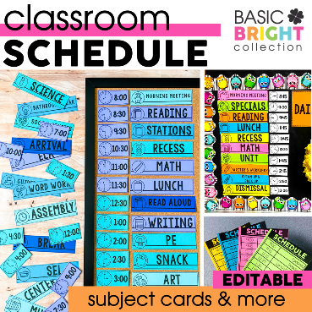
- Use of an authentic, positive, and warm tone of voice

Visual aids-
- Visual Timers
- Visual Schedules
- Visual Reminders
- Are there certain supplies students need to keep with them during the day, or as part of a specific lesson plan?
- You have a list of classroom expectations you would like students to remember.

Positive home contact-

- Tell a student’s family something that you are grateful to their child for. Expressing thanks for a student's behavior to a student’s family shows that the educator values the student and behavior. This reinforces both the behavior and the relationships between educator, student, and family.

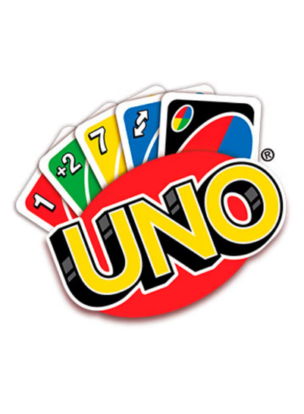
Brain breaks-
- Tic-tac toe
- Coloring sheets
- Uno
- Jenga


Active supervision-
- Movement
- Scanning
- Proximity
- Positive feedback and interactions
- Consistency

Precorrection-
- Example- “Before we head to the assembly, let's remember to walk quietly and sit respectfully.”
- Identify Potential Problem Areas: Teachers or staff anticipate situations where students might struggle to meet behavior expectations (e.g., transitions, assemblies, lunchroom, group work).
- Clearly State Expectations: Provide a short, specific reminder of the behaviors you want to see. Use positive language to set students up for success.
- Practice When Needed: For complex or new routines, a brief practice session may help students understand what the expectations look like in action.
- Monitor and Reinforce: During and after the transition or event, watch for positive behaviors and provide reinforcement (e.g., praise, acknowledgment).

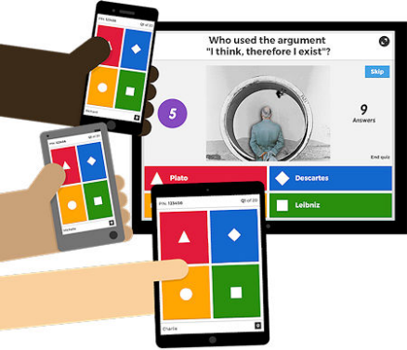

Engagement techniques-
- Make eye contact with your students.
- Weave relatable stories into your lessons using narratives that make your lessons memorable and impactful.
- Encourage questions and provide thoughtful responses.
- Call and response attention grabbers.
- Use live polls or surveys for quizzes and multiple-choice questions to promote engagement and hands-on learning.

Daily emotional check-in-
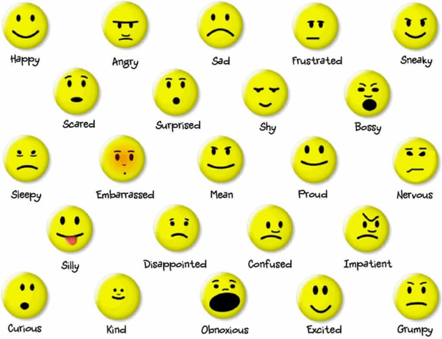

Fidgets-
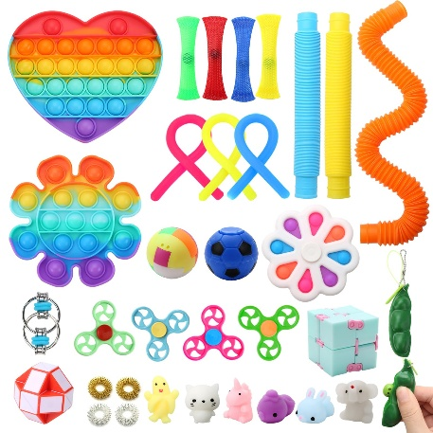
A wide range of high-quality fidget toys to alleviate anxiety, ADHD, and other conditions through calming tactile stimulation.
- Pop-its
- Fidget cubes
- Fidget spinners
- Clicker fidgets

Movement breaks-
Movement breaks are short, active periods from sedentary work that improve well-being by releasing tension, preventing physical strain, and boosting focus and alertness.
Above resources from: 7 Tier 1 PBIS Interventions for Your District

Tier 2-

Tier 2 behavior interventions are targeted, small-group strategies for students who need more support than Universal Tier 1 supports can provide, aimed at preventing more serious issues.

Tier 2 examples-
Check in/Check out system-
A structured program where students check in with a designated coach at the start of the day to receive behavior goals and check out at the end to report on their progress.

Social skills groups-

Small groups focused on teaching and practicing self-regulation, social, emotional, and behavioral skills.

Behavior contracts-
Agreements between a student and a teacher that clearly define behavioral expectations and the rewards for meeting them.

Academic support-
Providing targeted academic interventions, such as tutoring or extra instruction, because academic challenges can be linked to behavioral issues.


Self-monitoring-
Teaching students to track their own behavior, emotions, and progress, which helps them develop self-regulation skills.

Tier 3-
Tier 3 is for students with intensive needs to receive highly individualized and comprehensive support tailored to their specific challenges, often developed with family and educators.
Tier 3 examples-
Function-based Assessments-
Functional Behavior assessment (FBA) is the formal process for ensuring a student’s plan centers on why a student behaves the way they do. FBA allows teams to identify which interventions are most likely to be useful for an individual student. Plans resulting from a formal FBA process will include strategies for:
- Preventing unwanted behavior
- Teaching appropriate behavior
- Positively reinforcing appropriate behavior
- Reducing rewards for unwanted behavior
- Ensuring student safety

Behavior Intervention Plan-
A written plan created for a student with behavioral challenges to help them develop appropriate behaviors by identifying triggers and using teaching strategies and rewards.

One-on-one or small-group support-
  - Mentoring
  - Intensive individual or small-group counseling
  - Collaboration with external professionals like a physician or mental health provider
Structured routines and supports-
  - Individual visual schedules
  - Structured breaks
  - Daily behavior checklists or forms

Skills-based interventions-
  - Teaching social skills, coping skills, or conflict resolution skills
  - Using social stories to explain situations and expected behaviors.
  - Teaching self-monitoring or relaxation techniques

Before you start, a few important points:
- Try multiple interventions.
- Each intervention should be tried for a minimum of 4 weeks, & more than one intervention can be implemented at the same time.
- Collect and track specific data on each intervention tried & its effect.
- If your data indicates no progress after a minimum of 6 months, you may consider moving to Tier two interventions.

Above resources from: MTSS Tiers: Tier 1, 2, and 3 Explained

Intervention examples for low/ no work completion-
Tier 1 Interventions:
- Alternative modes of completing assignments
- Assign a buddy or partner
- Break down assignment
- Break down directions
- Call on student frequently
- Call parents or note home
- Clear and concise directions
- Clear, consistent, and predictable consequences
- Color coded folders
- Daily planner
- Do unfinished work during recess or unstructured time
- Encourage interaction with a more self-confident student
- Engage student
- Explain assignment
- Explain directions
- Give choices
- Have student repeat directions back
- Helping Students with Homework
- Individual workspace
- Move to a new location in the classroom
- Nonverbal cues
- Praise student frequently
- Proximity to students
- Reduce assignment
- Rewards, Simple Reward Systems, & Incentives
- Talk one on one with student
- Use timer
- Visual schedule

Tier 2 Interventions:
Alternatives To Suspension
Behavior Contract
Behavior Intervention Plan (BIP)
Structured Breaks
Check In Check Out (CICO)
Counselor Referral
Daily Behavior Form
Forced Choice Reinforcement Survey
Functional Behavior Assessment (FBA)
Individual & Visual Schedules
Response To Intervention (RTI)
Reward System
Self-Monitoring
Sensory Tools
Social Stories
Teach Organizational Skills

Intervention examples for tantrums and out of control behavior-
Tier 1 Interventions:
- Avoid power struggles
- Break down directions
- Call parents or note home
- Clear and concise directions
- Clear, consistent, and predictable consequences
- Count to 10
- Deep breathing
- Give choices
- Help student start assignment
- Ignore
- Individual workspace
- Logical consequence
- Nonverbal cues
- Praise when cooperative and well behaved
- Praise when good attitude and involvement occur
- Proximity to students
- Reassurance
- Redirection
- Reduce assignment
- Reflection sheet
- Remove from room
- Rewards, Simple Reward Systems, & Incentives
- Speak in calm and neutral tone
- Stress ball or fidget
- Teach conflict resolution skills
- Teach coping skills
- Teach relaxation techniques
- Teach social skills

Immediate de-escalation
- Prioritize safety: Your priority is to ensure the safety of all students. Have a plan to evacuate the other students to a designated safe room or classroom.
- Stay calm: Maintain your composure. Speak in a low, calm voice and avoid pleading, yelling, or making threats.
- Limit verbal communication: Keep your commands minimal, clear, and direct to avoid escalating the situation.
- Remove the student: If the student does not comply with a request to stop or leave, follow your school's policy for removing the student from the immediate area. If necessary, call for backup.
- Avoid physical engagement: Do not use physical force unless it is a last resort and you are trained and authorized by school policy to do so.

Long-term strategies
- Build a positive relationship: Create rapport with the student to understand the underlying issues driving the behavior.
- Identify the root cause: Try to understand why the behavior is happening, as it is often a result of stress, frustration, or a lack of understanding of value.
- Teach replacement skills: Focus on teaching the student appropriate ways to express their feelings or cope with frustration.
- Implement a clear system:
  - Use a visual system like a color-coded chart, sticky notes, or "yellow cards" as a warning system before a consequence is enforced.
  - Make sure the consequences are consistent and followed through with, so the student knows you are serious.
- Create a crisis plan: Work with your school's support staff (e.g., administrators, counselors, behavior specialists) to create a specific crisis plan for the student. This should include steps for prevention, de-escalation, and post-incident procedures.
- Modify the environment: Consider making the classroom more sensory-friendly or using more durable materials, especially if the behavior is related to sensory input.

Above resources from: PBIS World | The Best Complete Tier 1 Through Tier 3 Positive Behavior Interventions & Supports (PBIS) FREE Resource.

ABC Model Fundamentals
Following are the main elements of the ABC model:
- Antecedent: This refers to the events, circumstances, or stimuli that occur before a behavior. Antecedents may occur immediately before a behavior or may include “setting events” that take place over the hours or days preceding a behavior. For example, missing breakfast before school is an antecedent that might make your child cranky by late morning and contribute to speaking rudely to the teacher.
- Behavior: This is the specific action or response that is observed. It is the actual conduct that follows the antecedent and precedes the consequence. In the example above the behavior is rudeness.
- Consequence: This is what happens immediately after the behavior. It can be positive (reinforcing the behavior) or negative (discouraging the behavior), and it influences the likelihood of the behavior recurring in similar situations. In this example, consequences might include a warning from the teacher, removing the child from the classroom, calling home, etc.
- Function: Proponents of the model say that every behavior has a function, meaning it serves a purpose, either consciously or subconsciously for the child. They recognize four broad functions:
  - Sensory: The behavior provides sensory stimulation or meets a sensory need. This could be visual, auditory, tactile, or related to any of the senses. Fidgeting and rocking are common examples.
  - Escape: The behavior helps the individual avoid or escape from an undesirable situation, demand, or stimulus. Wrapping a vegetable in a napkin to avoid eating it is an example.
  - Attention: Behavior is a means to gain attention from others, whether it is peers, caregivers, or authority figures. Whining or tugging on your clothes while you are on a phone call are examples.
  - Tangible: The behavior is used to obtain a desired item or activity. One example is a tantrum in the grocery store checkout line when you say your child cannot have a candy bar.

Put It All Together
Consider the example of a child tapping their pencil on their desk. The table below lists antecedents, consequences, and functions of this single behavior.

Antecedent | Behavior | Consequence | Function
The room is a bit loud and hectic.  The student has ADHD. | Pencil tapping | Movement stimulates faster brainwaves, which help many students with ADHD focus. | Sensory: Increased focus.
The teacher tells students they  can turn test papers over and begin. | Pencil tapping | The student does not begin the test. | Escape: Postpone a difficult test.
The student is shy. They do not  understand the assignment. | Pencil tapping | The teacher comes over to tell the student to stop the noise. | Attention: The student has a chance to ask their question.
The student knows the teacher  has a drawer of fidget toys. The student finished their work early. | Pencil tapping | The teacher gives the student a stress ball to use instead of pencil tapping. | Tangible: A preferred object.

Above resources from: ABC Behavior Model - Smart Kids
Sensory input can help lower behaviors.
What is sensory input?
Sensory input refers to the information our senses receive and process, and in a classroom, students with sensory processing differences (SPD) or other conditions like autism, ADHD, or anxiety may need specific sensory input to regulate and focus. ​
- Sensory input is the information our senses (sight, sound, smell, taste, touch, movement, and body position) receive and the way our brains process it. ​
- Sensory integration is the process by which the brain organizes and interprets this information, allowing us to respond appropriately to our environment. ​

Who Might Need Sensory Input in the Classroom?​
Students with Sensory Processing Differences (SPD):​
These students may have difficulty processing sensory information, leading to over- or under-responsiveness to stimuli. ​
- Over-responsiveness: Students might be overwhelmed by bright lights, loud noises, or certain textures, leading to anxiety or distress. ​
- Under-responsiveness: Students might seek out intense sensory input, like fidgeting or needing more movement, or they may have difficulty paying attention. ​
All Students:​
Even students without diagnosed sensory processing differences can benefit from a sensory-friendly classroom environment that supports their individual needs. ​
Consulting with an Occupational Therapist (OT) and or Physical Therapist (PT) specializing in sensory input is vital for individuals with sensory processing difficulties because they can assess and develop tailored interventions to improve sensory regulation, motor skills, and tolerance for participation in daily activities. Also, it is important to make sure not to overstimulate a student which could cause verse effects. ​
Examples of sensory input:
- Visual: Using calming colors, minimizing clutter, providing visual schedules, or using visual timers. ​
- Auditory: Using noise-canceling headphones, providing quiet spaces, or using calming music. ​
- Tactile: Providing fidget toys, weighted blankets, or textured materials. ​
- Proprioceptive/heavy work: Allowing movement breaks, using wiggle seats, or providing opportunities for physical activity. ​
- Vestibular: Providing opportunities for movement, like rocking chairs or swings, or using a therapy ball as a seat. ​
- Olfactory: Using low-odor cleaning products and markers or having a calming scent available. ​
Above resources from: Meet students' sensory needs | inclusionED

Resources:
PBIS World | The Best Complete Tier 1 Through Tier 3 Positive Behavior Interventions & Supports (PBIS) FREE Resource.
What are the ABCs of Behavior?
Message from Panorama Education
ABC Behavior Model - Smart Kids
Understanding the 4 Behavior Functions
Sensory Input Ideas in The Classroom - Where I Aut-a Be
Meet students' sensory needs | inclusionED

