What is a School-Parent Compact?  A School-Parent compact is an agreement with parents that outlines how parents, the entire school staff, and students will share the responsibility for improved student academic achievement and the way in which the school and parents will build and develop a partnership to help children achieve the State’s high standards.  The Compact will:  - align goals of the School Improvement Plan  - focus on student learning skills  - describe how teachers will help students develop skills using high-quality instruction  - share strategies families can use at home  - explain how teachers and families will communicate about student progress | Activities to Build Partnerships  -TDS remains open to all ideas about best practices to improve student achievement. Teachers and staff engage in all types of Professional Development in order to improve their practices.  -We believe in developing strong relationships in order to fully understand the needs of our students. Parent volunteers are encouraged and welcomed at TDS. These relationships are strengthened each day in our classrooms when we gather and celebrate good news, say the pledge to the flag, and say the school pledge.  -Each Monday, take time to read your child’s weekly folder and grade level newsletters.  -The Explorers Express will tell you about all the upcoming events and activities. Mark your calendars and join us for the fun! | THE DISCOVERY  SCHOOL  School-Parent  Compact  2023-2024  http://www.dcstn.org/tds.aspx
Jointly Developed  The families, students, and staff of THE DISCOVERY SCHOOL developed this School-Parent Compact. Teachers suggested home learning strategies, families added ideas to make them more specific, and students told us what would help them learn. Meetings and events are held each year to review the compact and make changes based on student’s needs, parent comments and teacher recommendations.  Families are welcome to contribute comments and suggestions at any time.  If you would like more information or have a suggestion, please contact Rachel Storment at rstorment@dcstn.org or 615-441-4163 | Communication About Student Learning  THE DISCOVERY SCHOOL is committed to frequent two-way communication with families about student learning. Some of the ways you can expect us to reach you are:  *Weekly and daily folder.  *Updates on the school website and Skyward  *Parent newsletters & Explorers Express  *Parent-Teacher Conferences  *Phone calls, emails, or notes sent home  *Intouch messages, Class DoJo messages, Remind, TDS Facebook page  *RTI benchmark assessment and Fastbridge progress monitoring results will be sent home  *Weekly assessment results  *Report cards and progress reports  *Grade level objectives sent home | 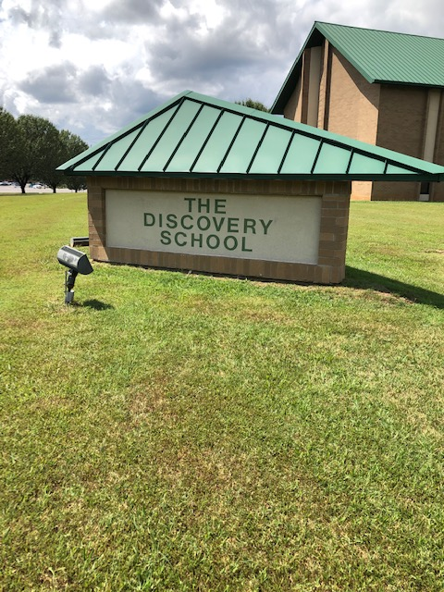  615-441-4163

Our Goals for Student Achievement | Teachers, Families, Students – Together for Success
District Goals  Increase the percentage of students who are on track or mastered in Mathematics from 43% to 46.6% in 2024  Increase the percentage of students who are on track or mastered in Reading/Language Arts from 45% to 48.4% in 2024  School Goals  Increase the percentage of students who are on track or mastered in Reading from 60.7% to 63.2% in 2024  Increase the percentage of students who are on track or mastered in Math from 53.3% to 56.2% in 2024 | In the Classroom  As the teacher, I will:  -maintain open lines of communication with students and parents  -provide information about what your child will be studying and the expectations  -keep you informed about your child’s achievement and behavior  -encourage your child to put forth their best effort  -treat your child with dignity and respect  -work together in the best interest of your child  -utilize technology to help keep parent informed  -set high academic standards and goals to meet state achievement standards  -provide learning activities to help each child reach academic goals | At Home  As the parent, I will:  -see that my child attends school regularly and on time  -provide a home environment that encourages my child to learn  -read with my child 20 minutes at home each night and talk to my child about his/her school activities each day  -check to see all homework assignments are completed  -communicate regularly with my child’s teacher  -work together in the best interest of my child  -support the school to maintain proper discipline  -attend school functions and make school a priority for my child
Students
As the student, I will:
-be on-time and prepared with all the necessary materials
-resolve conflicts in positive ways
-listen and participate in class
-get plenty of sleep each night
-set aside a time for homework each night
-return completed assignments each day
-share notices to parents about school activities
-read 20 minutes each night
-behave well and obey all school rules according to the behavior expectations matrix.

