Bath High School
TABLE OF CONTENTS


2025-2026

CURRICULUM

GUIDE

pg. 2 Earning an Ohio High School Diploma
pg. 3 Seal Requirements
pg. 4 Honors Diploma
pg. 5 Grade Classification, Course Changes, Early graduation, College Credit Plus, Credits earned outside of
regular programs, Bath Digital Academy, Articulation Agreement, Note to parent regarding graduation
requirements

Course Departments
pg. 6-8 ART
pg. 9-11 BUSINESS/TECHNOLOGY
pg. 12 CAREER EDUCATION
pg. 12 CBI
pg. 13-15 ENGLISH
pg. 16 ENGINEERING AND ROBOTICS
pg. 16-17 FOREIGN LANGUAGE
pg. 18 HEALTH AND PHYSICAL EDUCATION
pg. 19 MANUFACTURING
pg. 20-23 MATHEMATICS
pg. 23-24 MUSIC
pg. 25-27 SCIENCE
pg. 28-29 SOCIAL STUDIES
pg. 29 SOCIAL EMOTIONAL LEARNING
pg. 30 APOLLO
pg. 31 INDUSTRY RECOGNIZED CREDENTIAL

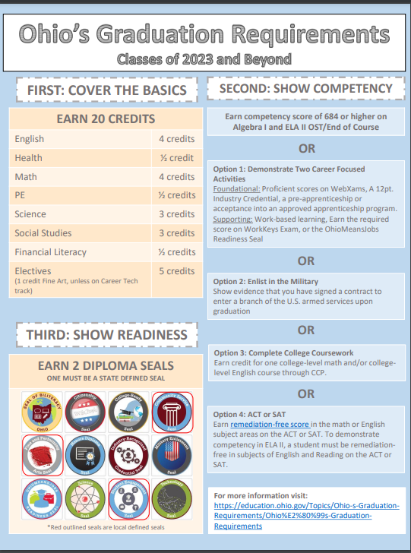
SEAL REQUIREMENTS

- The Ohio Department of Education requires all graduates in the Class of 2023 and Beyond earn a minimum of two diploma seals for graduation. One seal MUST be a state (Ohio) seal. Please see a brief description below of each.

OhioMeansJobs Readiness Seal (Ohio) Must demonstrate certain professional skills required for success in the workplace. Students work with at least three experienced and trusted mentors who validate the demonstration of these skills in school, work, or the community.

Industry-Recognized Credential Seal (Ohio) Earn an approved industry-recognized credential or group of credentials totaling 12 points in a single career field.

College-Ready Seal (Ohio) Earn remediation-free ACT scores; currently these are English 18 or higher, Reading 22 or higher, and Mathematics 22 or higher- these values are subject to change

Military Enlistment Seal (Ohio) Provide evidence that a student has enlisted in a branch of the U.S. Armed Forces; or participate in an approved JROTC program

Citizenship Seal (Ohio) Earn a score of proficient or higher on both the American History and American Government end-of-course exams; earn a final course grade of B or higher in both high school American History and American Government courses.

Science Seal (Ohio) Earn the Science Seal is by earning a score of proficient or higher on the biology end-of-course examination; earn a final course grade of B or higher in an advanced science course

Honors Diploma Seal (Ohio) Students can earn one of the following: Academic Honors Diploma; International Baccalaureate Honors Diploma; Career-Tech Honors Diploma; STEM Honors Diploma; Arts Honors Diploma; Social Science and Civic Engagement Honors Diploma (See next page for details)

Seal of Biliteracy (Ohio) Must show proficiency in English and another language. One of the options for showing proficiency in English is earning a score of proficient or higher on the ELA II EOC, as well as a foreign language competency exam.

Technology Seal (Ohio) A student can earn a final course grade that is equivalent to a “B” or higher in an appropriate class taken through the College Credit Plus program.

Community Service Seal (Local) Student must have 12 hours of documented community service during 9th-12th grade and show signed approval from the organization.

Fine and Performing Arts Seal (Local) Successful completion of 2 semesters of a fine or performing art course within 9th-12th grade (successful completion means a C or higher both semesters); documentation comes from course grade being on transcript.

Student Engagement Seal (Local) Throughout the 9th-12th grade, students must successfully participate in 2 seasons of a sport(s), 2 seasons of marching band, 2 years of show choir and/or jazz band, or 2 semesters of participation in a school approved organization(s) or club(s) and both organization advisors and/or coaches must sign approval form

Please see descriptions of Ohio state seals if you need more clarification. https://education.ohio.gov/Topics/Ohio-s-Graduation-Requirements/Summary-of-Graduation-Updates-%E2%80%93-2023-and-Beyond

For the class of 2026 beyond, updated honors diploma requirements can be found at: https://education.ohio.gov/Topics/Ohio-s-Graduation-Requirements/Contacts-and-Resources/Honors-Diplomas
HONOR DIPLOMA

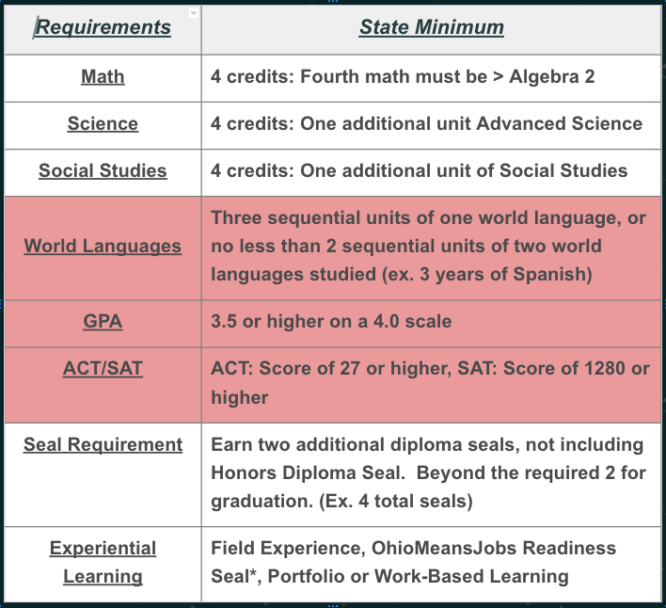

GRADE CLASSIFICATION
SOPHOMORES = 5 CREDITS JUNIORS = 10 CREDITS SENIORS = 15 CREDITS

COURSE CHANGES
The courses selected in the Spring will determine the master schedule of classes for the next year. Student Registration in a course requires a commitment on your part to that course. You have freedom of choice regarding the classes you and your parents select for the coming school year; however, following the registration deadlines you are not permitted to change courses unless you meet one of the following criteria. Changes will be considered for the following reasons only:
- LACK OF REQUIRED COURSE: If you are missing a course that is a graduation requirement OR failed a mandatory course and need to repeat the course.
- FAILURE TO MEET PREREQUISITES: If you registered for a course but failed to meet the prerequisites mandatory for that course.
- PROCEDURAL ERRORS: A course code incorrectly inputted.
- SUMMER: Students who complete a course for credit recovery or CCP in summer school for which they are scheduled will be permitted to substitute another class for that course only.
- CCP: Registered for an equivalent CCP course.

EARLY GRADUATION
Bath High School requires twenty (20) units of credit for graduation. These credits may be completed in six (3 years) or seven (3 ½ years) semesters. Among these twenty (20) credits, students must meet state minimum standards and local requirements for graduation. Recommendations for approval of early graduation will include such factors as vocational readiness, participation in co-curricular activities, social factors, physical factors, student goals and unusual family situations, as well as academic excellence. Application for three-year graduation must be made by April 1 of the sophomore year. Application for 3 ½ year graduation must be made by April 1 of the junior year. For students to be eligible for early graduation after three years in attendance, they must have completed fourteen (14) units of credit by the end of the sophomore year. For students to be eligible for graduation after 3 ½ years in attendance, they must have completed 17.50 units of credit by the end of the junior year.

COLLEGE CREDIT PLUS
This program permits any qualified students, grades 7 through 12, to enroll in public college on a full or part-time basis for nonsectarian courses for which they may receive high school and/or college credit. College Credit Plus courses can be taken in the summer, fall, or spring semester with a maximum of 30 semester hours per year which includes high school credits earned. Complete information regarding this program will be available to parents in February in the high school auditorium. All signed CCP forms due on or before April 1st.

CREDITS EARNED OUTSIDE OF REGULAR PROGRAMS
Under special circumstances, a student may earn 4 credits in independent study; 2 credits per year in summer school; 2 credits by correspondence courses; however, only a total of 6 credits may be earned toward the 20 units required for graduation. These are separate programs and are not to be considered as a substitute for the regular school program. Prior approval from administration must be granted before a student is eligible for any of these programs.

BATH DIGITAL ACADEMY (BDA)
The Bath Digital Academy is a credit flexibility option for students who need to recover the necessary credits towards graduation and/or for those students who may be unable to attend the traditional school setting. Enrollment in the digital academy requires administrative approval. Please see an administrator or school counselor for more information. Students will be required to pay for credit recovery courses. Students are required to pay $150 of the total credit recovery course. If the student fails, they will be required to pay the remaining balance. In total, a full credit course is $449 and a half credit course is $299. Students can only take a maximum of 2 classes per year. Your school counselor will inform you of the course(s) needed to recover.

ARTICULATION AGREEMENT (SUBJECT TO CHANGE)
Students successfully completing classes in the BathPride Company may have the opportunity to earn college credit from The University of Northwestern Ohio.

NOTE TO PARENTS REGARDING GRADUATION REQUIREMENTS
It is the student’s responsibility to see that requirements for graduation are met. Bath High School will make every effort to keep up-to-date records and to keep students and parents informed about the status of progress toward necessary coursework for graduation requirements. However, it is the student’s responsibility to be acquainted with the necessary requirements to meet this goal. Note: It is required that students take six courses each semester.
Course
Descriptions

ART

104 FUNDAMENTALS OF ART 1/2 CREDIT GRADES 9,10,11,12
SEMESTER MATERIALS FEE: $20.00
A general fine arts course presenting a series of introductory art experiences in multiple media. The course emphasizes the basic elements of art (line, shape, value, color, space, form and texture) and helps the student develop a working knowledge of the principles of design. The study of different artists and cultures will be explored through the use of technology, artistic prints and the student textbook, The Visual Experience.

105 DRAWING/PAINTING I 1/2 CREDIT GRADES 9,10,11,12
SEMESTER MATERIALS FEE: $20.00
PREREQUISITE: Fundamentals of Art
A fine arts course which covers a variety of 2-dimensional media such as acrylic, pastel, colored pencil, charcoal and graphic art. Subject matter will focus on drawing from “life” and will include still-life and portraits as well as exploring other genres of art. Further study of the principles of design will be emphasized in order for the student artist to become adept in the creation of strong compositions. The study of different artists, movements, and cultures will be explored through the use of technology, artistic prints and the student textbook, The Visual Experience.

106 DRAWING/PAINTING II 1/2 CREDIT GRADES 10,11,12
SEMESTER MATERIALS FEE: $20.00
PREREQUISITE: Grade of B or higher in Drawing/Painting I and teacher recommendation
A fine arts course which continues with more in depth study of experiences, ideas and concepts introduced in Drawing & Painting I. This is a course for the student who is extremely interested in Art. Emphasis will be placed on using artists, movements, and cultures as inspiration for student work, individual creativity, and approaching art as a means of communication. Drawing & Painting II involves in depth studies of art concepts that require independent and individualized study and classroom work.

112 DRAWING/PAINTING III 1/2 CREDIT GRADES 11,12
SEMESTER MATERIALS FEE: $20.00
PREREQUISITE: Drawing/Painting II
Students should have a B average in prerequisite classes and permission from the instructor.
A theme based fine arts course with a strong emphasis in art history for the student who is very interested and proficient in the arts or is considering art as a major in college and a career in the field. Drawing and Painting III/IV involves in depth studies of art concepts. The class requires independent and individualized study and classroom work, self-motivation, persistence, and self-direction in the creation of student work. This class will include the creation/maintenance of a portfolio (and making it digital).

113 DRAWING/PAINTING IV 1/2 CREDIT GRADES 11,12
SEMESTER MATERIALS FEE: $20.00
PREREQUISITE: Drawing/Painting III
Student should have a B average in prerequisite classes and permission of the instructor.
A theme based fine arts course with a strong emphasis in art history for the student who is very interested and proficient in the arts or is considering art as a major in college and a career in the field. Drawing and Painting III/IV involves in depth studies of art concepts. The class requires independent and individualized study and classroom work, self-motivation, persistence, and self-direction in the creation of student work. This class will include the creation/maintenance of a portfolio (and making it digital)

114 DRAWING/PAINTING V 1/2 CREDIT GRADES 11,12
SEMESTER MATERIAL FEES: $20.00
PREREQUISITE: Drawing/Painting IV
Student should have a B average in prerequisite classes and permission of the instructor.
These courses are for the student who is very interested in pursuing a career in visual arts and who is skilled in creative thinking, techniques and art concepts. The thematic work will carry on into these various levels of art courses. Students will be expected to create project proposals that follow established guidelines and will require independent and individualized study of artists, cultures, and movements in art history as well as the incorporation of more advanced techniques in various media. Photography will be a component of this course. Self-motivation, persistence, and self-direction in the creation of student work will be required. These courses will include the maintenance and refinement of their digital portfolio in preparation of portfolio review at the university level. These courses are offered as an independent study and can be scheduled during any 2-D art class.

115 DRAWING/PAINTING VI 1/2 CREDIT GRADES 11,12
SEMESTER MATERIAL FEES: $20.00
PREREQUISITE: Drawing/Painting V
Student should have a B average in prerequisite classes and permission of the instructor.
These courses are for the student who is very interested in pursuing a career in visual arts and who is skilled in creative thinking, techniques and art concepts. The thematic work will carry on into these various levels of art courses. Students will be expected to create project proposals that follow established guidelines and will require independent and individualized study of artists, cultures, and movements in art history as well as the incorporation of more advanced techniques in various media. Photography will be a component of this course. Self-motivation, persistence, and self-direction in the creation of student work will be required. These courses will include the maintenance and refinement of their digital portfolio in preparation of portfolio review at the university level. These courses are offered as an independent study and can be scheduled during any 2-D art class.

116 DRAWING/PAINTING VII 1/2 CREDIT GRADE 12
SEMESTER MATERIAL FEES: $20.00
PREREQUISITE: Drawing/Painting VI
Student should have a B average in prerequisite classes and permission of the instructor.
These courses are for the student who is very interested in pursuing a career in visual arts and who is skilled in creative thinking, techniques and art concepts. The thematic work will carry on into these various levels of art courses. Students will be expected to create project proposals that follow established guidelines and will require independent and individualized study of artists, cultures, and movements in art history as well as the incorporation of more advanced techniques in various media. Photography will be a component of this course. Self-motivation, persistence, and self-direction in the creation of student work will be required. These courses will include the maintenance and refinement of their digital portfolio in preparation of portfolio review at the university level. These courses are offered as an independent study and can be scheduled during any 2-D art class.

107 SCULPTURE/CERAMICS I 1/2 CREDIT GRADES 9,10,11,12
SEMESTER MATERIALS FEE: $20.00
PREREQUISITE: Fundamentals of Art
A fine arts course divided into two areas of concentration working with clay and exploring other three-dimensional processes. This course will cover sculpture in the round, additive and subtractive sculpture techniques, throwing on the pottery wheel and hand-built pottery.

109 SCULPTURE/CERAMICS II 1/2 CREDIT GRADES 10,11,12
SEMESTER MATERIALS FEE: $20.00
PREREQUISITE: Grade of B or higher in Sculpture/Ceramics I and teacher recommendation
A fine arts course which continues with more in depth study of experiences, ideas and concepts introduced in Sculpture/Ceramics I. This class will involve in depth studies of art techniques that require independent and individualized classroom work. It will also utilize art history as inspiration for student work. Advanced students considering a major or career in art will also be expected to include works in their digital portfolio.

117 SCULPTURE/CERAMICS III 1/2 CREDIT GRADES 11,12
SEMESTER MATERIALS FEE $20.00
PREREQUISITE: Sculpture/Ceramics II
Students should have a B average in prerequisite classes and permission of the instructor.
These fine arts courses will continue a more in-depth study of experiences, ideas and concepts introduced in previous Sculpture and Ceramics courses. Class will involve the creation of sculpture on a larger scale, jewelry, and wheel work. Advanced concepts and techniques will be expected in student created work. This class is recommended for students with a high interest in the arts and considering a future career in the field. These courses are offered as an independent study and can be scheduled during any 3-D art class.

118 SCULPTURE/CERAMICS IV 1/2 CREDIT GRADES 11,12
SEMESTER MATERIALS FEE $20.00
PREREQUISITE: Sculpture/Ceramics III
Students should have a B average in prerequisite classes and permission of the instructor.
These fine arts courses will continue a more in-depth study of experiences, ideas and concepts introduced in previous Sculpture and Ceramics courses. This class will involve the creation of sculpture on a larger scale, jewelry, and wheel work. Advanced concepts and techniques will be expected in student created work. This class is recommended for students with a high interest in the arts and considering a future career in the field. These courses are offered as an independent study and can be scheduled during any 3-D art class.

119 SCULPTURE/CERAMICS V 1/2 CREDIT GRADES 11,12
SEMESTER MATERIALS FEE $20.00
PREREQUISITE: Sculpture/Ceramics IV
Students should have a B average in prerequisite classes and permission of the instructor.
These fine arts courses will focus on thematic work across sculpture media. Students will be expected to create project proposals that follow established guidelines and will require independent and individualized study of artists, cultures, and movements in art history as well as the incorporation of more advanced techniques in various media. Self-motivation, persistence and self-direction in the creation of student work will be required. These courses will include the maintenance and refinement of their digital portfolio. This class is recommended for students very interested in pursuing a career in visual arts and who are skilled in creative thinking, techniques and art concepts in sculpture media. These courses are offered as an independent study and can be scheduled during any 3-D art class.

120 SCULPTURE/CERAMICS VI 1/2 CREDIT GRADES 11,12
SEMESTER MATERIALS FEE $20.00
PREREQUISITE: Sculpture/Ceramics V
Students should have a B average in prerequisite classes and permission of the instructor.
These fine arts courses will focus on thematic work across sculpture media. Students will be expected to create project proposals that follow established guidelines and will require independent and individualized study of artists, cultures, and movements in art history as well as the incorporation of more advanced techniques in various media. Self-motivation, persistence and self-direction in the creation of student work will be required. These courses will include the maintenance and refinement of their digital portfolio. This class is recommended for students very interested in pursuing a career in visual arts and who are skilled in creative thinking, techniques and art concepts in sculpture media. These courses are offered as an independent study and can be scheduled during any 3-D art class.

121 SCULPTURE/CERAMICS VII 1/2 CREDIT GRADES 11,12
SEMESTER MATERIALS FEE $20.00
PREREQUISITE: Sculpture/Ceramics VI
Students should have a B average in prerequisite classes and permission of the instructor.
These fine arts courses will focus on thematic work across sculpture media. Students will be expected to create project proposals that follow established guidelines and will require independent and individualized study of artists, cultures, and movements in art history as well as the incorporation of more advanced techniques in various media. Self-motivation, persistence and self-direction in the creation of student work will be required. These courses will include the maintenance and refinement of their digital portfolio. This class is recommended for students very interested in pursuing a career in visual arts and who are skilled in creative thinking, techniques and art concepts in sculpture media. These courses are offered as an independent study and can be scheduled during any 3-D art class.

BUSINESS/TECHNOLOGY EDUCATION

This class is set for the students to find their own path in technology, like an independent study. The student will pick from the following programs to complete to create an object using technology. A student cannot repeat programs.

- Microsoft Word is a word processing program that allows for the creation of both simple and complex documents. Word is one of the most commonly used programs for any college, business, and or work area you want to get into. Has high similarities to Google Docs.  - Microsoft Excel is a software program that uses spreadsheets to organize numbers and data with formulas and functions. Excel is used in the business and data analysts career pathway. It can also be used in the education and engineering fields. Has high similarities to Google Sheets.  - Microsoft PowerPoint is an easy to use presentation graphics software that allows you to create professional looking electronic slide shows. PowerPoint is used in business development, graphics design, education, and administrative careers. Has high similarities to Google Slides.  - Adobe Photoshop is where you can crop photos, adjust photo composition, correct lighting, and make any subject imaginable look its absolute best. Photoshop is a critical tool for designers, web developers, graphic artists, photographers, and creative professionals.  - Adobe Illustrator is the industry leading graphic design tool that lets you design anything you can imagine from logos to icons to graphics and illustrations and customize it with professional level precision. Illustrator is mainly used by Designers but it’s also an extremely useful tool for any visual artist including video editors, photographers, web designers, and animators.  - Adobe Dreamweaver and Web Design is a website creation program that allows you to build and publish web pages with software that supports HTML, CSS, and JavaScript. A student can become a Web Designer and work in fields such as Application Design, Information Architecture, and User Experience Design. | - Fusion 360 is a 3D modeling and design software. Fusion 360 is used in the career fields of engineering, architecture, and manufacturing.  - Raspberry Pi is a simple computer that doesn’t have many parts, making it perfect for new learners. Raspberry Pi can be used in career fields such as electronics, robotics, programming, and internet of things (IoT).  - Google Drive (Docs, Sheets, Slides, Forms)  - Photography is the art of producing an image by recording light with a camera.Digital cameras and editing software create lots of possibilities for the photos you’ll be able to produce if you choose to study photography. Career fields include commercial photography, photojournalists, digital photo editors, videographers, and educators.  - T-Shirt Design the student will be using the cricut software and cutter to produce their own t-shirt design.  - Garageband is a digital audio workstation and music sequencer that can record and play back multiple tracks of audio. Garageband allows you to create music with or without an instrument.  - iMovie can cut and edit videos, music, and graphics without changing any of the original files. iMovie is used to edit films and videos.  - Video Game Design is on CodeHS where the student will code to create basic and simple video games.  - JavaScript is on CodeHS where the student will learn how to use JavaScript and be able to apply it to many applications.  - Coding and Programming is for new students to the coding and programming world. It introduces students to the ideas around coding and programming. Allowing them to learn before getting into more complex coding.  - Circuits is to allow students to learn about how electricity flows using digital circuits on TinkerCAD.

214 CREATIVE TECHNOLOGY I 1/2 CREDIT GRADES 9,10, 11, 12 SEMESTER FEE: $20.00

215 CREATIVE TECHNOLOGY II 1/2 CREDIT GRADES 9,10,11,12
SEMESTER FEE: $20.00
PREREQUISITE: Creative Technology I

216 CREATIVE TECHNOLOGY III 1/2 CREDIT GRADES 10,11,12
SEMESTER FEE: $20.00
PREREQUISITE: Creative Technology II

217 CREATIVE TECHNOLOGY IV 1/2 CREDIT GRADES 10,11,12
SEMESTER FEE: $20.00
PREREQUISITE: Creative Technology III

218 CREATIVE TECHNOLOGY V 1/2 CREDIT GRADES 10,11,12
SEMESTER FEE: $20.00
PREREQUISITE: Creative Technology IV

219 CREATIVE TECHNOLOGY VI 1/2 CREDIT GRADES 10,11,12
SEMESTER FEE: $20.00
PREREQUISITE: Creative Technology V

230 CREATIVE TECHNOLOGY VII 1/2 CREDIT GRADES 11,12
SEMESTER FEE: $20.00
PREREQUISITE: Creative Technology VI

231 CREATIVE TECHNOLOGY VIII 1/2 CREDIT GRADE 12
SEMESTER FEE: $20.00
PREREQUISITE: Creative Technology VII and Permission from Instructor

232 CREATIVE TECHNOLOGY IX-JR. YEARBOOK 1 CREDIT GRADE 11
ALL YEAR FEE: $20.00 PREREQUISITE: Junior Status

233 CREATIVE TECHNOLOGY X-SR. YEARBOOK 1 CREDIT GRADE 12
ALL YEAR FEE: $20.00
PREREQUISITE: Senior Status

This is a year-long course. In this course students will gain skills in one or more of the following areas: page design, advanced publishing techniques, copywriting, editing, and photography while producing a creative, innovative yearbook which records school memories and events. Participants gain useful, real-world skills in time management, marketing, teamwork and design principles. There is an opportunity for the student to receive college credit.

234 CREATIVE TECHNOLOGY XI 1 CREDIT GRADE 11
JR.THE PAW PRINT NEWS FEE: $20.00
ALL YEAR
PREREQUISITE: Junior Status

235 CREATIVE TECHNOLOGY XII 1 CREDIT GRADE 12
SR. THE PAW PRINT NEWS FEE: $20.00
ALL YEAR
PREREQUISITE: Senior Status

“In order to be involved in the Paw Print Newspaper or Newscast, students and parents/guardians must sign and agree to abide by a code of conduct set forth by the Paw Print organization. Failure to follow the Code of Conduct may result in a reassignment of duties and/or a loss of staff member privileges.”
An application must be completed online by the student and approved by Mr. Gomez before signing up for the class.
This is a course where students will write, edit, design, and layout the school newspaper. Students also work on completing a weekly newscast that is published on YouTube. Self-motivation, a positive attitude, and high standards of achievement are essential in all staff members.
CCP TECHNOLOGY COURSE OFFERINGS

CPT 1050 - Technology Basics for IT Pro
3 Credit hours
Teaches students advanced computer terms and concepts. This course is required for all Information Technology majors. Students will learn Windows operating system, command line logic, electronic spreadsheets, and HTML/CSS programming. Emphasis will be on command line logic.

CPT 1580 — Introduction to Graphic Design and Layout
3 Credit hours
Introduces students to design and layout concepts that make an effective presentation. Topics of instruction will include layout, type design, color usage, scaling photographs and artwork, design of various documents, and integration with written work. An introduction to the use of desktop publishing software will also be included.

CPT 2650 — Creating and Editing Digital Image
3 Credit hours
Introduces students to creating and/or editing digital images. Students will learn to create bitmap images using a variety of software tools, and will capture digital images using a digital camera and a scanner, and transfer those images to a computer for editing. Students will learn both the design and production perspective, including creating and managing layer masks, creating color effects and improving images with adjustments layers, working with text and combining text and imagery, and using filters and layer styles to create eye-popping special effects. This is a hands-on course.

CPT 2670 — Graphics Software and Applications
3 Credit hours
Introduces students to creating and/or editing digital graphics. Students will learn to create vector graphics using a variety of software tools to create simple graphics, icons, and text to complex and multilayered illustrations. Through a thorough exploration of vector graphics students are able to apply their knowledge to all of the software tools, features and special effects, allowing them to create fun and interesting artwork. This is a hands-on course.

BUSINESS COURSE OFFERINGS

236 PERSONAL FINANCIAL LITERACY ½ CREDIT Required for Juniors
SEMESTER
Financial Literacy is defined as the ability to read, analyze, manage and communicate about personal financial conditions that affect one's material well-being. It includes the ability to discern financial choices, discuss money and financial issues without (or despite) discomfort, plan for the future and respond completely to life events that affect every day financial decisions, including events in the general economy. Counts toward the financial literacy credit required for graduation.

FIN 1250 - Personal Finance 1 CREDIT
3 credit hours
RHODES STATE COLLEGE Financial Literacy is defined as the ability to read, analyze, manage and communicate about personal financial conditions that affect one's material well-being. It includes the ability to discern financial choices, discuss money and financial issues without (or despite) discomfort, plan for the future and respond completely to life events that affect every day financial decisions, including events in the general economy. Counts toward the financial literacy credit required for graduation.

CAREER EDUCATION

704 CAREER EXPLORATION 1/2 CREDIT REQUIRED FOR GRADE 9
SEMESTER FEE: $10
This is a two-part course where students will learn best practices for managing their own finances along with the basic principles of economics. Students will understand money and income, decision making and planning, managing credit and debt, along with saving and investing. In the second part of the course students will explore a variety of careers and career pathways. A variety of skills will be introduced and developed such as resume writing, interviewing skills, professionalism, networking, and leadership. Students will research careers and review postsecondary admission requirements. Classroom discussions and guest speakers will relate to job attainment and advancement. Students in this class will have an understanding of career opportunities, job outlooks, and the pathways necessary in order to obtain a career in a field of interest.

706 COLLEGE AND CAREER READINESS 1/2 CREDIT REQUIRED FOR GRADE 10
SEMESTER FEE: $10
In this course students will learn effective learning strategies and skills to provide a strong foundation for successful lifelong learning. Throughout the semester, students will research careers and occupations, review post-secondary admissions qualifications, and develop interviewing skills. Additional topics will include professionalism, networking, conflict resolution, negotiation, leadership, and entrepreneurship. Career Readiness may be a requirement for graduation for the classes of 2023 and beyond, if a student has not demonstrated a clear career pathway (CBI, Pre-Apprenticeship, Military Enlistment, CAT, or CCP).

705A CAREER AWARENESS TRAINING A (CAT) 1 CREDIT GRADE 12
1st SEMESTER
705B CAREER AWARENESS TRAINING B (CAT) 1 CREDIT GRADE 12
2nd SEMESTER
The CAT program is offered to seniors as an elective course where students are released during the school day and partnered with either a teacher to provide educational experiences or local businesses which will provide internships, apprenticeships, or other business opportunities. Students have the opportunity to learn the skill sets that are necessary for a specific career and learn the soft skills necessary in the workforce. Students will complete the course knowing the type of post-secondary education/training required in their career field. Grading is on a pass or fail basis. The grade will not count in the grade point average. CAT applications must be completed and turned into the guidance department with scheduling forms and administration approval required
CBI

700 CAREER BASED INTERVENTION RELATED 1 CREDIT GRADES 11,12
ALL YEAR FEE: $25.00
This class is designed to introduce the students to methods of obtaining and holding a job, as well as those of personal finance. Job safety is stressed throughout the program in conjunction with the students’ work study. Field trips and fundraising activities are also part of the program.

701 CBI WORK 2 CREDITS GRADES 11,12
ALL YEAR
PREREQUISITE: Must be in CBI related
A structured and supervised paid work experience that must average a minimum of fifteen hours per week during each nine-week grading period. Due to the work requirement, students in this course will be released for work during 6th and 7th period and will NOT be permitted to take other classes during this time. Grading is on a pass or fail basis. The grade will not count in the grade point average.

ENGLISH

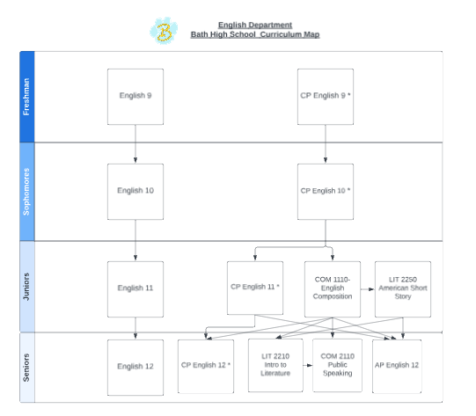

321 ENGLISH 9 1 CREDIT GRADE 9
ALL YEAR
This non-college bound course is designed for the student who has experienced difficulty with reading, grammar, usage, and/or writing. In this yearlong course the student will read a variety of literary forms with the emphasis placed on comprehension and the development of listening, speaking, and analyzing skills. In the study of writing and composition, emphasis will be on sentence structure, usage, and paragraph development leading to the basic essay. Vocabulary and spelling will also be stressed. All academic content standards taught are aligned to grade 9. The student will be expected to purchase paperback books for literature study.

322 COLLEGE PREP ENGLISH 9 1 CREDIT GRADE 9
ALL YEAR
PREREQUISITE: Grade of “A”, “B” or ‘C” in English 8 or Permission of the Instructor
This course is designed for the college bound student. In this year-long course, the student will begin his/her preparation for more advanced study of literature and composition at the high school level. Students will study the various forms of literature including short stories, essays, drama, novels, informational texts, and poetry. Special emphasis will be directed toward identifying the main idea/theme of literary works and informational texts through the analysis of the author’s choices. Grammar, usage, spelling, and vocabulary will be studied in conjunction with their functions as part of the writing process, particularly the crafting of narratives and essays. Students will be involved in writing different forms of compositions including exposition and narration with emphasis on good sentence and paragraph structure leading to the basic essay. The student may need to purchase paperback books for literature study.

323 ENGLISH 10 1 CREDIT GRADE 10
ALL YEAR
In this yearlong course the student will read a variety of literary forms including short stories, essays, poetry, drama, and novels. The emphasis will be on reading comprehension and inference. Students’ skills in grammar, usage, vocabulary, and spelling will be emphasized as important components of their writing. Sentence structure, paragraph development, and basic essay structure will continue to be improved. All academic content standards are aligned to current state level indicators for grade 10. The student may be expected to purchase appropriate paperback books for literature study.

324 COLLEGE PREP ENGLISH 10 1 CREDIT GRADE 10
ALL YEAR
PREREQUISITE: Grade of “A”, “B” or “C” in English 9 or permission of the instructor (A grade of D or F in CP English 9 requires the student to drop to the non-college bound level of English 10.)
This course is designed for the college bound sophomore. This yearlong course will expose the student to more critical and analytical reading and writing. In the study of composition, the student will be expected to refine his paragraph skills and to develop his essay skills in expository writing. Vocabulary study will be included. The study of literature will focus on more detailed analysis of short stories, poetry, drama, non-fiction, and novels. Students will be expected to use their composition skills to write about and analyze the literature that they read.

306 ENGLISH 11 1 CREDIT GRADE 11
ALL YEAR
Over the course of the year, students will study various forms of literature including plays, short stories, poetry, and the novel. Vocabulary, grammar, and writing skills will be studied along with each of the literature units. Students will also learn to write a professional email as well as a resume. A unit on ACT prep will prepare students for the state mandated test in February.

325 COLLEGE PREP ENGLISH 11 1 CREDIT GRADE 11
ALL YEAR
PREREQUISITE: Grade of “A”, “B” or “C” in English 10 or Permission of the Instructor (A grade of D or F in CP English 10 requires the student to drop to the non-college bound level of English 11.)
This course is designed for the college bound junior. This course offers an overview of American literature, emphasizing the major literary periods and significant writers in each period. The study includes essays, poetry, short stories, novels and modern plays. The writing for this course is designed to refine essay skills and prepare the student for writing in college. Writing in this course includes critical analyses, an argumentative essay, a resume, and a formal research paper. Grammar will be integrated within writing and vocabulary will be addressed to prepare for the ACT.

309 ENGLISH 12 1 CREDIT GRADE 12
ALL YEAR
Over the course of the year students will study, write, and present speeches of various types with emphasis on grammar, structure, mechanics, audience, and organization. Literature study will emphasize leisure reading to encourage reading as a life-long activity. Compositions will be assigned in conjunction with the reading portion of the course. The student will be expected to purchase paperback books.

326 COLLEGE PREP ENGLISH 12 1 CREDIT GRADE 12
ALL YEAR
PREREQUISITE: Grade of A, B or C in English 11 or Permission of the Instructor (A grade of D or F in CP English 11 requires the student to drop to the non-college bound level of English 12.)
This course is designed for the college bound senior. The course offers an overview of British and World Literature, emphasizing the main literary movements in history and the significant writers within such periods. The first semester will be focused on British Literature in which classical writers such as William Shakespeare and Geoffrey Chaucer will be emphasized. The second semester will be focused on World Literature in modern fiction. The writing of this course will include critical analyses, thematic analysis, and a formal research paper. Grammar, vocabulary, and college preparation will be included in this course throughout the year.

327 ADVANCED PLACEMENT ENGLISH 12 1 CREDIT GRADE 12
ALL YEAR
PREREQUISITE: Grade of B+ or above in College Prep English 11 AND the Permission of the Instructor are required in order to register for this course.
This course is designed for college bound seniors who both enjoy the subject of literature and excel in the study of it. Students who complete this course will be encouraged to take the AP English Literature and Composition exam in the spring and may earn multiple college credits based upon the results of this test. The College Board charged $88.00 last year for the administration and scoring of each AP exam.
AP English 12 will focus on the reading, analysis, and evaluation of works of literary merit (as prescribed by the College Board). Summer reading may be required. Assignments will include large amounts of reading, frequent analytical essays (both extemporaneous and polished pieces) and oral presentations. Active participation in class discussions will be required. Students may need to purchase paperback books.
Work in this course will proceed at an accelerated pace and will require students to put forth their best effort on a consistent basis. It is hoped that students who accept the challenge of AP will find it intellectually stimulating and academically rewarding. Students should expect to increase their exposure to fine literature and to improve their vocabulary, close reading skills, and analytical writing skills as they strive to earn a 3 or higher on the AP English Literature and Composition exam in May.

COM 1110 — ENGLISH COMPOSITION Rhodes State College GRADES 11,12
3 Credit Hours
Provides practice in sound organization and effective expression of ideas in original expository and argumentative compositions as well as the research paper. Extensive discussion of rhetorical modes and editing techniques

LIT 2250— AMERICAN SHORT STORY Rhodes State College GRADES 11,12
3 Credit Hours
Centers of American authors and their themes. These themes are often a reflection of the author's education, experiences, and social milieu. The course will focus on the historical, social, philosophical and theological implications of the stories.

LIT 2210— INTRO TO LITERATURE Rhodes State College GRADES 12
3 Credit Hours
Serves as an introduction to the three major areas of literature: poetry, drama, and prose. It provides an overview of the three genres and may focus upon a central theme.

COM 2110 — PUBLIC SPEAKING Rhodes State College GRADES 12
3 Credit Hours
Covers the analysis, formation, organization, development, and delivery of ideas and attitudes within contemporary issues by means of audience analysis and dialogue. Various rhetorical modes and group projects are also included.

ENGINEERING & ROBOTICS

702 COMPUTER MODELING & DESIGN 1/2 CREDIT GRADES 9,10,11,12
SEMESTER FEE: $20.00
The major focus of the course will expose students to the basic principles of 2D Computer Drawings and use AutoCAD Software, 3D Solid Modeling, and a basic introduction to Robotics and programming using 3D printing. The program is designed to allow students to develop strategies to enable and direct their own learning. CMD will also help develop the problem-solving skills necessary to create solutions to the various challenges and projects that increase in difficulty throughout the course. Students will also learn about 3D assemblies and 3D printing. This class will benefit students interested in any field of engineering, manufacturing, or architecture.
703 PLTW: INTRODUCTION TO ENGINEERING DESIGN 1 CREDIT GRADES 9,10,11,12 ALL YEAR FEE: TBD
Project Lead the Way (PLTW): You will learn how engineers apply a design process to solve real-world problems. You will work individually and as a member of collaborative teams to apply math, science, and a variety of engineering tools, including 3D modeling software, to design, document, and communicate your engineering work. Many of the transportable skills you practice in this course—such as communication, collaboration, ethical reasoning, and process thinking—can be applied to your other courses and your future career!

FOREIGN LANGUAGE

404 SPANISH I 1 CREDIT GRADES 9,10,11,12
ALL YEAR
¡Bienvenidos! In this course we will be studying the language and the culture of the Hispanic world. Right from the start you will be emerged in communicating in the language which involves speaking, reading, writing, listening and learning vocabulary and grammar. Classes are held in Spanish.

405 SPANISH II 1 CREDIT GRADES 9,10,11,12
ALL YEAR
PREREQUISITE: Spanish I with “C” or better
In Spanish II, we will add more vocabulary to your repertoire and learn to communicate more effectively by incorporating intrinsic sentence structures. In addition to vocabulary and communication skills, we will continue our study of the culture and history of the Spanish speaking world. Classes are held in Spanish.
OR
SPN 1010 — Beginning Spanish Language I RHODES STATE COLLEGE
3 Credit hours
Provides an introduction to Spanish language and culture through multiple approaches in order to develop spoken and written communication skills, listening and reading comprehension skills, and cultural awareness. This course will practice functional Spanish in basic listening and speaking situations. The focus will be on meaningful and achievable communication as per the American Council on the Teaching of Foreign Languages (ACTFL) current national standards.

406 SPANISH III 1 CREDIT GRADES 10,11,12

ALL YEAR

PREREQUISITE: SPANISH II WITH “C” OR BETTER
We will learn to communicate in different tenses: present, past, and future. We will also learn how to express emotions, doubt, and uncertainty. We will utilize authentic materials such as news articles and literature to gain a heightened sense of the language used for communication, the study of culture, and the everyday communication resources of the Spanish speaking world.
OR

SPN 1020 — Beginning Spanish Language II RHODES STATE COLLEGE
3 Credit hours
Prerequisites: SPN 1010 (with a grade of "C" or better).
Provides the second course in a series of two courses which serve as an introduction to Spanish Language and culture. Spoken and written communication skills will be developed as will listening and reading comprehension skills, and cultural awareness. This course will continue introducing and practicing functional Spanish in basic listening and speaking situations, as well as basic reading and writing. The focus will be on meaningful and achievable communication as per the American Council on the Teaching of Foreign
Languages (ACTFL) current national standards.

407 SPANISH IV 1 CREDIT GRADES 11,12
ALL YEAR
PREREQUISITE: SPANISH I, II, III WITH “C” OR BETTER
En este curso repasaremos la gramática y los elementos gramaticales que son difíciles para los angloparlantes. Estudiaremos la lingüística básica como la ortografía, la acentuación y la sintaxis. Además, utilizaremos las noticias, los cuentos y la literatura para ver la gramática y la cultura en acción. Escribirás resúmenes y llevarás a cabo trabajos de investigación y presentaciones sobre los países hispanohablantes. Nos comunicaremos en español sobre estos temas.
OR
SPN 2010 -Intermediate Spanish Language & Culture I RHODES STATE COLLEGE
3 Credit hours
PREREQUISITE: SPN 1020 (with a grade of "C" or better)
Provides the first in a series of two intermediate courses in Spanish language and culture. The course focuses on using the five skills needed to learn a language: reading, writing, speaking, culture, and listening. The course will adhere to the national communication standards as identified by the American Council on the Teaching of Foreign Languages (ACTFL). Transfer: TAG.
_______________________________________________________________________________________________________________________________________

411 SPANISH V 1 CREDIT GRADE 12
ALL YEAR
PREREQUISITE: SPANISH I-IV WITH “C” OR BETTER: Teacher recommendation is needed.
Leeremos y utilizaremos los recursos auténticos tales como obras literarias para repasar y analizar la gramática y el vocabulario. Estudiaremos temas de arte e historia. Ampliaremos el vocabulario con el estudio de palabras que suelen causar confusión. Nos comunicaremos en español sobre estos temas. Se necesita una recomendación de la maestra para tomar este curso.
OR
SPN 2020 — Intermediate Spanish II RHODES STATE COLLEGE
3 Credit hours
PREREQUISITE: SPN 2010 (with a grade of C or better)
Provides the second in a series of two intermediate courses in Spanish language and culture. The course focuses on using the five skills needed to learn a language: reading, writing, speaking, culture, and listening. The course will adhere to the national communication standards as identified by the American Council on the Teaching of Foreign Languages (ACTFL). Transfer: TAG

423 AMERICAN SIGN LANGUAGE III 1 CREDIT GRADES 11,12
ALL YEAR
PREREQUISITE: ASL 2 with a “C” or better
The third year of ASL will be a continuation of ASL 2 but this year will be done without voices during class. Students will be making a vocabulary notebook and learning more about culture, different types of deafness, interpreting code of ethics and different interpreting settings. Students will also be watching performances in Sign such as videos, plays, and stories. We will begin doing more sign-to-voice and voice-to-sign interpreting. Students will need a 2” 3-ring binder and dividers for this class.
This class is online.

HEALTH - PHYSICAL EDUCATION

500 HEALTH 1/2 CREDIT GRADES 9,10,11
SEMESTER
IF CREDIT NOT EARNED IN 8TH GRADE
Health class focuses on a wellness approach to improve a person’s overall health. Important aspects of health are identified for the student and include, but are not limited to: physical health, mental/emotional health and social health. Topics covered in this class offer a broad overview of health concepts and ideas, such as personality and self-esteem, preventing drug abuse, sexually transmitted infections and diseases, food and nutrition, and consumer health and safety. Health class provides the student with an array of knowledge that creates an opportunity for youth/adults to make wise decisions and choose desirable alternative behaviors to improve their overall wellness and quality of life. This course is offered through BDA – Bath Digital Academy.

501 PHYSICAL EDUCATION 1/4 CREDIT GRADES 9,10
SEMESTER
Half of a credit is required for graduation. Regulation of gym clothes and active participation are required. Grading is on a satisfactory or unsatisfactory basis. The grade will not count in the grade point average. Due to this course being less than a half credit, PE does NOT count towards the five necessary credits for athletic eligibility. Failure may result from three days of no participation per nine weeks or by being absent 1/4 of the scheduled classes per 9-week grading period.

502 CPR and FIRST AID 1/2 CREDIT GRADES 9,10,11,12
SEMESTER FEE: $30.00
In this course, students learn, practice, and apply the CPR standards set forth by the American Heart Association. This course educates students in CPR and AED skills on an adult, child, and an infant; then students will apply this knowledge in the first aid portion where fundamentals of first aid response are covered and practiced. Basic first aid knowledge will be discussed in medical emergencies, injury emergencies, environmental emergencies, and other special occasions that can be applied to everyday life. The course will also educate on how this information will be beneficial to health-related career fields such as athletic training, nursing, an Emergency Medical Technicians, and more by offering basic knowledge of ACLS (Advanced Cardiac Life Support) practices, basic identification of sport injuries, knowledge of basic anatomy, and opportunities for professional speakers. At the conclusion of this course, participants are trained to identify a medical emergency and will be properly educated on how to handle the situation. All who successfully pass the course will have the opportunity to be examined for a BLS (Basic Life Support) certification in First Aid, Adult CPR/AED, Infant CPR/AED issued from the American Heart Association.

BHS 1390 — MEDICAL TERMINOLOGY ⅓ CREDIT RHODES STATE COLLEGE
2 Credit hours
Discusses an understanding of foundational medical terminology used in communication with the health care team. Terminology pertaining to the treatment of disease, including standard abbreviations, anatomic, diagnostic, symptomatic, eponymic, laboratory, pathologic, radiology, anesthetic, operative, and drug items will be covered in this course. Transfer: TAG

505A STRENGTH & CONDITIONING 1/2 CREDIT GRADES 10,11,12
1st SEMESTER

505B STRENGTH & CONDITIONING 1/2 CREDIT GRADES 10,11,12
2nd SEMESTER
Strength and Conditioning will provide an opportunity for development of strength and conditioning for various sports and fitness related activities. Free weights, exercise machines, agility activities, stretching, and nutrition will be incorporated to promote improvement in strength, endurance, balance, agility, speed, and overall body wellness. Students will lift according to their strength program and will participate in classroom activities on alternating days to learn the fundamentals of taking care of their body through nutrition. Proper technique, safety precautions, and proper application of the principles of training will be emphasized. A plan to achieve goals will be developed and implemented during this semester-long course.

MANUFACTURING DEPARTMENT

602 PRE-ENGINEERING TECHNOLOGIES 1 CREDIT GRADES 9,10,11,12
ALL YEAR
Students will acquire knowledge and skills in problem solving, teamwork, and innovation. Students explore STEM careers as they participate in a project-based learning process, designed to challenge and engage curiosity and imagination. Teams design and test their ideas using modeling, automation, robotics, mechanical and computer control systems while also exploring energy and the environment.

600 WOODWORKING I ½ CREDIT GRADES 9,10,11,12
SEMESTER FEE: $25.00
Students will engage in introductory skills utilized in working with various wood construction materials. They will learn to use basic measuring tools, hand tools, and machines that are common to the wood industry and construct basic projects. Additionally, students will examine various wood construction materials and their properties. Throughout the course, students will demonstrate the safe and proper use of hand tools and machines.

601 WOODWORKING II ½ CREDIT GRADES 9,10.11,12
SEMESTER FEE: $25.00
Prerequisite: Woodworking I or Industrial Technology I
The Woodworking II course provides opportunities for students to apply knowledge, attitudes, and skills that were learned in Woodworking I in a more comprehensive and authentic way. Students will use knowledge of hand tools and machines obtained in Woodworking I, along with new instruction, to construct a major project of their choosing. This is a hands-on course with the majority of the semester spent on their project.

603 SMALL ENGINE REPAIR (ENGINES AND FUEL SYSTEMS) ½ CREDIT GRADES 9,10,11,12
SEMESTER FEE: $25.00
Students will identify, diagnose, maintain, and repair engines and fuel systems. Topics include differentiation of fuels and fueling systems along with their characteristics, designations, and additives. Students will learn the principles of cooling, lubrication, intake, exhaust and after-treatment systems and how to make necessary repairs while maintaining system cleanliness. Throughout the course, site and personal safety along with business and employability skills are emphasized.

604 HOME IMPROVEMENT ½ CREDIT GRADES 9,10,11,12
SEMESTER FEE: $25.00
Students will be introduced to the basic principles of architecture and construction. During this course, students will read and create construction drawings and use hand tools to create basic construction projects and models. Throughout the course, students will use hands-on skills and procedures in a lab setting. Additionally, students will investigate career opportunities in construction and architecture related fields.
MATHEMATICS

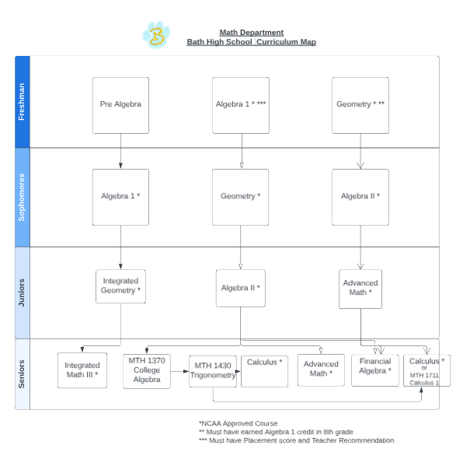

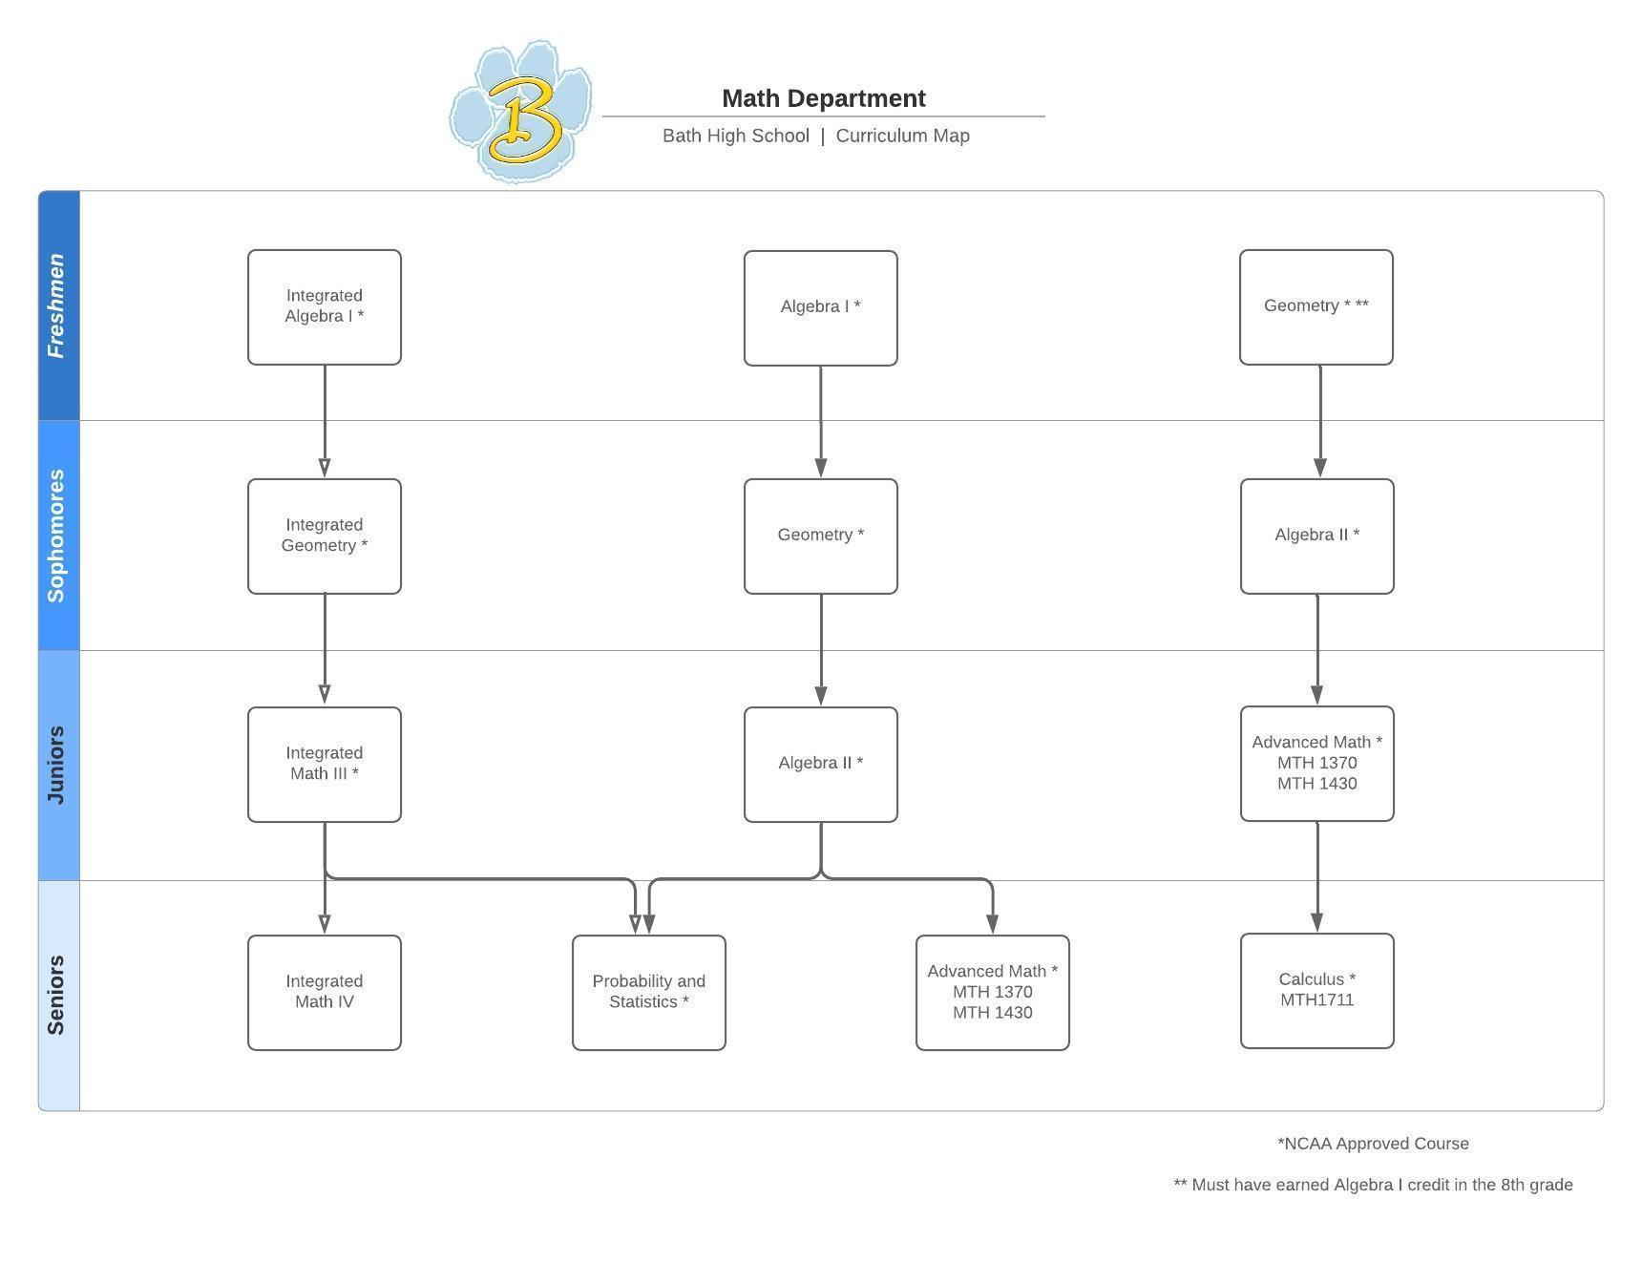

811 PRE-ALGEBRA 1 CREDIT GRADE 9
ALL YEAR
Students will develop algebraic skills, both symbolic and graphical. This course will strengthen mathematical skills with arithmetic concepts, solving equations and inequalities, solving systems of two equations, simplifying radical expressions, factoring polynomial expressions and creative problem solving. This course places a strong emphasis on real world problems and an investigative approach.

803 ALGEBRA I 1 CREDIT GRADE 9,10
ALL YEAR
PREREQUISITE: Placement for 9th graders is based on placement testing and teacher recommendation.
Algebra I is the foundation for all advanced mathematics. Students will learn the language and usage of symbols and signs. Great emphasis will be concentrated toward the logic and the pattern of solving equations. These applications will be used in problem solving and will help in the preparation for studying the physical sciences such as Chemistry and Physics. This is the beginning of the college prep program. Students will be prepared for state mandated end of course exam.

812 INTEGRATED GEOMETRY 1 CREDIT GRADE 10
ALL YEAR
PREREQUISITE: Algebra I
Students will continue to develop algebraic skills, along with building knowledge of points, lines, planes, circles, and angles. This course will strengthen mathematical skills while covering topics such as coordinate geometry, transformations, measurements, areas and volumes, logical reasoning, congruences, similarities, and trigonometry. Emphasis will be placed on practical intuitive approaches to solving problems. This course meets preparation requirements for college intending students and is aligned to the Common Core State Standards. Students will be prepared for the state mandated end of course Geometry exam.

807 GEOMETRY 1 CREDIT GRADES 9,10
ALL YEAR
PREREQUISITE: “C” or better in Algebra I
A course designed to include facts about plane, solid and coordinate Geometry. Methods of reasoning and perceptions of geometric relations will be stressed. Subject matter includes basic properties, congruent triangles, plane and solid figures, proportions, similar polygons, circle areas of polygons and loci. Students who pass remedial Algebra I in summer school are not eligible to take Geometry.

813 INTEGRATED MATH III 1 CREDIT GRADE 11
ALL YEAR
PREREQUISITE: Integrated Geometry or Geometry
This course is designed to further the study of the Algebra and Geometry concepts taught in previous courses. This course will help those students who are anticipating going to college or a technical school and plan on taking the ACT. The course will cover a quick review of algebra concepts such as order of operations, solving equations, factoring polynomials, solving linear equations, quadratic equations and basic geometry and trigonometry concepts. Also included will be the study of complex numbers, graphing and solving 3 equations with 3 variables, matrices, probability, functions, angles and angle measurement, rational expressions, trigonometry functions, logarithms and conics. A graphing calculator (TI 83 plus or TI 84 plus) is highly recommended and will be used extensively.

805 ALGEBRA II 1 CREDIT GRADES 10,11
ALL YEAR
PREREQUISITE: “C” or better in Geometry
The first semester includes a review of Algebra I, and covers topics including real numbers, linear equations and functions, polynomials, rational expressions, irrational and complex numbers, and quadratic functions. Advanced topics presented in the second semester include the study of exponents and logarithms, sequences and series, matrices and determinants, conic sections, trigonometry, and statistics and probability. A TI-83 graphing calculator is a necessary tool for success in this course.

808 ADVANCED MATHEMATICS 1 CREDIT GRADES 11,12
ALL YEAR
PREREQUISITE: “C” or better in Algebra II
A year course designed to prepare the college bound student for college mathematics. Emphasis will be placed on the study of functions, graphing, trigonometry, analytic geometry, vectors, equation solving and other algebraic techniques.

MTH 1370 — College Algebra 1 CREDIT
Credit Hours: 4.00 1st semester only
RHODES STATE COLLEGE Covers equations and inequalities, complex numbers, graphs and equations of lines, functions including quadratic functions and composite functions, inverse functions, polynomial and rational functions, the Fundamental Theorem of Algebra, exponential and logarithmic functions, systems of equations and inequalities, conic sections, and sequences and series.
A specific calculator requirement will be made by the instructor on the first day of class.
Prerequisites: Algebra II (with a grade of "B" or better) and teacher recommendation

MTH 1430 -- Trigonometry 1 CREDIT
Credit Hours: 3.00 2nd semester only
RHODES STATE COLLEGE Concentrates on the development and use of the trigonometric functions with additional study of vectors. The course will cover trigonometric functions, solving right and oblique triangles, graphs of trigonometric functions, identities, trigonometric equations, inverse trigonometric functions, complex numbers, polar coordinates and graphs, and vectors.
Transfer: TM.
Prerequisites: MTH 1370 (with a grade of "C" or better)

MTH 1711-- Calculus 1
Credit Hours: 5.00 All Year
Covers limits including the definition and L'hopital's Rule; continuity; derivatives including the transcendental functions; applications of derivatives including related rate, curve sketching, and optimization problems; introduction to integration; Fundamental Theorem of Calculus; and applications to area and volumes.
Transfer: TM.
Prerequisites: MTH-1370, MTH-1430 (w/grade of "C" or better) or placement
809 CALCULUS 1 CREDIT GRADE 12
ALL YEAR
PREREQUISITE: “C” IN ADVANCED MATH AND TEACHER APPROVAL
First Semester – This offering integrates the Algebra, Geometry, Trigonometry and Analytic Geometry course. Calculus will be introduced late in the first semester.
Second Semester – The second semester is offered as a basic beginning course in calculus. Content of the course will include the study of functions with respect to the derivative, the integral and the differential.

815 FINANCIAL ALGEBRA 1 CREDIT GRADE 12
ALL YEAR
This course will involve the application of key Algebra, Geometry, and Statistics concepts to real-world financial topics such as Banking Services, Consumer Credit Usage, Automobile and Home Ownership, Income Taxes, Budgeting, Investing, and more. The course will prepare students to be able to apply mathematical concepts and make informed financial decisions in their everyday lives.

- –
MUSIC

900 CONCERT CHOIR 1 CREDIT GRADES 9,10,11,12
ALL YEAR FEE: $10.00
This choir is open to students through an audition with the director.
Attendance at rehearsals and performances is mandatory.
Music from all periods of history is studied to help develop an eclectic repertoire of musical styles. This organization performs numerous times throughout the year in formal concerts and contest.

913 CHAMBER CHORALE 1 CREDIT GRADES 9,10,11,12
ALL YEAR FEE: $15.00
This choir is open through selective audition to students in grades 9, 10, 11 and 12.
Attendance at rehearsals and performances is mandatory.
Only students who maintain the highest standards of musical excellence through performance will be permitted to hold membership in the Chamber Chorale. The Chamber Chorale performs numerous times throughout the year in formal concerts, contest and community performances.

905 SHOW CHOIR 1/2 CREDIT GRADES 9,10,11,12
ALL YEAR FEE: $15.00
Attendance at rehearsals and performances is mandatory.
You must be a member of the choir program and have the approval of the director.
This “early bird” choir class meets Tuesday and Thursday mornings from 7:30 to 8:10 a.m. An audition process will be followed in order to achieve admittance into this group. Attendance and punctuality are the major factors in granting 1/2 credit for this course. The emphasis of this group will be singing, dancing, and performing.

901 BAND 1 CREDIT GRADES 9,10,11,12
ALL YEAR FEE: $30.00
Attendance at rehearsals and performances is mandatory.
Placement in the two concert bands is through individual auditions.
The band program is open to any student who passes proficiency on a band instrument. Two concert bands combine to form the marching band. Emphasis is on group and individual musicianship. These groups will perform many types of music. All students earn a grade.

906 FLAGS 1/2 CREDIT GRADES 9,10,11,12
SEMESTER FEE: $30.00
Attendance at rehearsals and marching band performances is mandatory.
Membership in the Flag Corp is by audition only. This is a one-semester course in which students earn one half credit and a grade. All members are required to attend a summer camp and all Bath High School Marching Band functions. This “906 Flags” is for non-instrumental playing Flag Corp members. All members earn a grade.

912 JAZZ BAND 1/2 CREDIT GRADES 9,10,11,12
ALL YEAR
You must have permission from the band directors to register for this course.
Attendance at rehearsals and performances is mandatory.
This "early bird" class meets Monday and Wednesday from 7:30 to 8:10 a.m. You must be a member of the band program or be proficient on an instrument needed for Jazz Band that a band member cannot play. Attendance and punctuality are the major factors in granting 1/2 credit for this course. Emphasis will be on musical style and improvisation, the basis of all jazz.

903 MUSIC THEORY 1/2 CREDIT GRADES 9,10,11,12
1st SEMESTER ONLY FEE: $20.00
PREREQUISITE: Requires Director’s approval
Music Theory is open to ALL students. This course offers an opportunity to learn and utilize the concepts of basic music theory. Reading and writing musical notation, rhythms, and key signatures combined with using proper musical terminology will allow students to better understand and appreciate music, as well as give them the tools necessary to write and compose simple songs. Students are only allowed to take the course once.

911 MUSIC APPRECIATION 1/2 CREDIT GRADES 9,10,11,12
2nd SEMESTER ONLY
Music Appreciation is open to ALL students. The purpose of this course is to increase students’ musical awareness and give students the tools to actively listen to, discuss, and critique various styles of music. The first portion of the course will focus on learning the basic elements of music: Melody, Rhythm, Harmony, Form, Texture, Timbre, Tempo, and Dynamics. The second portion of the course will focus on the history of Classical music from the Middle Ages to the present. Using appropriate vocabulary, students will study a variety of musical genres, including: Classical, Jazz, Opera, Musical Theater, and Popular music. Students are only allowed to take this course one time.

MUS 1010 - MUSIC APPRECIATION 1 Credit GRADES 9,10,11,12
2nd semester only
Rhodes State College provides an introduction to music from its origins in Gregorian Chant to the Romantic Period. Students will acquire background information on the various aspects of music from music notation, analysis, aesthetic value, and an overall brief history of music within various cultures and eras.

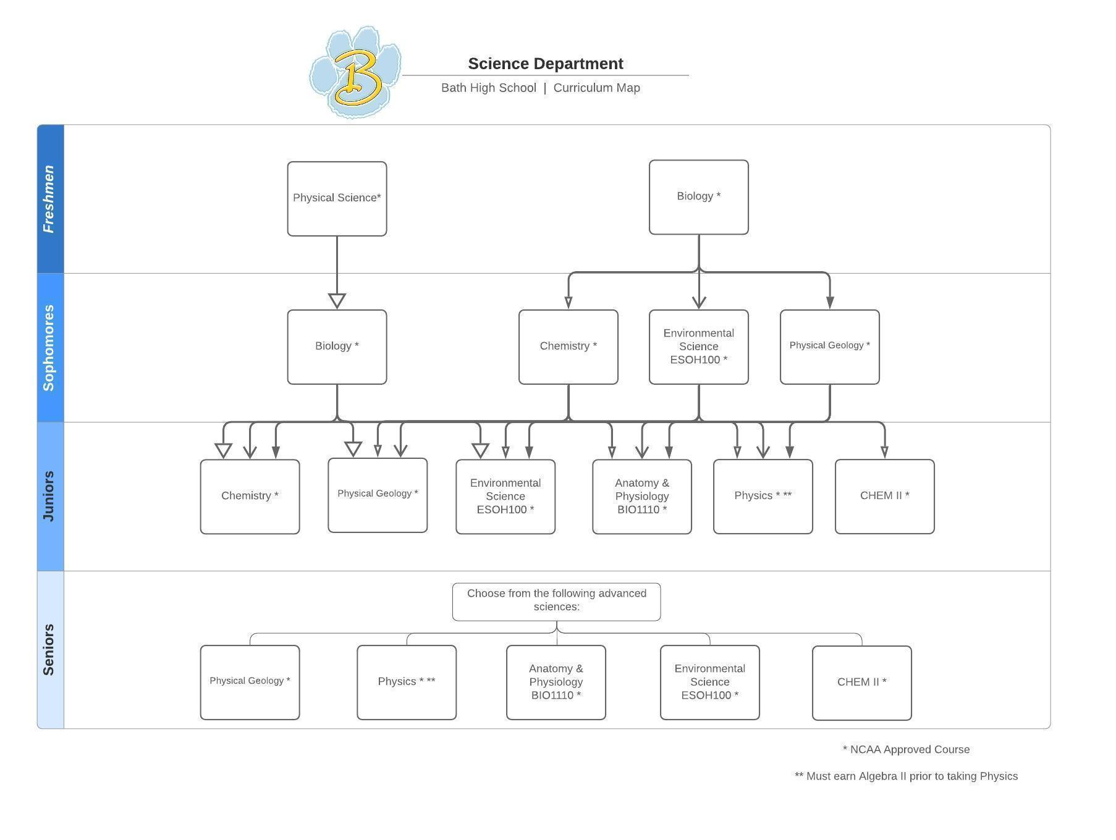
SCIENCE

927 PHYSICAL SCIENCE 1 CREDIT GRADE 9
ALL YEAR
This course will introduce the students to elementary physical and chemical concepts. Topics such as metrics, motion, gravity, systems energy, waves, optics, electricity, matter, atoms, compounds, the periodic table, carbon compounds, crystals, fluids, solutions, acids, bases, and salts will be covered. The students will use basic math to solve science problems and there will be some laboratory work. This course is designed to prepare the student for further coursework in science. A calculator is helpful. This class counts as a physical science towards graduation requirements.

933 BIOLOGY 1 CREDIT GRADES 9,10
ALL YEAR FEE: $25.00
PREREQUISITE: Placement for 9th graders is based on placement testing and teacher recommendation.
Biology is the study of life from microscopic to macroscopic forms. Students will study life forms on a molecular level, cellular level, and genetic level. This course will also include the study of evolutionary patterns, ecological dynamics, and individual forms. Use of microscopes and dissections will be required. This class counts as a life science towards graduation requirements.

934 CHEMISTRY I 1 CREDIT GRADES 10,11,12
ALL YEAR FEE: $10.00
PREREQUISITE: Biology OR COREQUISITE: Biology
Chemistry I is designed to introduce the student to the basic facts of chemistry and to provide a solid core of the fundamental concepts. Topics include the atomic structure and periodic table, quantitative relations in chemical formulas and equations, the nature of chemical reactions, energy changes, and reaction rates, solutions, and understanding and interpreting laboratory procedures and observations. A scientific calculator is necessary. This class counts as a physical science or advanced science towards graduation requirements.
926 PHYSICAL GEOLOGY 1 CREDIT GRADES 10,11,12
ALL YEAR FEE: $5.00
PREREQUISITE: Biology
Physical Geology will study topics that deal with the planet earth. It will include concepts such as: the universe, solar system, moon, space travel, maps, minerals, rocks, earth’s structure, earth’s energy, mountains, soil, water, glaciers, oceans, geologic time, air, climate, and weather. Some topics will have lab projects introducing them where people in lab groups will work together to learn more about that specific topic. This class counts as a physical science or advanced science towards graduation requirements.

936 AP PHYSICS 1 CREDIT GRADES 11,12
ALL YEAR FEE: $10.00
PREREQUISITE: Algebra I, II, Geometry
A scientific calculator is necessary.
AP Physics 1 is an algebra-based, introductory college-level physics course. Students cultivate their understanding of physics through inquiry-based investigations as they explore the following topics: kinematics, dynamics, circular motion and gravitation, energy, momentum, simple harmonic motion, torque and rotational motion. The learning objectives for this course are all focused around 5 “Big Ideas” that serve as the basis for AP Physics 1 as described in the AP course description (Systems, Fields, Force Interactions, Charge, and Conservation). These allow students to make connections between the topics discussed and overall concepts at the heart of the physical world. Students will have the opportunity to take the AP Physics 1 Exam in May which they earn college credit based on their exam score. There is an exam fee, set by the College Board, was $88 last year.
A scientific calculator is necessary.

942 ANATOMY AND PHYSIOLOGY 1 CREDIT GRADES 11,12
ALL YEAR FEE: $25.00
PREREQUISITE: Biology
Studies the structure and function of the human body as an integral whole. The course begins with a brief study of inorganic chemistry, organic chemistry, and histology, then examines the following body systems: integumentary, skeletal, muscular and nervous. Laboratories include dissections, physiology experiments and plastic model demonstrations. This class counts as a life science or advanced science towards graduation requirements.
OR
BIO 1110 – Anatomy and Physiology I RHODES STATE COLLEGE
4 Semester Credit Hours
Studies the structure and function of the human body as an integral whole. The course begins with a brief study of inorganic chemistry, organic chemistry, and histology, then examines the following body systems: integumentary, skeletal, muscular, and nervous. Laboratories include dissections, physiology experiments, and plastic model demonstrations. “C” grade policy applies for a student in a health program.
Transfer: TM
Prerequisites: CHM 0960 with “C” or better, or ACT Science score of 20.
Co-requisites: BIO 1110L.
BIO 1110L – Anatomy and Physiology I Lab
Laboratories include dissections, physiology experiments, and plastic model demonstrations.
AND
BIO 1120 – Anatomy and Physiology II
4 (Semester) Credit Hours
Prerequisite: BIO 1110 with a “C” or better
Co-requisites: BIO 1110L (see below)
Builds upon BIO 1110 by continuing with the following body systems: endocrine, cardiovascular, lymphatic/immune, respiratory, urinary, digestive and reproductive. Includes additional topics of fluid and electrolyte balance, metabolism, and fetal development are included.
BIO 1120L Anatomy and Physiology II Lab
Laboratories include dissections, physiology experiments, and plastic model demonstrations.

946 ENVIRONMENTAL SCIENCE 1 CREDIT GRADES 10,11,12
ALL YEAR FEE: $25.00
PREREQUISITE: Biology
Environmental Science initially examines the structure and function of ecosystems. The course then examines man’s impact upon ecosystems and public health by identifying various sources of air contaminants, water contaminants, and soil contaminants, and the composition of municipal and industrial waste. The course concludes with an examination of society’s use of and dependency upon energy and the fuels used to generate power and electricity, including fossil fuels, nuclear fuels, and alternative energy sources (solar, wind, hydro, and geothermal). Current writings and events related to the environment are identified and discussed. Public officials and governmental bodies and the processes that protest human health and the environment are also examined. This class counts as a life science or advanced science towards graduation requirements.

OR

ESOH 100 ENVIRONMENT AND SOCIETY UNIVERSITY OF FINDLAY
Credits: 3 (Semester) Credit Hours
PREREQUISITE: Biology
Environment and Society studies the dependency of humans on their natural environment while emphasizing conservation, sustainability, and energy efficiency. The course initially examines the structure and function of ecosystems. The course then examines man's impact upon ecosystems and public health by identifying various sources of air contaminants, water contaminants, and soil contaminants and the composition of municipal and industrial waste. The course concludes with an examination of society's use of and dependency upon energy and the fuels used to generate power and electricity, including fossil fuels, nuclear fuels, and alternative energy sources (solar, wind, hydro, and geothermal). Current writings and events related to the environment are
identified and discussed. Public officials and governmental bodies and processes that protect human health and the environment are also examined. Interested students must have an overall GPA of 2.5 or higher and one of the following standardized test scores: ACT composite of 20, Reading Next-generation ACCUPLACER of 250. Those with a 3.0 or higher GPA will be excluded from submitting test scores.

AND

ESOH 100L ENVIRONMENT AND SOCIETY/LAB
Credits: 1 (Semester) Credit Hours
PREREQUISITE: ESOH 100 or concurrent with ESOH 100
This is a science laboratory course designed to provide students with hands-on experiences that are relevant, easy to understand, and presented in an interesting and informative manner. The laboratory sessions are grouped by topical categories that can be used in conjunction with the ESOH 100 textbook. Topics will be explored by laboratory exercises, independent investigation, and literature review. The ESOH 100L course may be taken with the ESOH 100 course.

947 LAB AIDE 1/4 CREDIT GRADES 11,12
SEMESTER
PREREQUISITE: 4 Science Credits in 3 Years of High School
Lab Aide is designed for a student that has a keen interest in science. The student will help the instructor as a lab aide for a lower level science class, typically Biology or Chemistry. This class is ideal for a student who wants to major in science or education. Grading is on a satisfactory or unsatisfactory basis. The grade will not count in the grade point average.

SOCIAL STUDIES
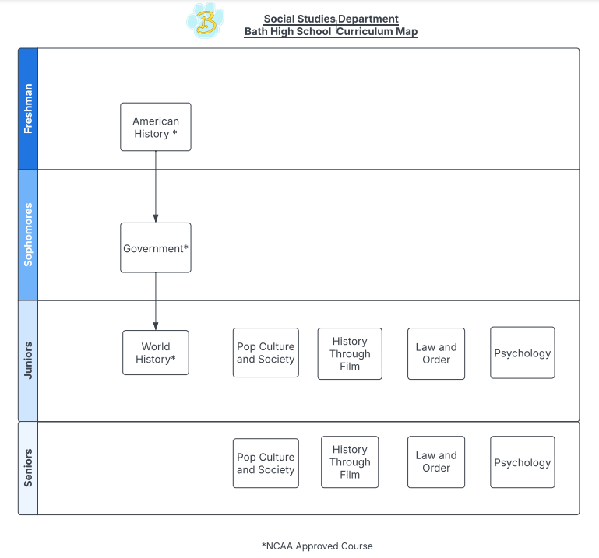

970 AMERICAN HISTORY-1876 to present 1 CREDIT GRADE 9
ALL YEAR
Students were presented American History until 1876 in their eighth-grade year. This course will begin as a review of that material and continue to recent events. Students will become acquainted with events that have shaped modern American society, America’s role in a changing world, and the current events that will become US history. Emphasis of this course will be the 10th grade level benchmarks/indicators.

963 AMERICAN GOVERNMENT 1 CREDIT GRADE 10
ALL YEAR
American Government is a course designed to give the students working knowledge of the American government. The introduction will cover the history of government and how the United States developed its current system. Lengthy emphasis will be placed on the three branches of US government at the national level. Smaller units on the election process, comparing the US government and economic style to that of other nations, and a study of state and local government will follow. Special emphasis on current events as well as the standards put forth by the Ohio Department of Education will be included.

960 WORLD HISTORY 1/2 CREDIT GRADE 11
SEMESTER
The first semester of this course examines events from 1600 to 1920. It explores the impact of the democratic and industrial revolutions, the ideas that led to independence movements, and the forces that led to world domination by the European powers and the build-up to World War I. The concepts of historical thinking introduced in earlier grades continue to build with students locating and analyzing primary and secondary sources from multiple perspectives to draw conclusions. The second semester of this course examines events from 1920 to present. It explores the impact of the wars that changed empires and the effects of global interdependence. As well as the impact of different politics on the world. The concepts of historical thinking introduced in earlier grades continue to build with students locating and analyzing primary and secondary sources from multiple perspectives to draw conclusions.

964 PSYCHOLOGY ½ CREDIT GRADES 11,12
SEMESTER
This is an introductory course in the general principles and concepts of psychology. The course is designed to provide an overview of the major topics and concepts and to help the students understand the practical application of these concepts for daily living.
971 POP CULTURE AND SOCIETY ½ CREDIT GRADES 11,12
SEMESTER
In this semester-long course, students will explore the dynamic and evolving world of pop culture, focusing on how music, film, television, fashion, social media, and other cultural trends reflect and influence society. Through the examination of key moments in pop culture history and analysis of current trends, students will gain insight into the intersection of entertainment, identity, politics, and economics. Topics will include the rise of digital media, celebrity culture, the impact of pop culture on social movements, and how different generations engage with and shape cultural norms. Students will engage in class discussions, multimedia projects, and critical analysis of various forms of media. By the end of the course, students will have a deeper understanding of how pop culture shapes our worldview and the broader societal implications of entertainment and media in everyday life.

972 HISTORY THROUGH FILM ½ CREDIT GRADES 11,12
SEMESTER
This semester-long course explores key historical events, eras, and figures through the lens of film. Students will analyze how filmmakers portray history, examining both the accuracy and creative interpretation of real-world events. By viewing and critically evaluating a variety of films, documentaries, and historical dramas, students will gain a deeper understanding of the cultural, social, and political contexts of different time periods.
The course will cover various themes such as war, revolution, civil rights, and historical leadership, while also addressing the role of film as a powerful medium for shaping public perception of history. Students will engage in discussions about the ethical responsibilities of filmmakers when representing historical truths, and they will assess how film can both illuminate and distort the past.
965 LAW AND ORDER ½ CREDIT GRADES 11,12
SEMESTER
This entry-level semester long course introduces high school students to the fundamental concepts of law, justice, and the criminal justice system. Students will explore the roles of law enforcement and the judiciary in maintaining social order. Key topics include the history and purpose of laws, the rights of individuals, and the role the courts play in the United States. Students will examine real-world case studies to understand the complexities of crime, legal proceedings, and ethical dilemmas faced by this branch of the government.

SOCIAL EMOTIONAL LEARNING

980 LEADERSHIP DEVELOPMENT ½ CREDIT Grades 11,12
SEMESTER
This semester-long course is designed to equip students with essential leadership skills and strategies to become effective leaders in diverse settings. Combining theoretical learning with hands-on exercises and real-world applications, students will explore key topics such as leadership styles, goal setting, conflict resolution, ethical decision-making, and executing leadership projects. By the end of the course, students will have developed a deeper understanding of leadership concepts and practices, as well as the confidence to lead, collaborate, and inspire others in various contexts.
APOLLO
CAREER CENTER

ADMISSION REQUIREMENTS
All applicants must meet the following general admission requirements:

UNCONDITIONAL ADMITTANCE
A minimum of eight (8) total credits in academic courses required by the State of Ohio for a high school diploma (commonly known as the Ohio Core), consisting of: Two (2) English credits, two (2) Math credits, one (1) Science credit, one (1) Social Studies credit, and two (2) additional state required courses.

Summer school credits earned after the end of the tenth grade count towards admittance, as long as the local school records the credit on the student transcript no later than one week before the opening of the Apollo high school year.

COLLEGE CREDIT

Students may want to take advantage of CCP classes and attend Apollo Career Center for a program. Students can obtain cost-free college credit through articulation agreements with many colleges, and Technical Credit Transfers are also available through Apollo programs. This gives students a head start if they choose to go on to college after graduation. Students can decide what is best for them, whether it is going right to work or continuing their education after high school graduation.

CREDENTIALS & CERTIFICATIONS

In addition to receiving college credit for Apollo programs, certifications and credentials can be earned. The industry recognized credentials vary by program. Some industry credentials can be earned in the first year of a program and in a second year of a program. For more information, please visit www.apollocareercenter.com.

ADMISSION STANDARDS

Students need: 2 credits English, 2 credits math, 1 credit science, 1 credit social studies and two additional state required courses for graduation.

Apollo offers 20 programs for high school students in which students earn 3 credits for their program. (Students also earn academic credits at Apollo.)

Automotive Collision Technology Fire/EMS Technology
Automotive Technology Health Science
Building and Renovations HVAC
Carpentry Multimedia Technology
Computer Information Support Print & Graphics
Construction & Equipment Technology Robotics/CNC Technology
Cosmetology Spa & Esthetics Technology (Seniors Only)
Culinary Arts Sports Fitness & Exercise Science
Early Childhood Education Welding and Fabrication
Electrical Systems Technology
COUNSELOR RECOMMENDED PROGRAMS
Career Explorations – Sophomores only (4 Credits-minimum)

INDUSTRY RECOGNIZED CREDENTIALS

LAW AND PUBLIC SAFETY | 12 points
National Incident Management System 100  (NIMS 100) Introduction to the Incident Command System | 4 points
National Incident Management System 700  (NIMS 700) Introduction to the National Incident Management System | 4 points
National Incident Management System 200  (NIMS 200) Basic Incident Command system for Initial Response | 1 point
National Incident Management System 800  (NIMS 800) National Response Framework, An Introduction | 1 point
Select Two Below
CPR & First Aid | 1 point
OHSA - 10 | 1 point
Ohio Driver’s License | 1 point

CCP Courses offered at Bath

Subject | Course # | Class | Semester Hours
English | COM 1110 | English Composition | 3
English | COM 2400 | Composition & Literature | 3
English | LIT 2110 | Introduction to Literature | 3
English | COM 2110 | Public Speaking | 3
Business | FIN 1250 | Personal Finance | 3
Math | MTH 1370 | College Algebra | 4
Math | MTH 1430 | Trigonometry | 3
Math | MTH 1711 | Calculus 1 | 5
Science | BIO 1110 | Anatomy & Physiology 1 | 4
Science | BIO 1120 | Anatomy & Physiology 2 | 4
Science | ESOH100+Lab | Environmental Science + Lab | 4
Spanish | SPN 1010 | Beginning Spanish Language 1 | 3
Spanish | SPN 1020 | Beginning Spanish Language 2 | 3
Spanish | SPN 2010 | Intermediate Spanish Language & Culture 1 | 3
Spanish | SPN 2020 | Intermediate Spanish II | 3
Health | BHS 1390 | Medical Terminology | 2
Computer | CPT 1050 | Technology Basics for IT Pro | 3
Computer | CPT 1580 | Introduction to Graphic Design and Layout | 3
Computer | CPT 2650 | Creating and Editing Digital Image | 3
Computer | CPT 2670 | Graphics Software and Applications | 3
Music | MUS 1010 | Music Appreciation I | 3
 |  |  | Total: 71

