Thomas Olivo Leadership Award
New York State ACTEA Zone Scholarship $500

The New York State Association of Career and Technical Education Administers has established the Thomas Olivo Leadership Award for each of the six ACTEA Zones in New York State.

This award was named in honor of C. Thomas Olivo, who was the New York State Education Department’s Director of Vocational Education in 1966, when VICA (now known as Skills USA) was established. Dr. Olivo had the foresight to see the value of instituting a youth organization for students enrolled in secondary trade, industrial, technical and health occupations. He advocated developing leadership skills through participation in career oriented student organizations, a goal that ACTEA continues to support today.

It is the responsibility of each zone representative to disseminate the application materials to their Zone Members and collect completed applications for return to the Executive Committee by March 20, 2019.

Once the committee has identified two students from each zone, checks for $500 will be issued from ACTEA in the students’ name. Award checks will be sent to the designated Administrator at the student’s CTE Center. It is the expectation that if possible, the award will be presented by an ACTEA Representative at an appropriate venue acknowledging the student’s achievement in front of his/her peers.

Attached are student application materials. The submission date for return to the Zone Representative has been identified as March 20, 2019 so that the committee will have time to review the applications prior to the Annual Conference.

Completed Applications should include the following:

- Application Form
- Resume
- Two letters of recommendation

Zone Reps should return your nomination materials to:

Rachelle Romoda
Executive Director
ACTEA

Thomas Olivo Leadership Award
New York State ACTEA Zone Scholarship $500

This scholarship is available to seniors who are enrolled in a Career and Technical Education program who have actively participated in a Career & Technical Student Organization and demonstrated leadership abilities.

Application requirements: Completed application form, typed resume, and two recommendations.

Name: _______________________________________ School District____________________

Telephone Number_______________ E-Mail Address_________________________________

Address______________________________________________________________________

CTE Center / District: _______________________________________Days Absent__________

CTE Program____________________________Teacher__________________GPA__________

CTE Administrator/Counselor signature_____________________________________________

Student Organizations: (Skills USA, HOSA, DECA, FFA, FBLA, FCCLA, TSA)

Dates of Participation: From ___________ to _________Activity_________________________

Leadership Position _________________________Brief Description______________________

_____________________________________________________________________________

______________________________________________________________________________

Dates of Participation: From ___________ to _________Activity_________________________

Leadership Position _________________________Brief Description______________________

_____________________________________________________________________________

______________________________________________________________________________

Dates of Participation: From ___________ to _________Activity_________________________

Leadership Position _________________________Brief Description______________________

_____________________________________________________________________________

______________________________________________________________________________

Extracurricular (e.g., student government, athletics, performing arts, yearbook, newspaper)

Dates of Participation: From ___________ to _______Activity___________________________

Leadership Position _______________________Brief Description________________________

Dates of Participation: From ___________ to _______Activity___________________________

Leadership Position _______________________Brief Description________________________

______________________________________________________________________________

Community and Volunteer Organizations (e.g., service organizations, religious activities, Habitat for Humanity, etc.)

Dates of Participation: From ___________ to _______Activity___________________________

Leadership Position _______________________Brief Description________________________

______________________________________________________________________________

Dates of Participation: From ___________ to _______Activity___________________________

Leadership Position _______________________Brief Description________________________

______________________________________________________________________________

Peer Education (e.g., SADD, tutoring, DARE)
Dates of Participation: From ___________ to _______Activity___________________________
Leadership Position _______________________Brief Description________________________

______________________________________________________________________________

Please list and describe any awards or honors you have received.

Please describe your paid employment and internship experiences.

Please describe your post-secondary plans for next year; college or post-secondary training. ___________________________________________________________________________
___________________________________________________________________________

Have you been accepted? ________________

Names of Two Recommenders
Please give the enclosed recommendation forms to two individuals who have worked directly with you in your leadership capacity (e.g., a club adviser, employer or coach). Please provide names and phone numbers:

1.__________________________________________________Phone:____________________

2__________________________________________________Phone:_____________________

Return completed application to:

ACTEA Zone Representative
for your ZONE

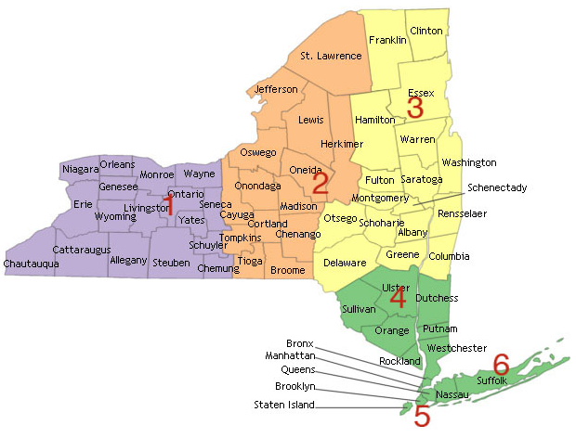

DEADLINE FOR SUBMISSION

March 15, 2019

OLIVO AWARD NOMINATION FORM

To the Applicant: Please complete the top portion and give the form to your nominator.

Student Name:

Please return by March 15, 2019 to your BOCES / District Administrator

To the Nominator:
Please complete the following questions, providing enough information to assess the abilities, character, and commitment of the student. (You may respond on a separate attachment if you prefer.) Please return your recommendation to the above address.

Your Name / Title:

How long and in what capacity have you known this student?

What leadership qualities has this student demonstrated to you?

Please describe the nature of the student’s work in any of the following categories: student career organizations, extracurricular activities, community service, volunteer work, peer education, leadership groups, internships, and paid employment.

