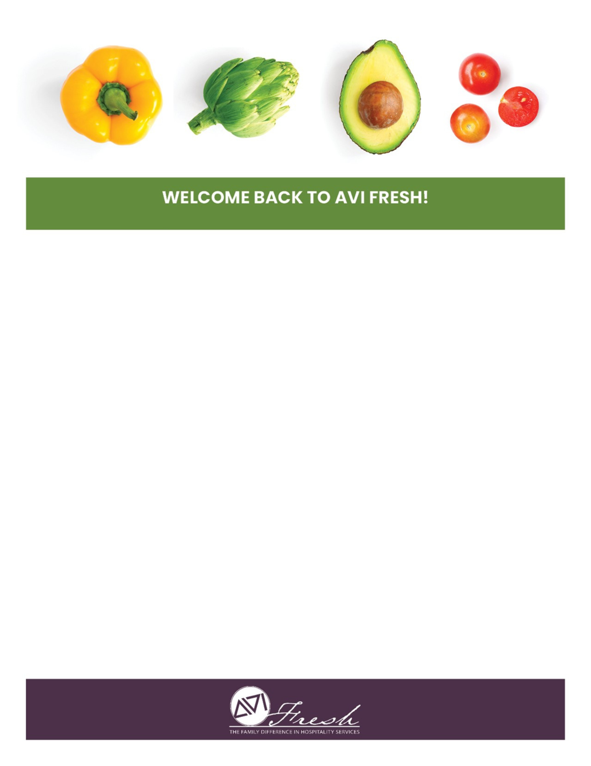
ST. THOMAS AQUINAS DINING INFORMATION FOR 2023-24 SCHOOL YEAR

The dining services team is excited to welcome you back as we start a new school year.
Our team is looking forward to your arrival and is honored to serve the students, faculty and staff
At St Thomas Aquinas High School and Middle School.

During summer break, we’ve been preparing new recipes and getting everything ready for back to school.
We have many exciting programs and menus planned!

Menus for your school are available at Lunch Menu (starkcountycatholicschools.org).
If you should have any questions or special requests regarding food sensitivities,
Please contact us and we’ll be glad to work together.

We’re grateful for the opportunity to serve you!

SCHOOL LUNCH ACCOUNTS
We make purchasing school lunches easy and convenient.
Options include:
1. Send your student with a check made out to St. Thomas Aquinas or cash for their account.
2. Visit www.payschoolcentral.com website to create and load your student’s account or download PAYSCHOOL APP.
3. Please see Mrs. Dudley for a free or reduced application.
This institution is an equal opportunity provider.

WE’RE HERE TO SERVE YOU!
Ryan Oliver
Resident Director
Phone: 330.875.1631 ext 3222 or
Email: roliver@AVIFoodsystems.com

