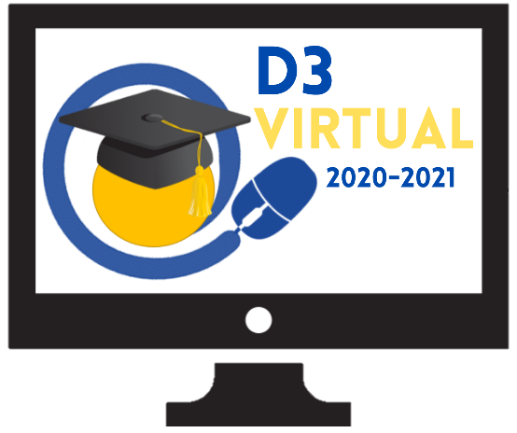
SPARTANBURG SCHOOL DISTRICT THREE VIRTUAL
3535 Clifton Glendale Road – Spartanburg, SC – 29307
Phone: 864-279-6005
Fax: 864-279-6010

D3 Virtual Parent Agreement
2020-2021

As a partner in education, I am completing this agreement in acknowledgement of my desire for my child(ren) to learn through the D3 Virtual program.

Please initial in the blanks below:
________ I attended the required orientation provided by Spartanburg School District Three on August 3rd, 2020 and fully understand the vital role I will play in the success of my child’s academics within the virtual platform and agree to work alongside the teacher to ensure my child’s academic success.

Registration:
_________I have completed my child’s registration online. Returning students use the Infosnap code provided by the child’s school.

Expectations:
1._______ My child has access to a reliable internet access to complete school assignments.
2._______ I will attend routine parent-teacher conferences to ensure my child is on-track with learning and completing assignments.
3._______ I will allow my child to be assessed on campus for in-person testing when designated by the D3 Virtual Director.
4._______I understand, agree, and support the student expectations explained during the D3 Virtual orientation and on the next page.

Important Dates:
August 10-14 LEAP days for K-8 students: Information about dates/times will come directly from your child’s school.
August 17th – First day of D3 Virtual for K-12

Student Expectations for D3 Virtual
1. It is expected that students will complete assignments for ALL classes during this online-learning experience.
2. Students will be held accountable for work during this time - content addressed as part of distance-learning is applied to unit competencies upon returning to regular schedule.
3. Students should log in each day to view assignments and complete them in a timely fashion. Late work will be penalized.
4. Students (and/or parents) should contact the teacher via email or Schoology with questions or concerns regarding assignments. Teachers will remain available via email throughout the school day.
a. Log in by 8:00 AM to view assignments
b. Complete assignments in a timely fashion
c. Contact your teacher with any questions
d. Must demonstrate participation to earn credit
5. Students will practice academic integrity, which requires all students to only submit work and/or assessments completed on their own.

Parent Expectations for D3 Virtual
- Parents will take an active role in their child’s learning on a daily basis.
- Parents will ensure their child has access to reliable internet.
- Parents will dedicate a space at home where their student can learn.
- Parents will work alongside the teacher to assist their student(s) with lessons and learning.
- Parents will monitor their student’s daily progress and if their assignments are completed in a timely manner.
- Parents should provide consistent encouragement and motivation for their student.

Signature Section:
Student Name:_________________________________________________________________________
School:_____________________________________________________________ Grade:____________
Parent Name (Print):____________________________________________________________________
Parent Signature:_______________________________________________ Date:____________________
Email on file:____________________________________________________________________________

