Guidelines for the Curriculum Review Cycle

Rationale

The Athens Area School District maintains and implements approximately 155 curricula in 12 content areas. All districts are required to evaluate and, if necessary, revise all district curricula every 5 years. The Athens Area School District will meet and exceed this standard once it is implemented and consistently utilized within our district from year to year. Additionally, the importance of following and implementing a curriculum review cycle will ensure that Athens has reviewed any changes that may occur within the state and national standards, state and national assessment practices, changes that may occur within curriculum materials, as well as district leadership. Through this cycle, all curricula will be reviewed and evaluated in a systematic process in order to provide the most rigorous and robust curriculum across our district, raising expectations for all learners.

It is absolutely critical that teachers are also provided with support, training, instructional resources and positive educational climate to successfully implement district programs in all content areas. This systematic process will evaluate, develop, and implement all curricula in a manner that allocates district resources wisely and effectively.

Overview

Curriculum renewal is a 4-step cyclical process by which all district curricula is analyzed and designed in a systematic and collaborative manner. This process provides for a comprehensive evaluation of each school’s program content by following the four steps over an extent of five years:

Step #1: Curriculum Review: Introduction of the new plan for action,
outlining recommended changes and improvements. (1 year)

Curriculum Review and Research - This is the process of conducting a comprehensive review of research and recommendations of best practice, reviewing state and national standards in the given field and conducting a complete scope and sequence of the standards. A variety of data is gathered and reviewed in determining what the actual, new program may look like. This data might include but would not be limited to:

• Review of current curriculum documents
• Results of curriculum mapping/scope and sequence exercises
• Curriculum audits of materials
• Assessment of staff development
• Feedback from staff, parents and students
• Review of standardized assessment data
• Review of district assessment data
• Analysis of the interrelationship between the area and other content areas

The evaluation reveals areas of strength in the current program as well as the deficiencies that need to be addressed during the curriculum development.

Budget Focus: During this phase, resources are budgeted for curriculum development during the following year, time for curriculum writing, substitutes for teachers, resources needed as well as professional development.

Step #2: Curriculum Development: Development of recommended
curriculum changes and instructional improvements. (1 year)

Curriculum Development – This process begins with establishing a shared vision for the program content, mission statements that will lead to the fulfillment of the vision and a completed scope and sequence/curriculum map.

During the curriculum development process, all program options are considered and investigated. Pilots may take place to determine the effectiveness of options. When pilots are used they are carefully evaluated and research-based decisions are made regarding content, scope, and sequence.

This is the stage in which actual curriculum is written. Involvement of staff and administration is absolutely critical at this stage. As a team we will re-write the curriculum to meet the standards set forth through curriculum maps. This typically will take a year to provide enough time for the team to collaborate, revise and create rigorous curriculum maps that are aligned with the standards. This process will also provide teachers with an opportunity to study the curriculum and plan for teaching over the summer.

Budget Focus: Prior to the final budget being established by the Board of Education, materials acquisition and staff development is planned for program implementation. Early in this stage, planning and budgeting of resources is done for program implementation the following year.

Step #3: Implementation and Review: Implementation of the Plan of Action
across the content area.
*Data collection and internal review. (up to 3 years)

Initial Curriculum and Program Implementation – This is the stage when the curriculum is put into practice in classrooms.

Staff development is the major focus during this stage. Workshops are planned during the school year and/or summer to support the implementation. District staff development time, grade level meetings and/or department meetings will be used to provide staff training for successful implementation. Other support systems for teachers are put in place. These might include, but are not limited to, email support, a mentor system, a buddy system, or other innovative strategies. Time is allocated from department/Professional Learning Communities (PLCs) team level meetings to articulate about the new curriculum and share strategies that work.

Checkpoints are established to gather feedback from teachers. Adjustments in implementation and staff development are made along the way. Program observations are conducted during this year. Observation of teacher performance in implementing the new curriculum is emphasized since teachers are teaching brand new material. Emphasis in observation is placed on the program by looking for correct implementation and interpretation of the curriculum, continuity in delivery, and other important aspects of implementation. Lesson plans and unit plans are assessed to obtain understanding of program implementation. This information is used to impact the staff development program to provide continued support.

Budget Focus: Continued support of the successful program. Budgeting for replenishment of materials and purchase of materials to accommodate enrollment growth and new staff.

Full implementation – At this point, the program is fully operational in all the target classrooms. Teachers are implementing curriculum and instruction in direct alignment with the newly established program. This full implementation continues throughout the curriculum evaluation and development years. This is a stage to continue to collect data for comprehensive program evaluation the following year. Staff development could be done in needed areas. Observation of teacher performance is appropriate during this stage.

Budget Focus: Continued support of the successful program. Budgeting for replenishment of materials and purchase of materials to accommodate enrollment growth and new staff.

Step #4: Evaluation: Evaluation of the effectiveness of the plan of action and
creation of a new plan of action for continuous improvement. (1 year)

Evaluation – Based on input gathered during the school year and feedback from
teachers and administrators some revisions to the curriculum may be necessary. It is critical to evaluate all aspects of the curriculum to ensure that we are raising expectations and meeting the standards.

Budget Focus: Continued support of the successful program Budgeting for replenishment of materials and purchase of materials to accommodate enrollment growth and new staff.

This model will assure that only one major content area is revised or developed in a given year, once the system is established. The model will facilitate effective and fiscally responsible use of district resources. Budget allocations for supplies and materials, textbooks and staff development can be focused on the successful implementation of the revisions or new program. Additionally, this phased approach to curriculum renewal will facilitate teachers’ focus in implementing new programs by allowing them to concentrate on one major content area at a time rather than attempting to manage multiple initiatives. This model will be phased in according to the following table.

Athens Area School District
FIVE-YEAR CURRICULUM/PROGRAM
REVIEW SCHEDULE

Subject | 2014-15 | 2015-16 | 2016-17 | 2017-18 | 2018-19
K-5  ELA | Implementation  And Review | Implementation  And review/  Purchase  Supplemental  Resources | Implementation and  Review | Evaluation | Curriculum  Review
6-12  ELA | Curriculum  Development | Implementation  And review | Implementation/  Review/Textbooks | Implementation  And review | Evaluation
K-5  Science | Curriculum  Development | Implementation  And Review/  Purchase  Resources | Implementation/  Review | Implementation/  Review | Evaluation
6-12  Science | Curriculum  Review | Curriculum  Review | Curriculum  Development | Implementation  And Review/  Textbooks | Implementation  And Review
K-5  Social Studies | Curriculum  Development | Implementation  And Review/  Purchase  Supplemental  Resources | Implementation and  Review | Implementation  And Review | Evaluation
6-12  Social Studies | Implementation  And Review | Curriculum  Review | Curriculum  Development  /Textbooks | Implementation  And Review | Implementation  And Review
K-5  Math | Curriculum  Development/  Purchase  Textbooks | Implementation  And Review | Implementation and  Review | Implementation  And Review | Evaluation
6-12  Math | Curriculum  Development/  Purchase  Textbooks | Implementation  And Review | Implementation  Review | Implementation  And Review | Evaluation
P.E  Business  F.A.C.S | Curriculum  Review | Curriculum  Development | Implementation  And Review | Implementation  And Review | Implementation  And Review
Music  World  Language | Curriculum  Review | Curriculum  Development | Implementation  And Review | Implementation  And Review | Implementation  And Review
Art  Vocational  Education | Curriculum  Development | Implementation  And Review | Implementation  And Review | Implementation  And Review | Evaluation
Life Skills | Curriculum  Development/  Purchase  Textbooks | Implementation  And Review | Implementation  And Review | Implementation  And Review | Evaluation

Athens Area School District
Curriculum and Instruction

The Curriculum and Instruction department of Athens Area School District has identified
the following four goals:

- Engaging Athens Area School District students in critical thinking, skill development and learning opportunities that promote academic growth amongst all learners.
- Developing rigorous and robust curriculums throughout the district that raise the level of expectations amongst all learners.
- Involving staff in targeted professional development training based on professional learning goals and student achievement.
- Creating authentic parental involvement experiences and school-to-community partnership.

The above curriculum and instruction goals are in alignment with the board approved district goals. As a learning community, we must continue to provide our students with the most rigorous and rewarding academic experience that we can offer.

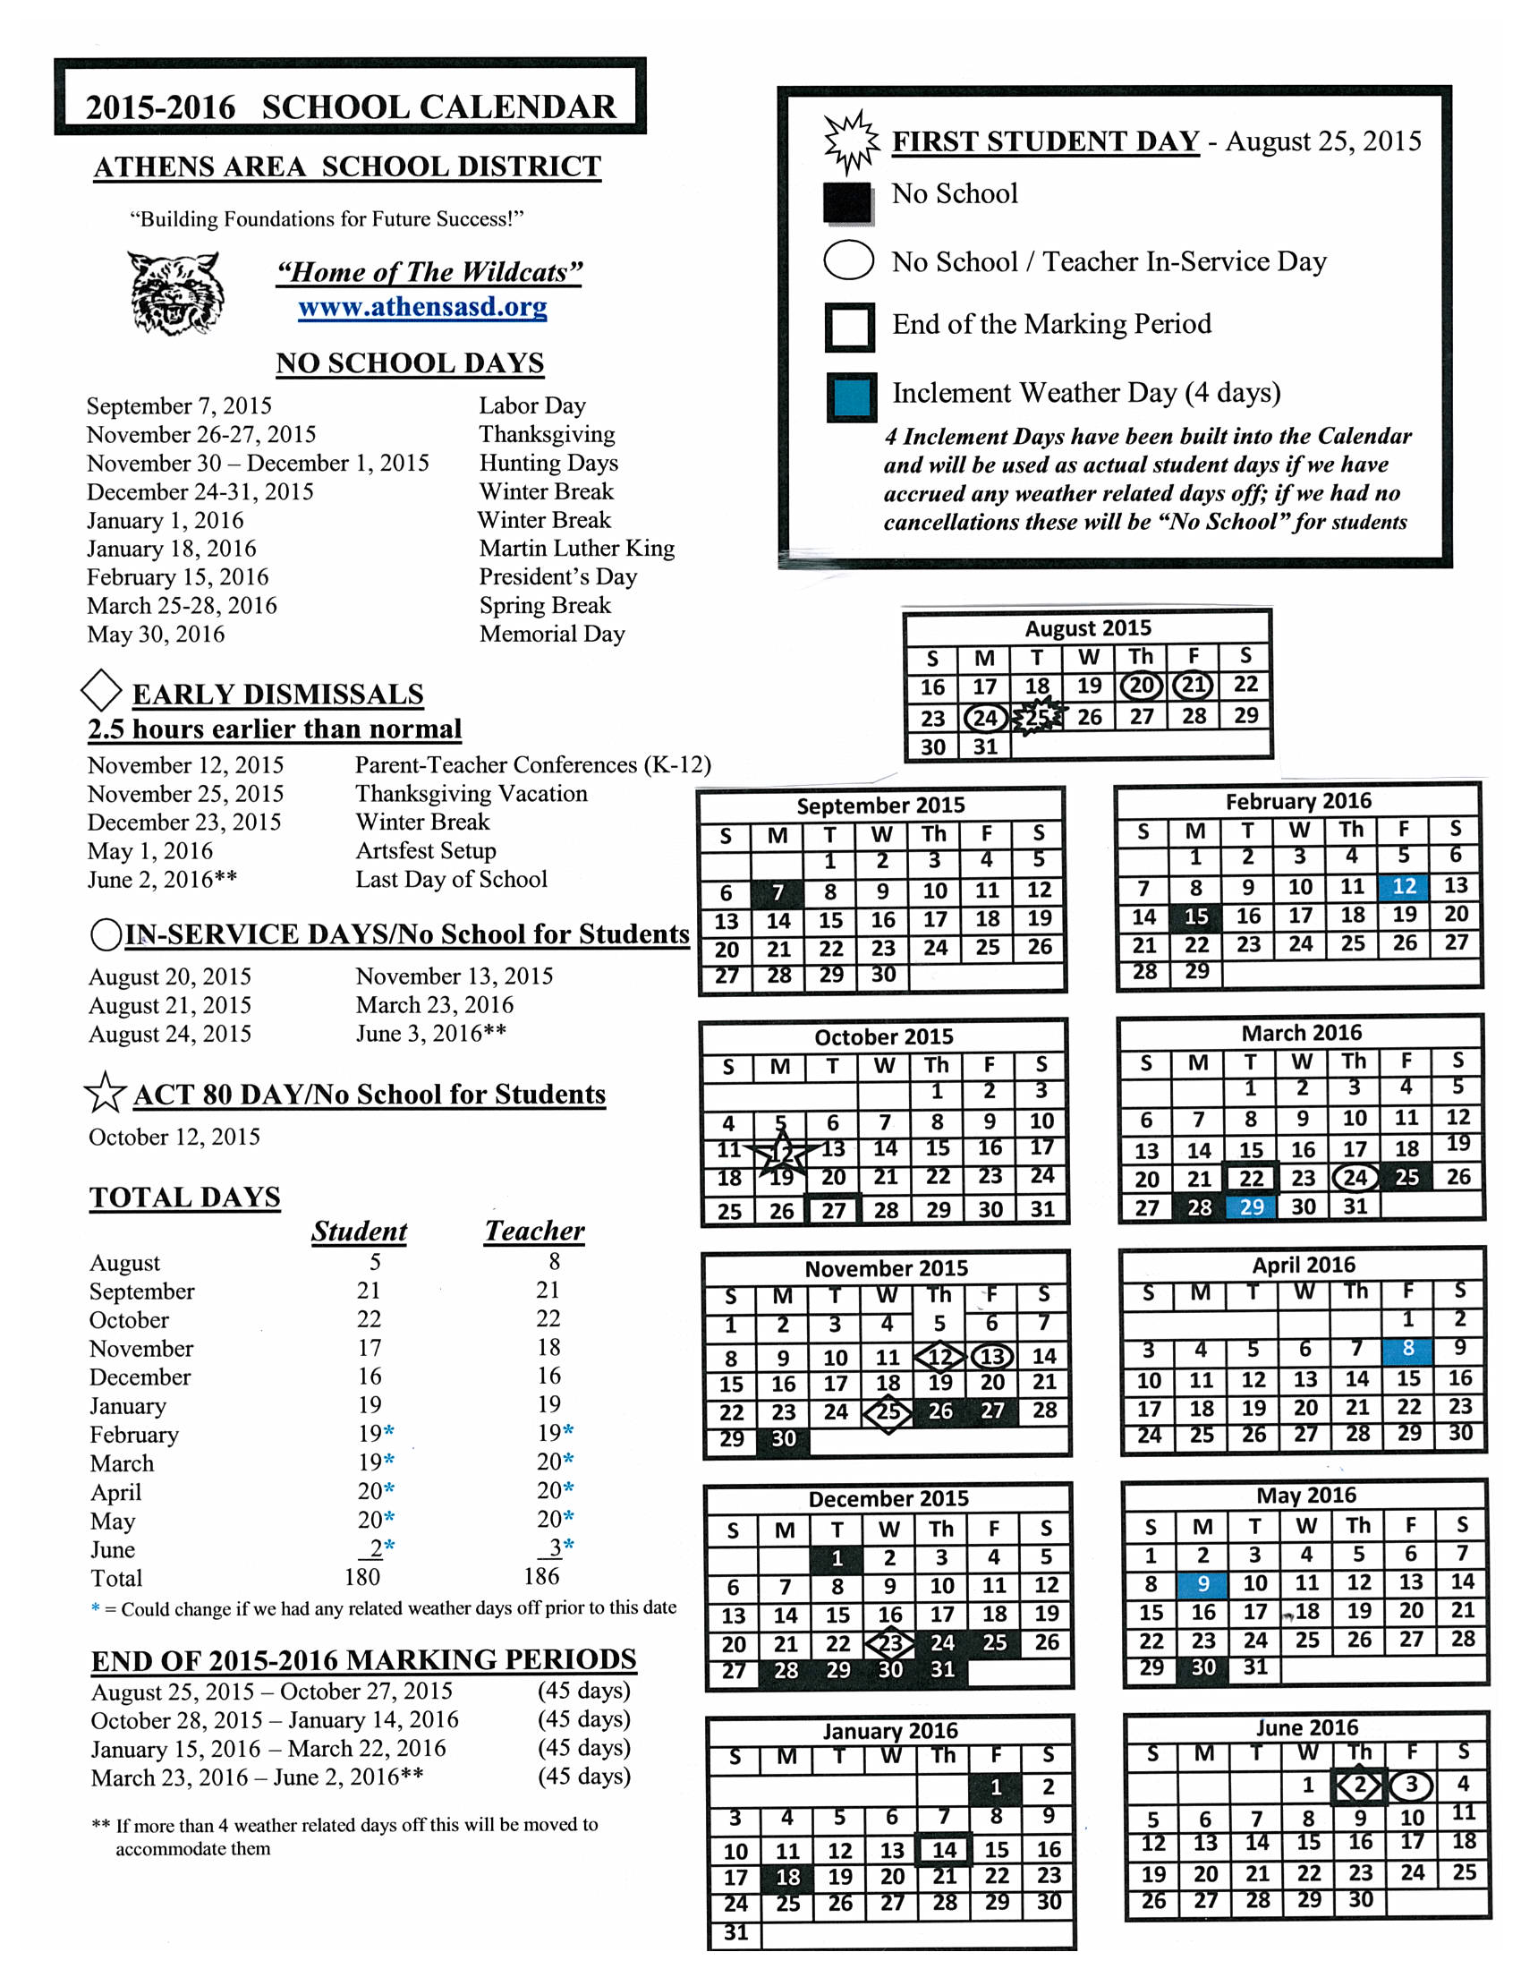

2015-2016 Instructional Goals/Initiatives

It is our goal to be consistent and transparent with all initiatives in the Athens Area School District. For the 2015-2016 school year, our focus will be to continue with the current initiatives, raising the expectation and developing a plan for the next level of these initiatives. The following initiatives were implemented during the 2014-2015:

- Learning Focused Schools
- Collins Writing
- MTSS Process
- APL Refresher

- Continuation of the Learning Focused School (LFS) Model-Book Two: Higher Order Thinking Skills

Rationale

It is our goal at Athens Area School District to continue to raise the level of expectations for all learners. District wide, during the 2014-2015 school year, we have spent much time promoting and supporting the Learning Focused School (LFS) framework. Teachers have been provided with one full day of training on LFS and have been asked to submit weekly LFS lesson plans to ensure that we are meeting the expectations set forth.

LFS is the core of how we raise the level of expectations within our classrooms. It is a framework that promotes differentiation in our classroom through the use of specific strategies. To ensure that LFS is being utilized, we have not only set expectations for all teachers in the district, but have also set expectations of our administrators. Teachers and administration has been provided with support through mini trainings, implementing a newsletter with examples of strategies, webinars as well as common planning time.

As a district, we are committed to LFS. For the 2015-2016 school year, teachers will receive the next level of training in LFS. This training will incorporate Higher Level Thinking Skills. The next level will also ensure that we are meeting the rigorous core standards that have been set forth by the Pennsylvania Department of Education. Throughout this school year, we will continue to offer support to our teachers and administration, educate the community and reach all learners at the next level.

- Continuation of Collins Writing (Attached is the proposal)

Rationale

It is our goal at Athens Area School District to embed writing into all content areas. We have adopted the Collins Writing Program into all of our classrooms, K-12. This program provides a consistent framework to improve students' written communication skills and build subject area knowledge. It is also aligned with state and national testing, which embeds writing in all forms of assessments. The teachers were provided with two days of training that introduced this program. During the 2014-2015 school years, teachers were expected to implement Collins Writing throughout the school day in all courses. This was the introductory stage of the program.

In the 2015-2016 school years, the district will contract with Collins Writing to educate our teachers and administration on the next stage of this program. This will be a one-year contract that provides a consultant from Collins to come into our schools (all schools) to not only educate the teachers, but also provide support to specific content areas. Teachers will be expected to utilize Collins Writing throughout all courses as well as implement all types of Collins Writing.

Move from RTII to MTSS
Rationale

Currently in our elementary schools and middle school, we are implementing the RTII process. The RTII process is the Response to Intensive Intervention (RTII), which is a multi-tier approach to the early identification and support of students. In all three schools, RTII is a scheduled block of time that occurs throughout the school day. It not only helps bridge the learning gap, but it also promotes acceleration at all levels. Through RTII, students have the ability to work on individual levels, master a skill and be pushed to the next level. Through this intervention it helps to solidify the skills needed to reach the PA Core standards.

Athens Area School District is committed to being on the front line of education. RTII is in the process of moving to the MTSS (Multi-Tiered System of Supports). This intervention encompasses not only academic needs, but also behavioral needs. By moving towards this system, it is our hope that Athens Area School District will reduce the number of students receiving Special Education services as well as reduce behavior issues that occur within the classroom setting. Professional development will need to be provided to ensure that teachers understand the system, have time to develop and plan for this system as well as provided resources to support this system.

Refresher in APL
Rationale

The Athens Area School District is committed to raising the expectations at all levels. As we have adopted the LFS framework, we also need to be reminded of the importance of classroom management. Learning Focused Schools compliments the APL organization. It is imperative to provide our teachers with a training that supports our initiatives. Through this one-day training, teachers will learn strategies that promote positive staff morale, meaningful and positive communication, productive time and task management, improved planning and organization, consistent and positive classroom management, as well as provide application of proven classroom instructional techniques and skills.

In-Service Training/Professional Development

Listed below is a list professional development needed for our teachers and administration. These trainings are aligned to our district initiatives and district goals. Providing professional development in these areas will also continue to raise the expectations of all of our faculty and staff as well as students in the Athens Area School District.

- MTSS Training-Initiative
- New Math Series Training-K-8 will begin implementing a new math series in 2015-2016 school years (this will be previewed at the end of 2014-2015 school year)
- Differentiated Instruction/Co-teaching-to support LFS and instructing different level of learners in one classroom
- Grading students with IEPs-all teachers need education on how to correctly grade students with IEPs and correctly understand the process of assessing students with IEPs
- Elementary Departmentalizing-Teachers will need to be educated on the process of departmentalizing and how it will effect their teaching (will be previewed at the end of 2014-2015 school year in grades 3-5)
- Collins Writing-Next Step
- APL Training
- I-Ready Training-Teachers utilize this as a data collection tool that helps drive the MTSS groupings in Reading and Math
- Assessment Writing
- PA-ETEP (Administration)
- Guided Reading (Elementary)-(will be previewed at the end of 2014-2015)

Dates Scheduled for In-Services with tentative schedules and Upcoming Events:

August 20th In-Service
Welcome Back ALL District Employees
LFS Book 2 (Higher Order Thinking Skills)

August 21st In-Service
Collins Writing-Next Step (1/2 day am for elementary) (1/2 day pm for secondary)
Differentiated Instruction
I-Ready (Elementary and Rowe)
Co-Teaching (High School)
Remediation Review (High School)

August 24^{th In-Service}
Work in designated schools
Review Faculty Handbooks
Review of PowerSchool and GRADES
Review of MTSS process/Guided Reading
Review of Grading Students with IEPs
Review of Departmentalization (Elementary)
Review of SLOs

September
Dibles Testing (Grades K-2)
Benchmark (CDT’s and Study Island) Testing (grades 3-12)
First I-Ready Diagnostic Test (Grades 1-8)
Just in Times for SLO’s and HOT (LFS)
F & P Testing (Elementary)
Implement SLOs

October
MTSS begins
Oder PSSA and Keystone Tests
Oct. 12th-APL Refresher all teachers
Complete F & P Assessments (Elementary)

November
Nov. 12th-Parent Conferences and Parent Information Fair at all schools
Nov. 13th-Assessment Writing-training on how to properly assess and develop
assessments for all learners

December
Winter Keystone Exams
Just in Times-Needs will be assessed to determine what supports are needed

January
Dibels Assessment (Elementary grades K-2)
I-Ready 2nd Diagnostic Assessment (Grades K-8)
CDT’s and Study Island Benchmark (HS)
F & P Assessments (Elementary)

February
PSSA prep
Just in Times-Needs will be assessed to determine what supports are needed

March
March 24th-Alternate In-Service day for teachers
Kindergarten Registration
F & P Assessments (Elementary)

April
April 6th-Parent Conferences in afternoon
April 7th-Parent Conferences in morning (8-11:30 am) and Act 80 Day in the afternoon (focused on PLC collaboration)
PSSA testing
Just In Times- Needs will be assessed to determine what supports are needed

May
Dibels testing (Grades K-2)
F & P Assessments (Elementary)
CDT and Study Island Benchmarks (HS)
I-Ready 3rd Diagnostic Test (Grades K-8)
Completion of SLOs
Preparation of Summer Slide Plans

June
June 3rd-Preview for the 2016-2017 School Year
Work in Classrooms

