April | Monday  21 | Tuesday  22 | Wednesday  23 | Thursday  24 | Friday  25
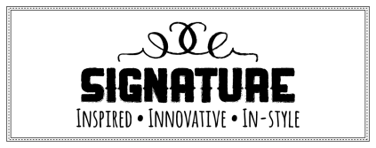 |  | 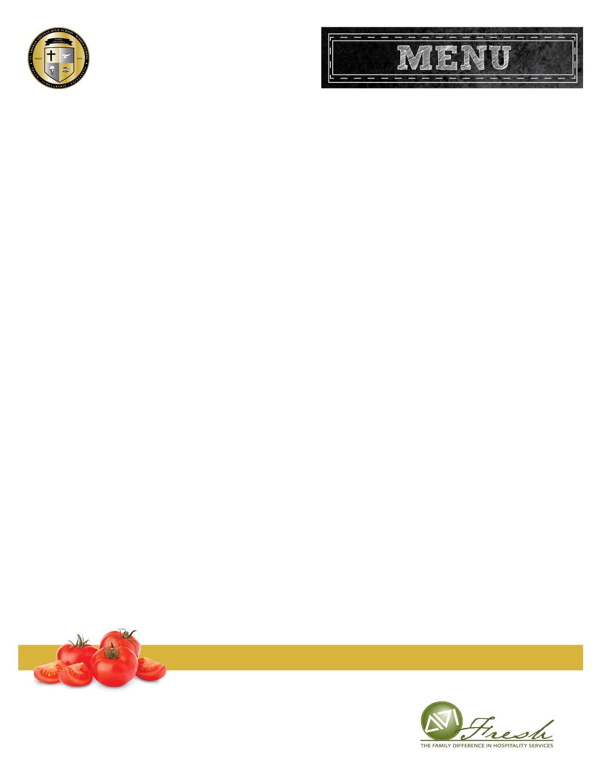  Chicken Tenders Potato Smiles  Fruit  Milk | Pizza Day! | French Toast Bites  Turkey Sausage  Fruit  Milk | Quesadilla with Tortilla Chips  Fruit  Milk
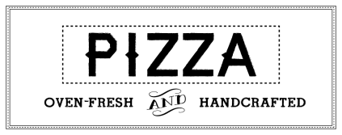 |  |  | Cheese or Pepperoni
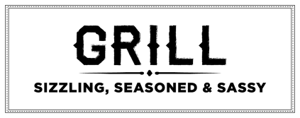 |  | Grilled Cheese | Cheeseburger | Chicken Sandwich | Chef Special
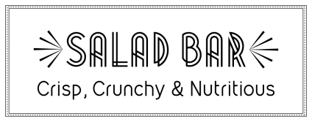 | Chopped Romaine, Carrots, Grape Tomatoes, Peppers, Broccoli, Cauliflower, Cucumbers, and other delicious ingredients.  Fruit Served Daily  Check the Coca-Cola Cooler for Cold Items, Wraps, and Uncrustables
Contact your Chef Resident Director, Brendan Dever,
bdever@avifoodsystems.com for questions or comments.
Breakfast: NO CHARGE, Served 7:15 AM to 07:45 AM
Lunch: $3.50
Extra Milk: $.75

This institution is an equal opportunity provider.
*MENU SUBJECT TO CHANGE*

St. Thomas Aquinas
Middle and High School

