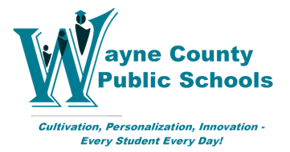

October 6, 2020

Effective October 6, 2020, in an effort to provide an enhanced and more secure service for our transfer students, all records requests for our former students must be made online using our new student record request system, K12 Transfer, by Scribbles Software. Fax, phone calls, emails and mail will no longer be accepted.

The new K-12 Transfer application was activated on October 6, 2020. It is a secure, self-service application that requires the following steps:
- Site Access. Go to https://wayne.scriborder.com/. Scroll down to the K-12 Districts. Select the Following to get started and click the Icon
- Account Creation. Each person requesting records from Wayne County Public Schools is required to set up an account. You must use your school email address. Personal emails addresses will not be accepted.
- Verification. Once the account is set up, there is a verification process that takes about 24 hours to complete. You will receive an email notification once your account is verified. You only need to be verified once then you may submit as many requests as you need.
- Submit Request. When you receive the “verification complete” email notification, you are then able to login to the K-12 Transfer application and submit your requests to Wayne County Public Schools. We enforce this verification process to keep students safe.
- Processing Time. Wayne County Public Schools will process your request electronically within 10 business days. You will receive an email notification once the request has been processed.
- Downloading. When you receive the “processing complete” email, you will need to login to the K-12 Transfer application to download the student record you requested.

Wayne County Public Schools has activated the K12 Transfer product from Scribbles Software, as they have been a long-time partner. K12 Transfer manages the cumbersome transfer process, but it also produces accurate reports of student whereabouts, helping us significantly when tracking students for graduation as well as for funding purposes. We know this is a new process, should you have any issues setting up your account, questions about the process, or want to know more about the product, please contact support@scribsoft.com.

Thank you,
Wayne County Public Schools

