Letterhead_SocialMediaIcons

Coronavirus: The Facts

2002 Sunset Blvd

Steubenville, OH 43952

**(740) 284-5712**

***SCS SBHC is a division of CHANGE, Inc.***  
*CHANGE, Inc. is an equal opportunity  
provider & employer.*

**Health Center**

**School Based**

SCS

**www.changeinc.org**

*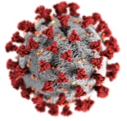*

April 2020

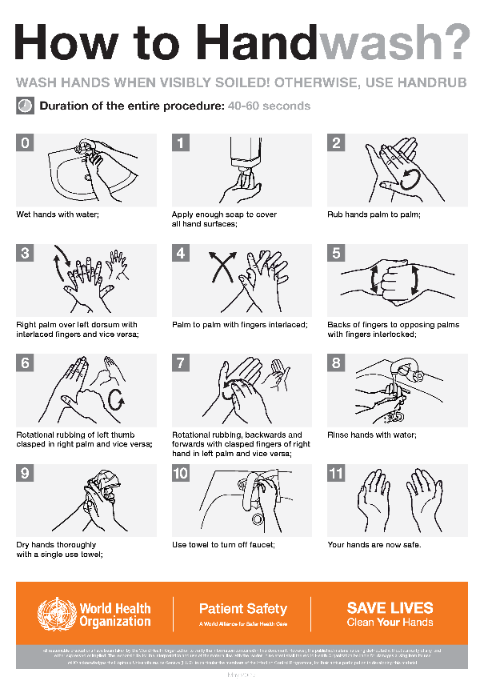

**-**Test/Replace smoke detectors and carbon monoxide detectors

**-**Change furnace filters

**-**Review/update family’s emergency plan

**-**Clean out medicine cabinet and properly dispose outdated medications

**-**Clean out dryer vents

Spring Cleaning

Wellness Tips

**What is coronavirus?**

The coronavirus (COVID-19) is a new virus that has not been previously identified. It is different from the coronaviruses that typically cause mild illness like the common cold.

**How does it spread?**

The virus is thought to spread mainly from person-to-person, being in close contact with someone. It is mainly spread through respiratory droplets with someone with the virus sneezes or coughs. It may also be spread by touching a contaminated surface or object and then touching ones mouth, nose or eyes, although this is not the main way it is spread.

**Who is at higher risk?**

Some people may be at higher rsik of getting very sick from this illness including older adults and those with serious chronic medical conditions such as heart disease, diabetes, and lung disease.

**What are the symptoms?**

The following symptoms may appear **2-14 days after exposure.**

* Fever
* Cough
* Shortness of breath

**How is it treated?**

Supportive care can help relieve symptoms. Antibiotics do not work for the coronavirus. There is no antivial treatment specific for COVID-19. Severe cases may need treatment to support vital organ functions. Stay home when you are sick, limit contact with pets and animals as well, only those that are sick need to wear facemasks when around other people.

**What can we do to prevent it?**

Avoid close contact with people who are sick, avoid going out in public if you are sick, always cover your cough or sneeze with a tissue, wash hands often, call your healthcare provider if you are experiencing any symptoms that are concerning to you, disinfect high traffic areas often, such as counter tops and door handles.

Taken directly from the CDC Website

Newsletter

**The SCS SBHC is open every day during school hours for your convenience.**

**Steubenville City Schools School Based Health Center**

Change, Inc has teamed up with SCS to provide a convenient health care center for students and staff. The SBHC is staffed through Family Medical Care. We provide preventative and immediate care inside the school while working closely with the school nurse. Our licensed staff can provide well checks, sick visits, injury treatment, immunizations, allergy shots, ADHD evaluation and treatment, chronic health management and behavioral health treatment. We have 2 full time clinics, one at Steubenville High School and one at Harding Middle School. We also have 3 satellite centers at West, East and McKinley STEM. We are not taking the place of your primary care provider or pediatrician. We are here for the convenience of care with the goal to keep students and staff healthy and in school.

**Steubenville HS/Wells Academy**

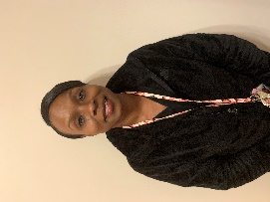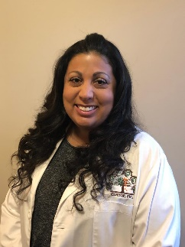

**Harding Middle School**

**Erica Pitts LPN**

Erica has been an LPN for 10 years and has worked for Change, Inc for years. She has two sons that attend Steubenville City Schools and has lived in the community all her life.

**Kathleen Sliva NP-C**

Kathleen in an AANP Certified Nurse Practitioner. She has been an NP for 1.5 years and an RN for 20 years with a background in critical care. She has 2 children that attend SCS and has lived in the community all her life.

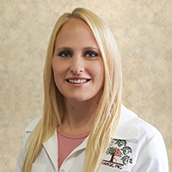

**Amanda Barnett NP-C**

Amanda is an AANP Certified Nurse Practitioner. She has been an NP for 3 years and an RN for 8 years with a background in telemetry. She was born and raised in WV and has 4 children.

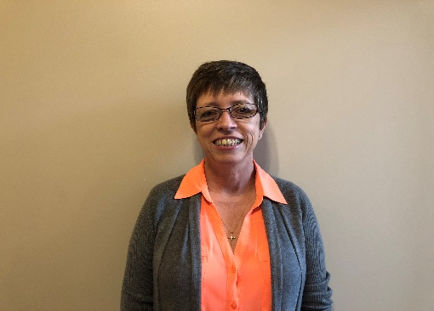

**Beth Williams LPN**

Beth has been an LPN for 36 years. She has a vast background working in several specialties including cardiac rehab and hospice. She is from Steubenville and is a Big Red graduate.

**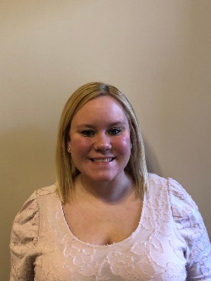**

**Allison Johnson LPC**

Allison has been a LPC for years. She has experience working with children, adolescents, drug rehab and crisis. She is from Mingo Junction and has 1 daughter.

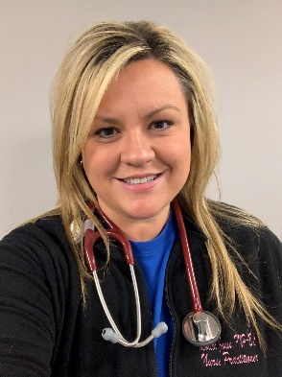

**Deanna Borsch CMA**

Deanna has been a CMA for 12 years with a background in pediatrics. She is from Steubenville and is married with 2 boys that attend Steubenville City Schools.

**Monica Jones FNP-BC**

Monica is an ANCC Certified Nurse Practitioner. She has been an NP for 3 years and an RN for 12 years with a specialty in critical care. She is from Steubenville and has 4 boys

**East/West/McKinley STEM**