Tips for Better
Time Management
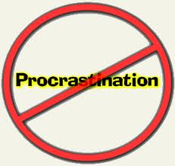
- Create a daily plan
- Set a time limit for each task
- Use a calendar/organizer
- Know your deadlines
- Learn to say “NO” to free time activities if tasks aren’t complete
- Have a clock visibly placed before you
- Set reminders 15 minutes before you plan to start
- Block out distractions
- Don’t worry about unimportant details
- Prioritize assignments and batch similar tasks together
- Eliminate time wasters
- Stop when you need to (brain breaks are important)
- Leave buffer time in between assignments to prevent burn-out

