CIRCLEVILLE HIGH SCHOOL

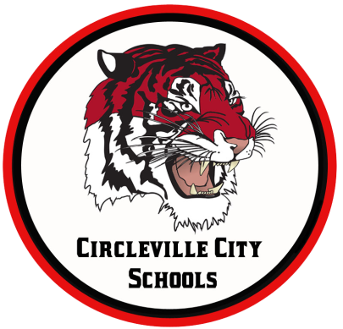
OHIO IMPROVEMENT PROCESS DISTRICT GOALS
GOAL 1: Students participating in state assessments will demonstrate an increase in MATH performance as evidenced by an increase in the Performance Index (PI) from 79.7 (77.56 in 2016) to 108 by 2018.
GOAL 2: Students participating in state assessments will demonstrate an increase in READING performance as evidenced by an increase in the Performance Index (PI) from 80.5 (72.3 in 2016) to 108 by 2018.
GOAL 3: Attendance Rate will increase from 93.7% (93.8% in 2016) (by 1% or more each year) to 96% by 2018 by implementing evidence-based school climate strategies.

MORNING ANNOUNCEMENTS
Monday, October 26, 2020
CHS staff will be available online each Friday that students are not in attendance beginning Friday 9/4. Each teacher will share with you via google classroom the link to join the google meet during their designated time frame. The purpose of setting up these online "office hours" is so that students are able to connect with their teachers to ask any questions they may have about the week's assignments. This is for students who are completely online using Tiger Remote Learning and also for students who are in attendance during the two days but are online the other three days. If you have any questions at all please do not hesitate to get in contact with your teachers or any of us in the office so that we can provide any assistance that we can. We are here to help make this start of the school year as successful as possible. Go Tigers!!! Please see below for the times:

Office Hours:
Math 9-10 am
English 9:30-10:30 am
Science 10-11 am
Social Stud 10:30-11:30 am
Unified Arts 11-1
All students will begin receiving an email each Friday morning that is an at-home learning day that contains a Google Form to be filled out for tracking Attendance. You will receive the email at 7:00 a.m. and have until midnight to complete the form to be counted as present. It is an expectation that all students complete this attendance survey.
All school pictures will be done on Wednesday Nov. 4th 2020 and Remote Learners are encouraged to come into school from 12-1:30 that day. Sign in at the office.
Attention CHS students’ breakfast and lunch at CHS is currently free of charge through June 30,2021 for all students at CHS. If you have lost or forgot your lunch card no worries just simply let the ladies know your name and they can look you up in the system. We encourage everyone to take advantage of this opportunity. Please stop in the mornings in the hallway and come down during your scheduled lunch. Don’t forget about preordering salads or grab and go lunches online by 8:30 am. The link is on our website under student resources!!!!
IN GUIDANCE NEWS:
SCHOLARSHIPS AVAILABLE: See Guidance Office for more details!
Engineers Foundation of Ohio (due 1.15.2021)
Prudential Spirit of Community Awards (due 11.10.2020)
Elks Most Valuable Student (due 11.15.2020)
Elks Legacy Scholarship (due 2.5.2021)
Profile in Courage Essay Contest (due 1.15.2021)
WiseGeek Women in STEM Scholarship (due 12.31.2020)
Coca-Cola Scholars Foundation (due 10.31.2020)
Horatio Alger Scholarship (due 10.25.2020)
Jack Kent Cooke (due 10.30.2020)
Bold.org Scholarship (due 2.1.2021)
ZONTA Scholarship (due 11.30.2020)

FOR LUNCH TODAY:
Popcorn Chicken
Salad
Dressing
Muffin
Fruit
Choice of Milk

HAPPY BIRTHDAY TO:
Peyton Burris
Raymond Perkins
Alexsha King
Justin Adams
Ian Virgin
Tanner Wallace
Jesse Seevers
Brooklyn Burgoon
Soni Grady
Doug Espie
Jen Merkle

