CIRCLEVILLE HIGH SCHOOL

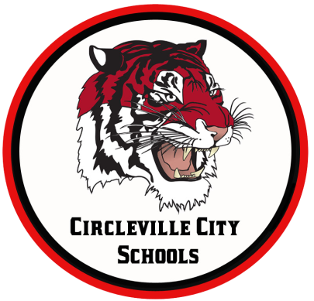
OHIO IMPROVEMENT PROCESS DISTRICT GOALS
GOAL 1: Students participating in state assessments will demonstrate an increase in MATH performance as evidenced by an increase in the Performance Index (PI) from 79.7 (77.56 in 2016) to 108 by 2018.
GOAL 2: Students participating in state assessments will demonstrate an increase in READING performance as evidenced by an increase in the Performance Index (PI) from 80.5 (72.3 in 2016) to 108 by 2018.
GOAL 3: Attendance Rate will increase from 93.7% (93.8% in 2016) (by 1% or more each year) to 96% by 2018 by implementing evidence-based school climate strategies.

MORNING ANNOUNCEMENTS
Tuesday, February 18, 2020
Students 10th to 12th grade there will be a presentation on 2/24/2020 with Matt Brown, Jared Ricart and others presenting about their apprenticeship program. It’s a co-op with Ricart where you will be learning to be a technician while working. If you are interested in attending please see Mrs. Rhymer to sign up.

The first Drrone racing practice will be held next Tuesday the 18th from 2:45-4:30 in the CHS Cafeteria. See Mrs. Stultz if you have questions

If you are 18 years old and would like to vote in the next presidential primary election on March 17th, see Mrs. Carter in the Study Hall to register to vote. The deadline to register is by the end of the school day, Tuesday, February 18th.

Are you considering a career in engineering? If interested please stop in Guidance to sign up.

IN GUIDANCE NEWS:
SCHOLARSHIPS AVAILABLE: See Guidance Office for more details!
ASMC Buckeye Chapter High School Scholarship (due 2.28.2020)
South Central Power Co. 2020 Youth Tour (due 3.1.2020)
Rumpke Scholarship (due 3.5.2020)
Circleville Education Association (due 3.13.2020)
Sheryl Wood Logan Scholarship (due 3.27.2020)
Ted Lewis Memorial Music Scholarship (due 4.17.2020)
BX Builders Exchange Scholarship (due 2.21.2020)
Pickaway Works (due 4.3.20)
The William D. Squires Educational Foundation (due 4.3.2020)
IBI Scholarship Fund (due 2.28.2020)
The Margaret (Peggy) Scherer Memorial Scholarship (due 4.3.2020)
Donald E. Minor Memorial Scholarship (due 4.17.2020)
The Eleanor Tootle Scholarship (due 4.1.2020)
The Circleville Pumpkin Show Band (due 2.28.2020)
Child Conservation League (due 2.18.2020)
Chief Clark First Responder Scholarship (due 4.17.2020)
Guy B. and Mabel Lykins Scholarship (due 4.3.2020)
OhioHealth Sports Medicine Foundation Scholarship (due 2.28.2020)
Annette G. Will Award (due 3.5.2020)
Ohio Oil & Gas Energy Education Scholarship (due 3.1.2020)
The Ben Kasler Memorial Fund Scholarship (due 2.28.2020)
GFWC Circleville Junior Women’s Club the Martha Poling Scholarship (due 2.19.2020)
The Cheryl Cunningham Memorial Student-Athlete Scholarship (due 4.3.2020)
Karen Matesky Grigg Memorial Scholarship (due 3.16.2020)
Floyd E. & Mary Irene Younkin Scholarship (due 2.28.2020)
Ohio Gass Association Scholarship (due 3.31.2020)
Greater Columbus Chapter of the Association of Govt Accountants Scholarship (due 4.13.2020)
Ed Umsted Memorial Scholarship (due 3.27.2020)
Congressional Advisory-Youth Preparedness Council (due 3.6.2020)
The William Ammer memorial Educational Scholarship (due 2.28.2020)
United Way Community Impact Scholarship (due 4.1.2020)
Child Conservation League (due 2.18.2020)
The Junior Women’s Martha Poling Scholarship (due 2.19.2020)

FOR LUNCH TODAY:
Chicken Rings
Curly Fries
Cut Green Beans
Fresh Apple Slices
Baked Lays Potato chops
Chocolate Milk, NF
White Milk, 1%

HAPPY BIRTHDAY TO:
Nicholas Justice
Sydney Wickline
Kathy Webb

