CIRCLEVILLE HIGH SCHOOL

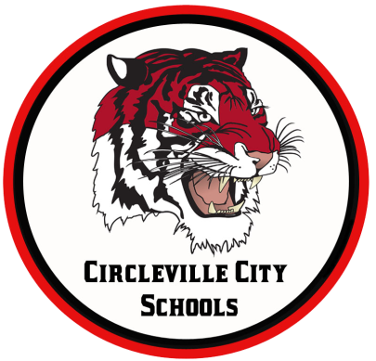
OHIO IMPROVEMENT PROCESS DISTRICT GOALS
GOAL 1: Students participating in state assessments will demonstrate an increase in MATH performance as evidenced by an increase in the Performance Index (PI) from 79.7 (77.56 in 2016) to 108 by 2018.
GOAL 2: Students participating in state assessments will demonstrate an increase in READING performance as evidenced by an increase in the Performance Index (PI) from 80.5 (72.3 in 2016) to 108 by 2018.
GOAL 3: Attendance Rate will increase from 93.7% (93.8% in 2016) (by 1% or more each year) to 96% by 2018 by implementing evidence-based school climate strategies.

MORNING ANNOUNCEMENTS
Wednesday, February 19, 2020
Each Spring the administration at Circleville High School reviews the CHS student handbook/code of conduct and makes changes based on student and staff input. This year I am seeking input electronically by asking you to please give us your input on any changes or suggestions you might have for the 2020-21 school year. The handbook and code of conduct can be found in the front pages of your student agenda book. This survey was emailed to you on Tuesday Feb. 18th and will be posted for 10 days. I ask that you please give your input by Friday Feb. 28th. Thanks, and have a great day!

This weekend, don't miss our production of "Chicago: High School Edition". It's an intriguing story of murder, greed, corruption, violence, exploitation, adultury, and treachery! Shows are Friday at 7pm, Saturday at 7pm, and Sunday at 3pm. Tickets are $8 at the door, cash or card.

Deadline to register for the April ACT is February 28, 2020

IN GUIDANCE NEWS:
SCHOLARSHIPS AVAILABLE: See Guidance Office for more details!
ASMC Buckeye Chapter High School Scholarship (due 2.28.2020)
South Central Power Co. 2020 Youth Tour (due 3.1.2020)
Rumpke Scholarship (due 3.5.2020)
Circleville Education Association (due 3.13.2020)
Sheryl Wood Logan Scholarship (due 3.27.2020)
Ted Lewis Memorial Music Scholarship (due 4.17.2020)
BX Builders Exchange Scholarship (due 2.21.2020)
Pickaway Works (due 4.3.20)
The William D. Squires Educational Foundation (due 4.3.2020)
IBI Scholarship Fund (due 2.28.2020)
The Margaret (Peggy) Scherer Memorial Scholarship (due 4.3.2020)
Donald E. Minor Memorial Scholarship (due 4.17.2020)
The Eleanor Tootle Scholarship (due 4.1.2020)
The Circleville Pumpkin Show Band (due 2.28.2020)
Child Conservation League (due 2.18.2020)
Chief Clark First Responder Scholarship (due 4.17.2020)
Guy B. and Mabel Lykins Scholarship (due 4.3.2020)
OhioHealth Sports Medicine Foundation Scholarship (due 2.28.2020)
Annette G. Will Award (due 3.5.2020)
Ohio Oil & Gas Energy Education Scholarship (due 3.1.2020)
The Ben Kasler Memorial Fund Scholarship (due 2.28.2020)
GFWC Circleville Junior Women’s Club the Martha Poling Scholarship (due 2.19.2020)
The Cheryl Cunningham Memorial Student-Athlete Scholarship (due 4.3.2020)
Karen Matesky Grigg Memorial Scholarship (due 3.16.2020)
Floyd E. & Mary Irene Younkin Scholarship (due 2.28.2020)
Ohio Gass Association Scholarship (due 3.31.2020)
Greater Columbus Chapter of the Association of Govt Accountants Scholarship (due 4.13.2020)
Ed Umsted Memorial Scholarship (due 3.27.2020)
Congressional Advisory-Youth Preparedness Council (due 3.6.2020)
The William Ammer memorial Educational Scholarship (due 2.28.2020)
United Way Community Impact Scholarship (due 4.1.2020)
The Junior Women’s Martha Poling Scholarship (due 2.19.2020)
Circleville Sunrise Rotary Leo Moats Scholarship (due 3.31.2020)

FOR LUNCH TODAY:
Mini Corn Dogs
Baby Carrots
Strawberry Cup
Macaroni & Cheese
Chocolate Milk, NF
White Milk, 1%
Ranch Dressing

HAPPY BIRTHDAY TO:

