CIRCLEVILLE HIGH SCHOOL

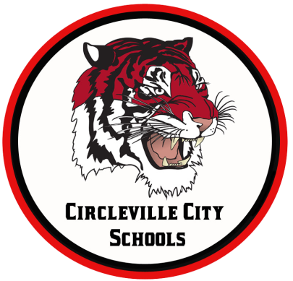
OHIO IMPROVEMENT PROCESS DISTRICT GOALS
GOAL 1: Students participating in state assessments will demonstrate an increase in MATH performance as evidenced by an increase in the Performance Index (PI) from 79.7 (77.56 in 2016) to 108 by 2018.
GOAL 2: Students participating in state assessments will demonstrate an increase in READING performance as evidenced by an increase in the Performance Index (PI) from 80.5 (72.3 in 2016) to 108 by 2018.
GOAL 3: Attendance Rate will increase from 93.7% (93.8% in 2016) (by 1% or more each year) to 96% by 2018 by implementing evidence-based school climate strategies.

MORNING ANNOUNCEMENTS
Tuesday, March 10, 2020
Attention Juniors and Seniors: Friday, April 3rd we will host our annual Tiger Boot Camp. This is an opportunity to begin to look at preparing for the workforce, finding money for college, and being a productive member of the community. Seniors please touch up your resume because you will be meeting with business members throughout the community during the Mock Interview Session. Juniors, you will be picking your top six sessions based on interest level. I will do my best to give you your top four choices. This is a great opportunity for you, Go Tigers!

AFS has a meeting Wednesday at 7:10am

IN GUIDANCE NEWS:
SCHOLARSHIPS AVAILABLE: See Guidance Office for more details!
Circleville Education Association (due 3.13.2020)
Sheryl Wood Logan Scholarship (due 3.27.2020)
Ted Lewis Memorial Music Scholarship (due 4.17.2020)
Pickaway Works (due 4.3.20)
The William D. Squires Educational Foundation (due 4.3.2020)
The Margaret (Peggy) Scherer Memorial Scholarship (due 4.3.2020)
Donald E. Minor Memorial Scholarship (due 4.17.2020)
The Eleanor Tootle Scholarship (due 4.1.2020)
Chief Clark First Responder Scholarship (due 4.17.2020)
Guy B. and Mabel Lykins Scholarship (due 4.3.2020)
The Cheryl Cunningham Memorial Student-Athlete Scholarship (due 4.3.2020)
Karen Matesky Grigg Memorial Scholarship (due 3.16.2020)
Ohio Gass Association Scholarship (due 3.31.2020)
Greater Columbus Chapter of the Association of Govt Accountants Scholarship (due 4.13.2020)
Ed Umsted Memorial Scholarship (due 3.27.2020)
United Way Community Impact Scholarship (due 4.1.2020)
Circleville Sunrise Rotary Leo Moats Scholarship (due 3.31.2020)
Circleville Noon Rotary Club Scholarship J.B. Stout Trust Fund (due 3.27.2020)
CMS Faculty and Staff Scholarship (due 3.31.2020)
Knight’s of Columbus James T. Shea Memorial Award (due 3.17.2020)
Circleville AMVETS Post 2256 (due 5.1.2020)
Student of Integrity-Juniors Only (due 5.11.2020)
The Circleville Band Boosters’ Scholarship (due 3.27.2020)
Circleville Athletic Boosters’ Scholarship (due 3.31.2020)
Kingston National Bank Scholarship (due 4.1.2020)

FOR LUNCH TODAY:
Chicken Sandwich or Spicy Chicken Sandwich
Curly Fries
Steamed Carrots
Pineapple Tidbits
Chocolate Milk, NF
White Milk, 1%

HAPPY BIRTHDAY TO:
Clayton Spencer

