CIRCLEVILLE HIGH SCHOOL

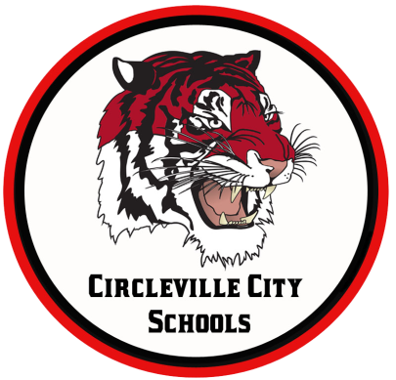
OHIO IMPROVEMENT PROCESS DISTRICT GOALS
GOAL 1: Students participating in state assessments will demonstrate an increase in MATH performance as evidenced by an increase in the Performance Index (PI) from 79.7 (77.56 in 2016) to 108 by 2018.
GOAL 2: Students participating in state assessments will demonstrate an increase in READING performance as evidenced by an increase in the Performance Index (PI) from 80.5 (72.3 in 2016) to 108 by 2018.
GOAL 3: Attendance Rate will increase from 93.7% (93.8% in 2016) (by 1% or more each year) to 96% by 2018 by implementing evidence-based school climate strategies.

MORNING ANNOUNCEMENTS
Monday, March 9, 2020
IN GUIDANCE NEWS:
SCHOLARSHIPS AVAILABLE: See Guidance Office for more details!
Circleville Education Association (due 3.13.2020)
Sheryl Wood Logan Scholarship (due 3.27.2020)
Ted Lewis Memorial Music Scholarship (due 4.17.2020)
Pickaway Works (due 4.3.20)
The William D. Squires Educational Foundation (due 4.3.2020)
The Margaret (Peggy) Scherer Memorial Scholarship (due 4.3.2020)
Donald E. Minor Memorial Scholarship (due 4.17.2020)
The Eleanor Tootle Scholarship (due 4.1.2020)
Chief Clark First Responder Scholarship (due 4.17.2020)
Guy B. and Mabel Lykins Scholarship (due 4.3.2020)
The Cheryl Cunningham Memorial Student-Athlete Scholarship (due 4.3.2020)
Karen Matesky Grigg Memorial Scholarship (due 3.16.2020)
Ohio Gass Association Scholarship (due 3.31.2020)
Greater Columbus Chapter of the Association of Govt Accountants Scholarship (due 4.13.2020)
Ed Umsted Memorial Scholarship (due 3.27.2020)
Congressional Advisory-Youth Preparedness Council (due 3.6.2020)
United Way Community Impact Scholarship (due 4.1.2020)
Circleville Sunrise Rotary Leo Moats Scholarship (due 3.31.2020)
Circleville Noon Rotary Club Scholarship J.B. Stout Trust Fund (due 3.27.2020)
CMS Faculty and Staff Scholarship (due 3.31.2020)
Knight’s of Columbus James T. Shea Memorial Award (due 3.17.2020)
Circleville AMVETS Post 2256 (due 5.1.2020)
Student of Integrity-Juniors Only (due 5.11.2020)
The Circleville Band Boosters’ Scholarship (due 3.27.2020)
Circleville Athletic Boosters’ Scholarship (due 3.31.2020)
Kingston National Bank Scholarship (due 4.1.2020)

FOR LUNCH TODAY:
Max Sticks
Marinara Sauce
Whole Kernel Corn
Fresh Apple Slices
Giant Goldfish Graham
Chocolate Milk, NF
White Milk, 1%

HAPPY BIRTHDAY TO:
Alexis Vanfossen
Sierra Imboden-Bowers
Daquilla Knight
Tatum Myers
Clay Mogan

