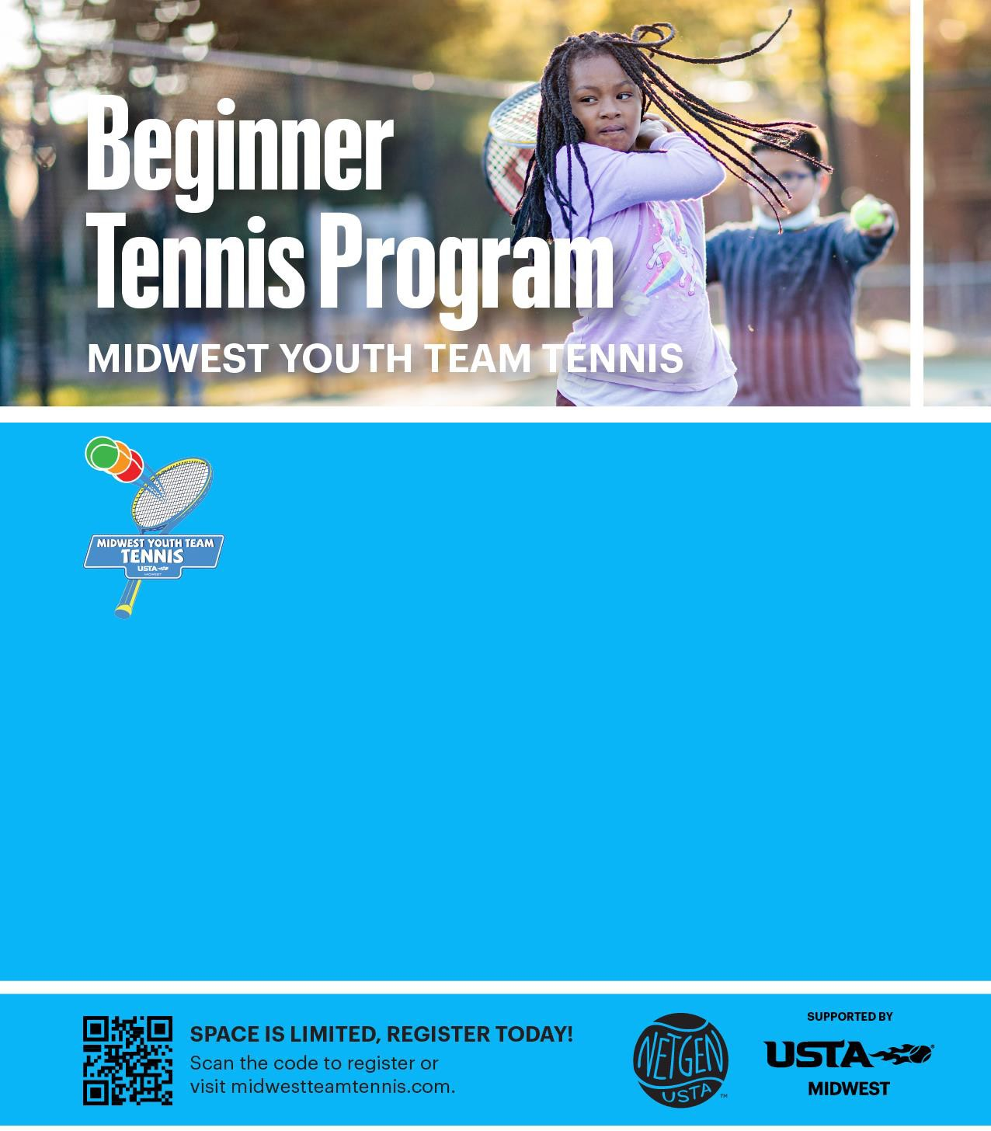
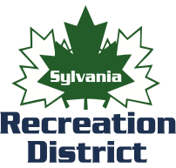

Tennis provides numerous benefits beyond good health and activity. Kids learn teamwork, communication, balance, agility, hand-eye coordination, problem-solving and self-reliance, all while having fun and making friends. Midwest Youth Team Tennis uses smaller courts, shorter racquets and lower bouncing balls, so youth players will achieve greater physical activity and feel successful at tennis right from the start.
Sylvania Northview High School 5403 Silica Tuesday and Thursdays June 4, 6, 11, 13, 18, 20
5:30-6:30 p.m. (Entering 1st-5th )

Sylvania Southview High School 7225 Sylvania Ave Monday and Wednesdays
June 3, 5, 10, 12, 17, 19
9:30-10:30 a.m. (Entering 1st-5th )

Sylvania Southview High School7225 Sylvania Ave Wednesdays
June 5, 12, 19, 26
5:00-6:30 p.m. (Entering 6th-9th)

Registration closes May 17th
Cost: $65 per player Includes a team t-shirt and age-appropriate tennis racquet

Program Coordinator

Liz Moulton 419-410-0733 tennisnorthwesternohio@gmail.com

