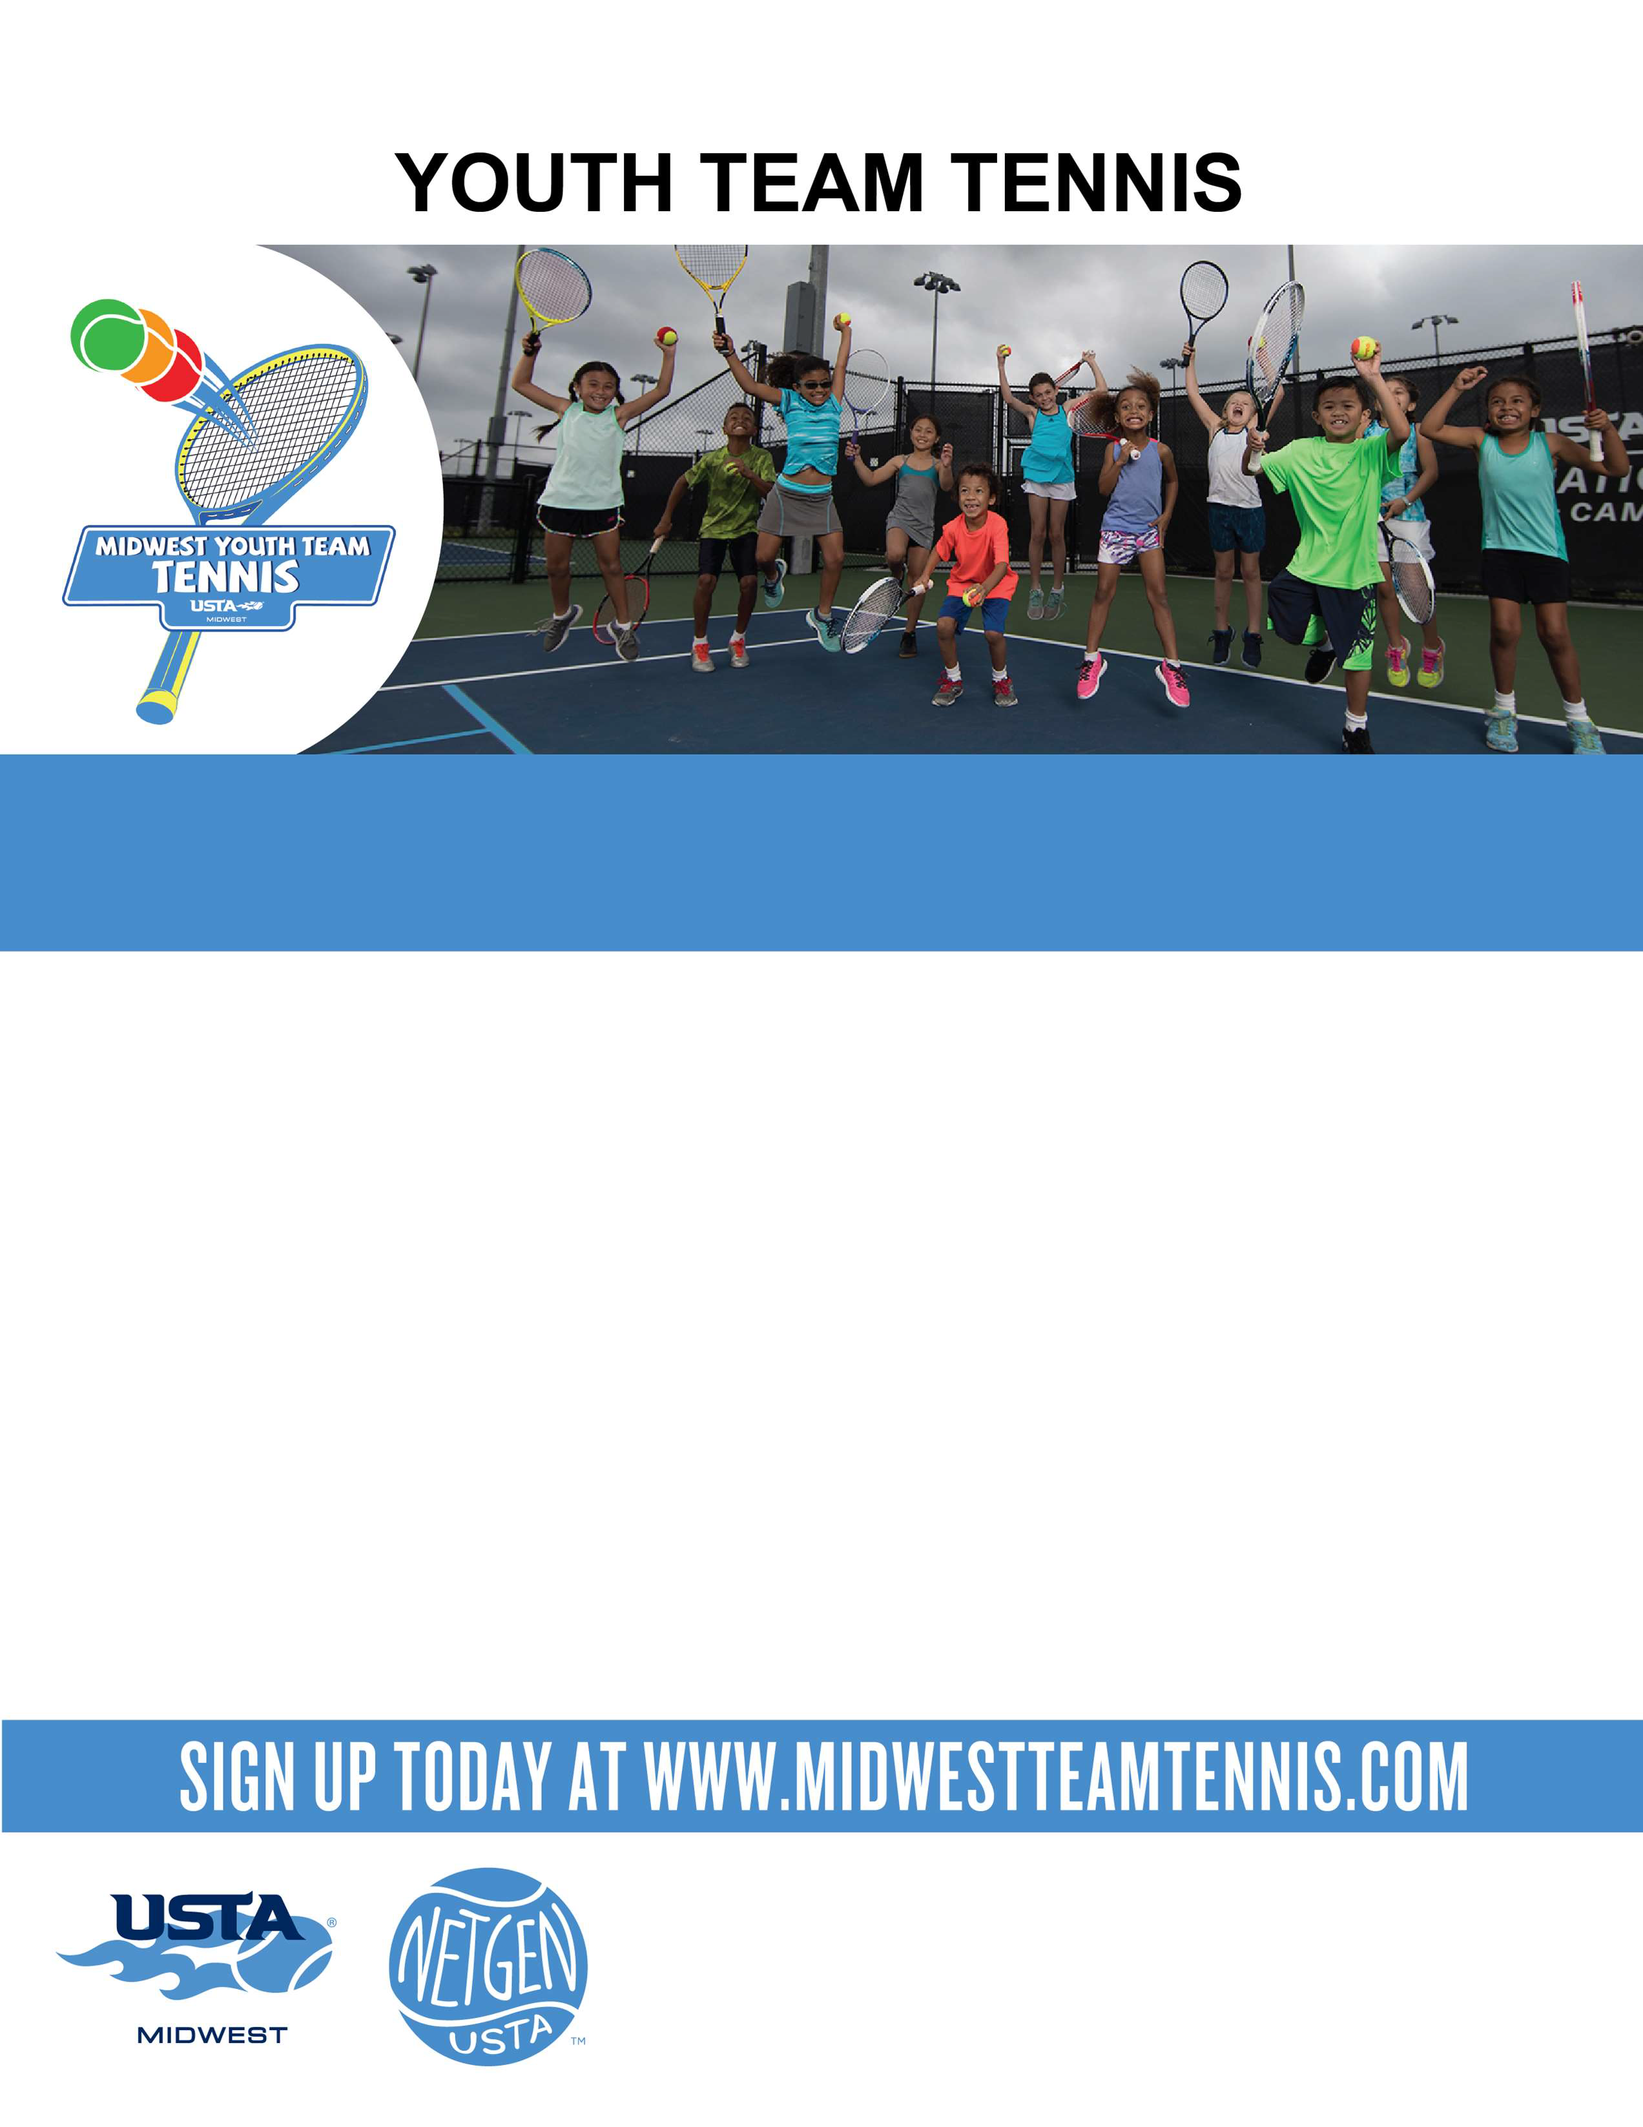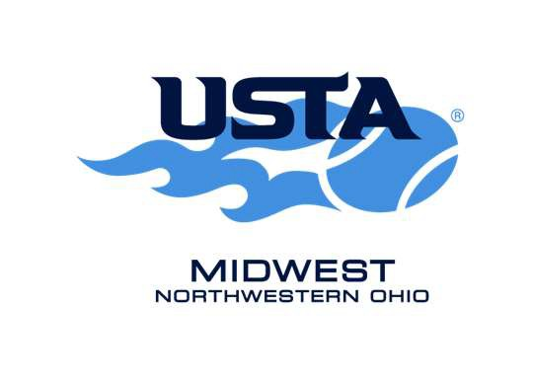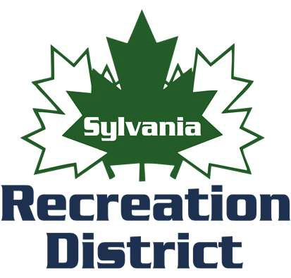Sylvania
Program coordinator :
Liz Moulton (419) 410-0733
tennisnorthwesternohio@gmail.com Register at www.midwestteamtennis.com

Tennis provides numerous benefits beyond good health and activity. Kids learn teamwork, communication, balance, agility, hand-eye coordination, problem-solving and self-reliance, all while having fun and making friends. Midwest Youth Team Tennis uses smaller courts, shorter racquets and lower bouncing balls, so youth players will achieve greater physical activity and feel successful at tennis right from the start.
Cost is $65 includes a racquet, t-shirt, tennis ball and 6 classes.
Sylvania Northview High School
5403 Silica Register by May 14
Tuesday and Thursdays
June 1,3,8,10,15,17
5:30-6:30 p.m. (Entering 1st-5th )

Sylvania Southview High School
7225 Sylvania Ave Register by May 14
Monday and Wednesdays
June 7,9,14,16,21,23
9:30-10:30 a.m. (Entering 1st-5th )

Sylvania Southview High School 7225 Sylvania Ave
Wednesdays Register by May 14
June 2,9,16,23,30 and July 7th 5:30-6:30 p.m. (Entering 6th-9th)

