Just in time for the holidays! Have your child personalize and decorate a piece of pottery as a keepsake item or a gift for the holidays. Choose your pottery design and preorder your pottery piece today. Stay after school and paint your own pottery!

December 7, 2023 3:30pm-4:45pm

* Please fill out the form below and send the form in with your pottery choice and payment. Return form to Mrs. Iacobucci.
* **Money and pre-order form due November 15, 2023 to pre-order your pottery piece(s) which will be painted on 12/7.**
* Parents who are picking up their child will need to pick their child up from the cafeteria using the back bus loop.
* 5 pm Late bus is available. After school snacks are included.
* Prices are $8.00 for flat ornaments (snowman, gift box, snowflake, tree in truck) and $13.00 for Tiny Tots 3-D figurines (Santa, reindeer, snowman).
* Pottery pieces will be dipped in glaze and returned approximately by December 15, 2023 to take home.

__________________________________________________________________

Brushstrokes Studios Afterschool Sign up Form & payment due 11/15

Student Name:________________________________________________________________

Classroom Teacher: ____________________________________________________________

Health alerts/Allergies: _________________________________________________________

Parent/Guardian Name: ________________________________________________________

Parent/Guardian Phone Number: _________________________________________________

Please circle: Parent pickup 5pm Late bus

Pottery Choice Selection:

$8 each- flat ornament: Snowman Tree in truck Snowflake Gift box

$13 each- tiny tot 3-D figurine: Reindeer Santa Snowman

Please return the form and payment to Mrs. Iacobucci.

Proceeds go towards the Elementary Student Council. Thank you for your support! 😊

Flat ornaments $8

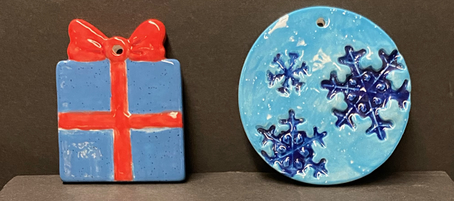

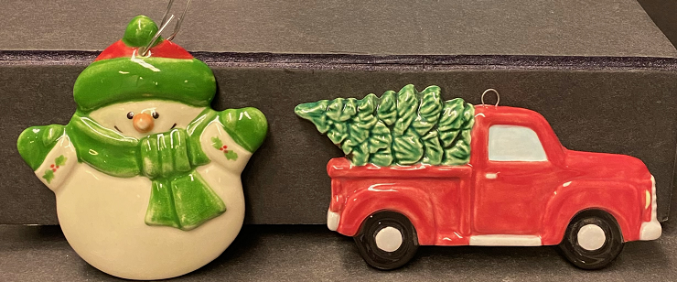

$13 Tiny Tot 3-D figurines

