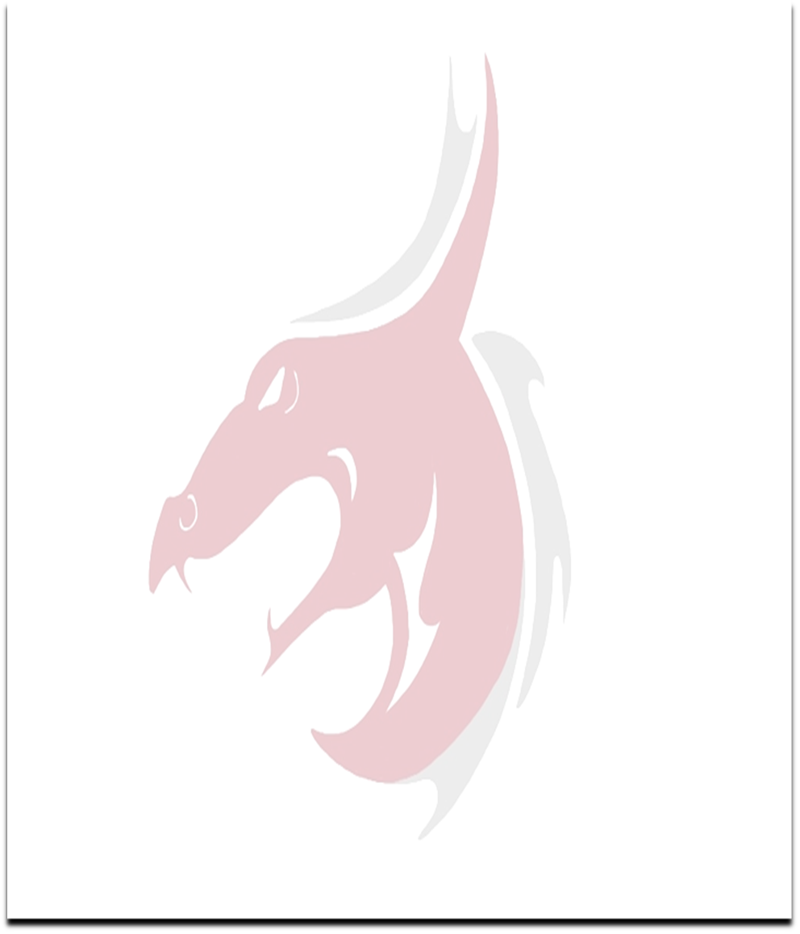
Dickson Middle School Football
2022 Schedule
Spring Practice – May 2 – May 20
Offseason Workouts – June
Open Field – April 23-June 25
Dead Period – June 27-July 10
Return to practice – July 11
Regular Season
Date Opponent Location Time Varsity
8/04/2022 Burns DMS 5:00 JV
Burns DMS 6:30 Varsity
8/11/2022 Greenbrier GMS 7:00 Varsity
8/16/2022 Lewis County DMS 6:00 JV
8/16/2022 Lewis County DMS 7:00 Varsity
8/18/2022 Sycamore DMS 6:30 Varsity
8/25/2022 Fairview FMS 5:00 JV
Fairview FMS 6:30 Varsity
9/02/2022 Harpeth DMS 5:00 JV
Harpeth DMS 6:30 Varsity
9/08/2022

9/15/2022 Cheatham CMS 5:00 JV
Cheatham CMS 6:30 Varsity
9/22/2022 Springfield SMS 6:30 Varsity
9/29/2022 Conference Bowl TBD TBD Varsity
Contact info for Coach Proffitt: lproffitt@dcstn.org , (615) 446-2273 ext. 128
  - Maroon signifies home games.
  - Black signifies road games.
  - Bowl game is hosted by rotation.

