Occupational Risk | Workers & Tasks | PPE Recommendations**
Very High Exposure Risk  - jobs are those with high potential for exposure to known or suspected sources of COVID-19 during specific medical, postmortem, or laboratory procedures | - Healthcare workers (e.g., doctors, nurses, dentists, paramedics, emergency medical technicians) performing aerosol-generating procedures (e.g., intubation, cough induction procedures, bronchoscopies, some dental procedures and exams, or invasive specimen collection) on known or suspected COVID-19 patients.  - Healthcare or laboratory personnel collection or handling specimens from known or suspected COVID-19 patients (e.g., manipulating cultures from known or suspected COVID-19 patients).  - Healthcare or laboratory personnel collecting or handling specimens from known or suspected COVID-19 patients (e.g., manipulating cultures from known or suspected COVID-19 patients).  - Morgue workers performing autopsies, which generally involve aerosol-generating procedures, on the bodies of people who are known to have, or suspected of having, COVID-19 at the time of their death.  - Health Care Providers in the school setting performing tasks including the physical assessment of any individual suspected of having COVID-19 and/or aerosol-generating procedures. Tasks such as but not limited to open suctioning of airways, sputum induction, and  non-invasive ventilation. | - gloves - a gown/coveralls - a face shield or goggles - and either a face mask or a respirator (N95) depending on their job tasks and exposure risks  Those who work closely with (either in contact with or within 6 feet of) patients known to be, or suspected of being, infected with COVID-19, should wear respirators (N95), if available. Surgical mask (may double mask if N95 (respirator) is not available or may be used along with a face shield).  ** Face Coverings are not PPE
High Exposure Risk  - jobs are those with high potential for exposure to known or suspected sources of COVID-19 | - Medical transport workers (e.g., ambulance vehicle operators) moving known or suspected COVID-19 patients in enclosed vehicles.  - Mortuary workers involved in preparing (e.g., for burial or cremation) the bodies of people who are known to have, or suspected of having, COVID-19 at the time of their death.  - Healthcare Providers in the school setting performing tasks include physical or nursing assessment of any individual suspected of having COVID-19. Sick/symptomatic student should wear a surgical mask, if tolerated. | - gloves  - a gown  - a face shield or goggles  - and either a face mask or a respirator (N95) depending on their job tasks and exposure risks  Those who work closely with (either in contact with or within 6 feet of) patients known to be, or suspected of being, infected with COVID-19, should wear respirator (N95), if available.  Surgical mask (may double mask if N95 (respirator) is not available or may be used along with a face shield).  **Face Coverings are not PPE
Medium Exposure Risk  - jobs include those that require frequent and/or close contact with (i.e., within 6 feet of) people who may be infected with COVID-19, but who are not known or suspected COVID-19 patients | - In areas without ongoing community transmission, workers in this risk group may have frequent contact with travelers who may return from international locations with widespread COVID-19 transmission.  - In areas where there is ongoing community transmission, workers in this category may have contact with the general public (e.g., schools, high-population-density work environments, some high-volume retail settings).  - Staff in the school setting, performing tasks including but not limited to first aid, oral medication administration, vision screening, hearing screenings, consultation, blood glucose checks (diabetes care), metered-dose inhalers (MDIs) for students with asthma, feeding, toileting, and/or diapering.  - Circumstances may include, but not be limited to any interaction that takes place in which social distancing cannot be maintained for prolonged periods of time, or with students who cannot manage body fluids (cough/sneeze/oral secretions) and/or are unable to wear their own face covering. | - gloves  - a gown (apron/smock)  - a face mask,  - and/or face shield or goggles  Depending on task/situation, the results of the employer’s hazard assessment and the types of exposure workers have on the job.  **Face coverings are not PPE
Lower Exposure Risk (Caution)  - jobs do not require contact with people known to be, or suspected of being, infected with COVID-19, nor frequent close contact with (i.e., within 6 feet of) the general public | School personnel and students must interact, and social distancing cannot always be maintained. Workers in this category have minimal occupational direct/close contact with the public and other coworkers. | Additional PPE is not recommended for workers in the lower exposure risk group.  Workers should continue to use the PPE, if any, that they would ordinarily use for other job tasks.  **Face coverings are not PPE
School Setting Notes:
Per OSHA’s Respiratory Protection Program, to use N-95s schools must have a fit test program in place. If it is not in place or there is a shortage, two surgical face masks should be used, along with a face shield. Some schools may have access to KN95 respirators that have been declassified and are NOT suitable for the highest risk tasks without a full-face shield. They may be allowed as non-PPE (face coverings).
All nurses will have access to surgical masks, face shields, & gloves for use in the health office. Additionally, all nurses will have access to goggles, isolation gowns, respirators N95s, as available for use in a program’s designated treatment room and/or isolation room.
Any staff assisting the nurse in the health office will also have access to surgical masks, face shields. Staff access to the health office will be limited to those assisting the nurse with coverage of student needs. Other staff will be provided with additional PPE, as necessary, in anticipation of identified as having frequent/prolonged contact with students while performing identified tasks.

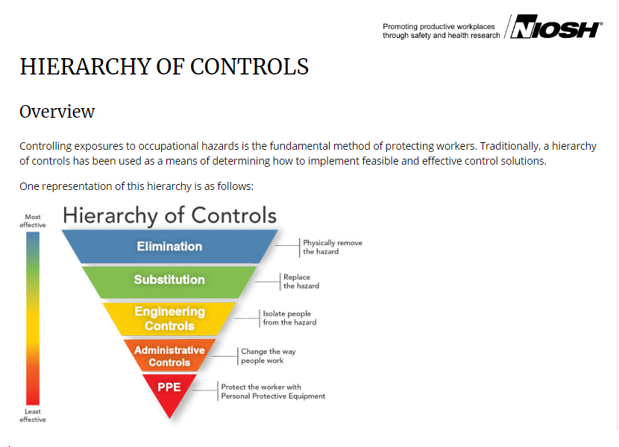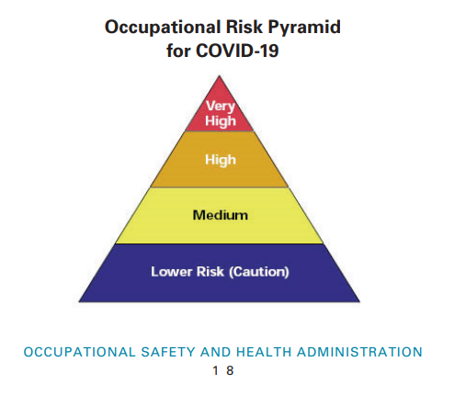
CDC/NIOSH (National Institute for Occupational Safety & Health)
(OSHA) Guidance on Preparing Workplaces for COVID-19

