Week 2  September | Monday  5 | Tuesday  6 | Wednesday  7 | Thursday  8 | Friday  9
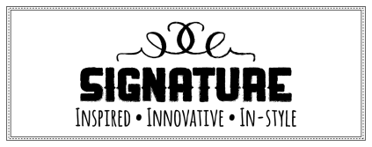 | No School | Pierogies w/ Spinach | BYO Nachos  Salsa, Cheese  Refried Beans | Baked Potato  Cheese, Bacon, Broccoli | Spicy Boneless Chicken Wings  Pop Corn Chicken  Carrots/Celery
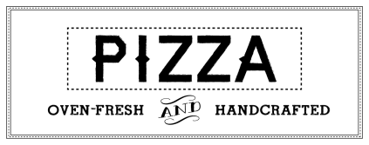 | No School | Cheese or Pepperoni | Cheese or Pepperoni | Cheese or Pepperoni | Cheese or Pepperoni
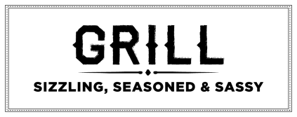 | No School | Cheeseburger | Spicy Chicken | Cheeseburger | Cheeseburger
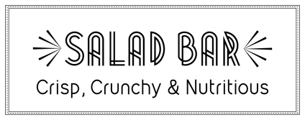 | Chopped Romaine, Spring Mix, Hard Boiled Eggs, Beets, Carrots, Celery, Cherry Tomatoes, Peppers, Garbanzo Beans, Red Onions, Corn, Cucumbers, and other fresh ingredients.
Contact your Chef Resident Director, Ryan Oliver,
roliver@avifoodsystems.com for questions or comments.
Breakfast: FREE, Served 7:20 AM to 07:40 AM
Lunch: $3.50($.40 for reduced), Extra Milk: $.75

This institution is an equal opportunity provider.
*MENU SUBJECT TO CHANGE*

St. Thomas Aquinas
Middle and High School

