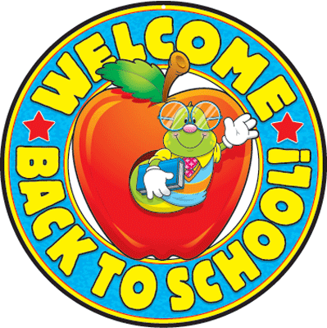
Monday Tuesday Wednesday Thursday Friday

AUGUST 2020 Lunch Menu
SS. Philip and James School
Name_________________

Grade_________________
 | 18  Taco Buttered Macaroni  Rice Corn Fruit  Meal / Milk $2.75_______  Milk Only (Choc/White) .50_______  Ala Carte $1.50_______  Total $_______ |  | 19  Chicken Burrito/diced potatoes  Green Beans Fruit  Meal / Milk $2.75_______  Milk Only (Choc/White) .50_______  Ala Carte $1.50_______  Total $_______ | 20  Rigatoni/ Meat Sauce  Romaine Salad/Fruit/ Garlic bread  Meal / Milk $2.75_______  Milk Only (Choc/White) .50______  Ala Carte $1.50_______  Total $_______ | 21  Pizza Romaine Salad  Fruit Cookie  Meal / Milk $2.75_______  Milk Only (Choc/White) .50______  Ala Carte $1.50_______  Total $_______
24  Hamburger/Bun French Fries  Celery Fruit  Meal / Milk $2.75_______  Milk Only (Choc/White).50_______  Ala Carte $1.50_______  Total $_______ | 25  Taco Buttered Macaroni  Rice Corn Fruit  Milk $2.75_______  Milk Only (Choc/White) .50_______  Ala Carte $1.50_______  Total $_______ |  | 26  Turkey Mashed Potato/gravy  Green Bean Roll Butter Apple Crisp  Meal / Milk $2.75_______  Milk Only (Choc/White) .50_______  Ala Carte $1.50_______  Total $_______ | 27  Rigatoni/ Meat Sauce  Romaine Salad/Fruit/ Garlic bread  Meal / Milk $2.75_______  Milk Only (Choc/White) .50______  Ala Carte $1.50_______  Total $_______ | 28  Pizza Romaine Salad  Fruit Cookie  Meal / Milk $2.75_______  Milk Only (Choc/White) .50______  Ala Carte $1.50_______  Total $_______
31  Creamed Chicken on Biscuit  Green Beans  Apple Crisp  Meal / Milk $2.75_______  Milk Only (Choc/White).50_______  Ala Carte $1.50_______  Total $_______ | Total for August  Meal $________  Ala Carte $________  Milk Only $________  Grand Total $________

