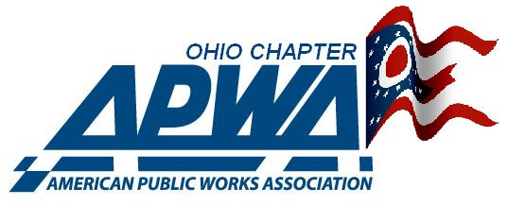
Northwest Branch
Post-Secondary Education Scholarship Program

The Northwestern Ohio Branch of the American Public Works Association is a local chapter belonging to a National Association of people involved in the Public Works sector of Government. Members of our association are engaged in the management and operation of public infrastructure funded by Federal, State and Local tax dollars.
Attracting talented, highly motivated, and well-educated people to fill positions in these service agencies is our highest priority. We are a training-based organization offering direct classroom training, training by association in the field, education programs and collective gatherings where ideas and best practices can be shared.
To continue our National tradition of education, the Northwestern Ohio Branch of the APWA is offering the following scholarship opportunities.

The $1000.00 NW Ohio APWA Public Works Scholarship
- for Engineering Core or Administrative Students enrolled in fields related to Public Works.

- for Vehicle Maintenance and Fleet Management Students

- for students engaged in the studies of Environmental Impact and Water Quality.

This Scholarship is funded by the NW Ohio APWA branch and its event offerings throughout the year.

The $500.00 Bennett J. Roessner Scholarship
- for small engine and lawn maintenance fields. This is for a student enrolled in a 2-year accredited Ohio educational facility.

This Scholarship is funded in partnership with the Roessner family and the NW Ohio APWA branch.

The $500.00 Abco-Services APWA Family Scholarship
- for all NW Ohio APWA family members. This student must be enrolled in an accredited Ohio educational facility and have a family member have a current APWA membership. No College Major requirement.

This Scholarship is funded in partnership with ABCO-Services, Inc. and the NW Ohio APWA branch.

These Scholarships will be awarded on an annual basis. The application deadline for submissions is March 15, 2021. All applications will be considered by the Awards and Scholarship Committee and presented to the Board for a vote of approval. The awards will be made to the winning applicants no later than June 15.

An applicant may apply for any of the available scholarships but is only eligible to receive one award per academic year.

To be considered, an applicant must provide proof of acceptance into an accredited institution’s secondary education program, a 300-word essay, along with their fully completed application.

For more information, contact Kim Roessner at 419/373-4482

