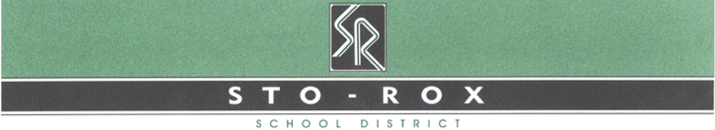
D. Livingston  Senior High School Teacher | 1105 Valley Street  McKees Rocks, PA 15136  Telephone: 412-771-3213 Ext. 1107  Fax: 412-771-8395  E-Mail: dlivingston@srsd.k12.pa.us

10/7/2020

Dear Supporter of Sto-Rox High School,
The yearbook staff is happy to announce the opportunity to purchase advertising space in the Sto-Rox High School yearbook. The 2020-21 full color yearbooks will be released in the fall of 2019. By purchasing advertising space in our Sto-Rox yearbook, you are helping the students and purchasing a permanent tax deductible advertisement for your business.
Listed below are the spaces available for your tax deductible advertisement. Please help support our yearbook and return your payment (payable to Sto-Rox High School Yearbook) and advertisement information as soon as possible. Our deadline for business advertisements is November 16th.

Ad Space | Price | Description
Line (Text only) | $20 | Single line of text. TEXT ONLY
Business card | $40 | Text and graphic.  (Eighth of a page)
Quarter page | $60 | Small message and graphic/picture.
Half page | $100 | Medium sized message,  graphic/ picture.
Full page | $200 | Longest message, graphic/picture.

Sincerely,

Mrs. Livingston

Sto-Rox High School Yearbook Advisor
1105 Valley Street
McKees Rocks, Pa 15136
412-771-3213 x1107
dlivingston@srsd.k12.pa.us

