Directions for Filling Out, Downloading, and Sharing of Registration Documents with your Counselor

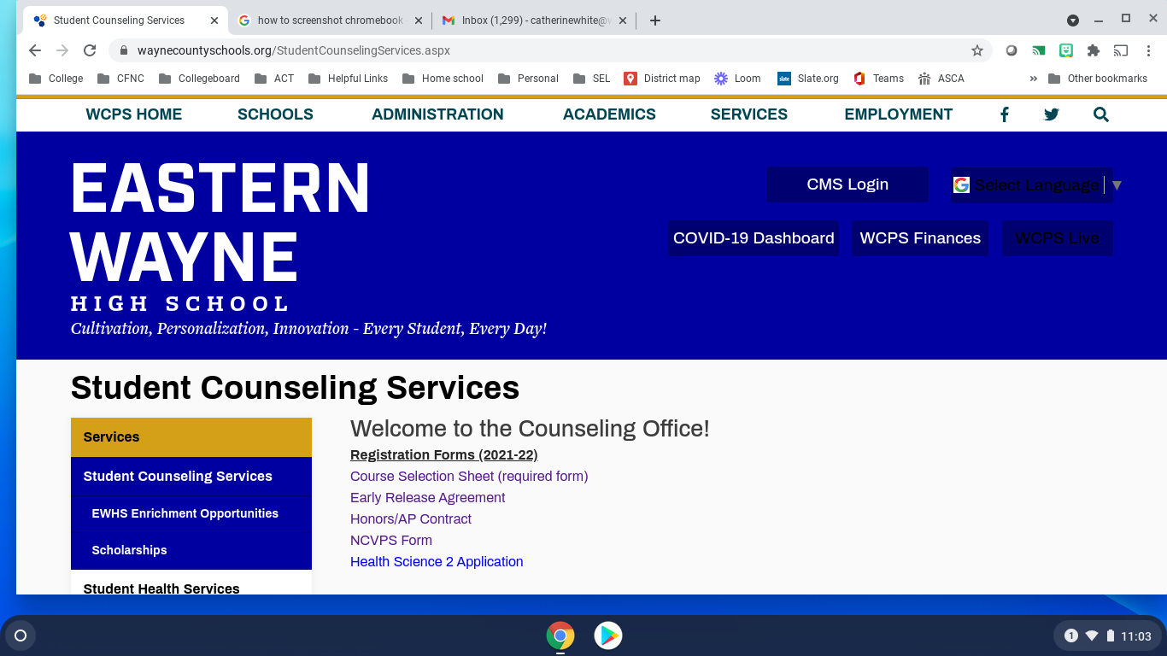

Click on "Course Selection Sheet (required form)" to fill out the form. Type in the blue shaded boxes to make your selections.

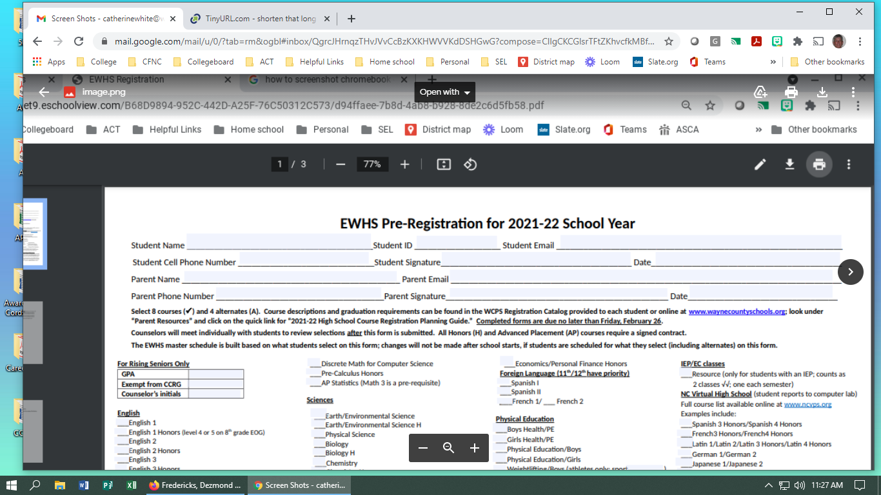

Once all selections are marked on all 3 pages (including alternate course selections on page 3), click on the down ↓ arrow in the upper right of your screen to download. A drop down box will appear and select "download with changes". A new window will appear.

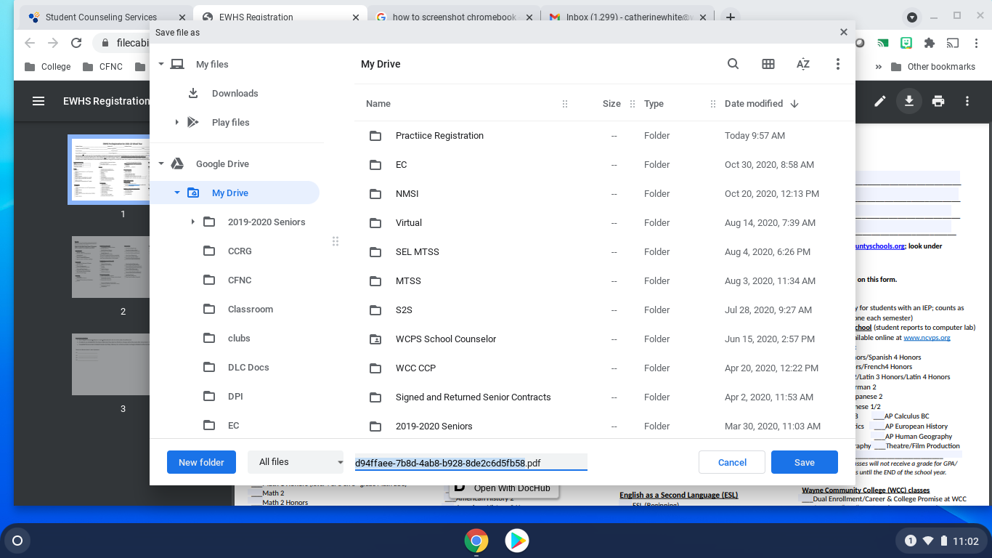

At the bottom of the new window you will name your document to save in your google drive. Once you have named your download, click save and the document will save in your google drive. Do these steps for every document you complete for your counselor.
After you have saved all your documents, open your google drive. To open your google drive, click on the 9 dot square to the left of your name in the upper right of your screen. It will open a drop down of google applications where you will see a multi-colored triangle with drive written under it.

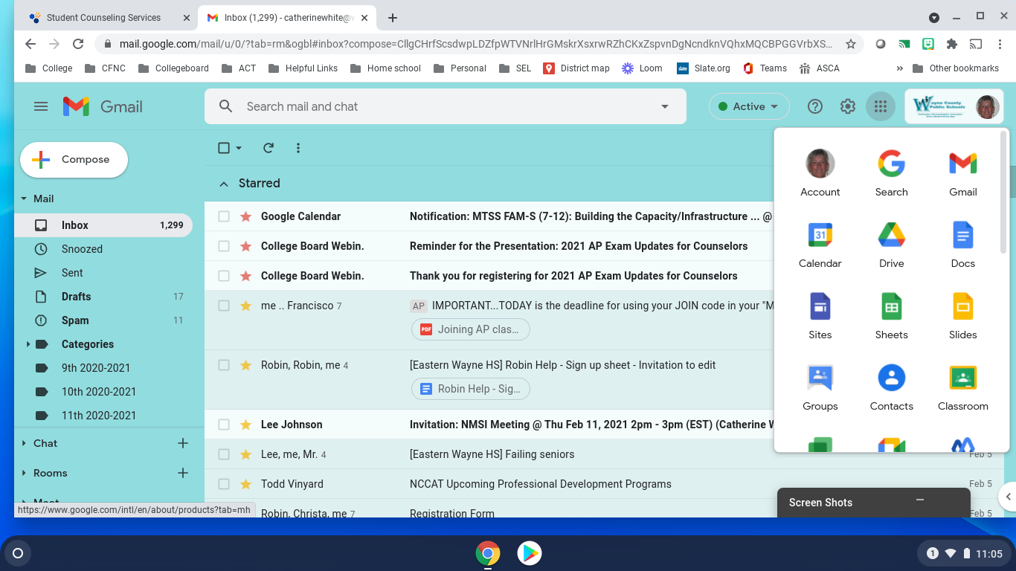
Once you have clicked on "drive", you will be able to find your saved registration documents. Scroll through your documents and click on the first document that you need to share with your counselor.

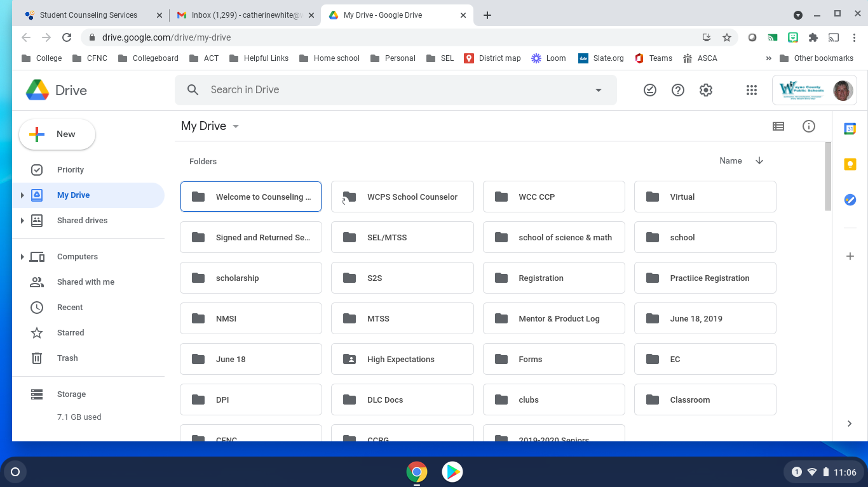

Click on the document that you want to share and a new window will open.

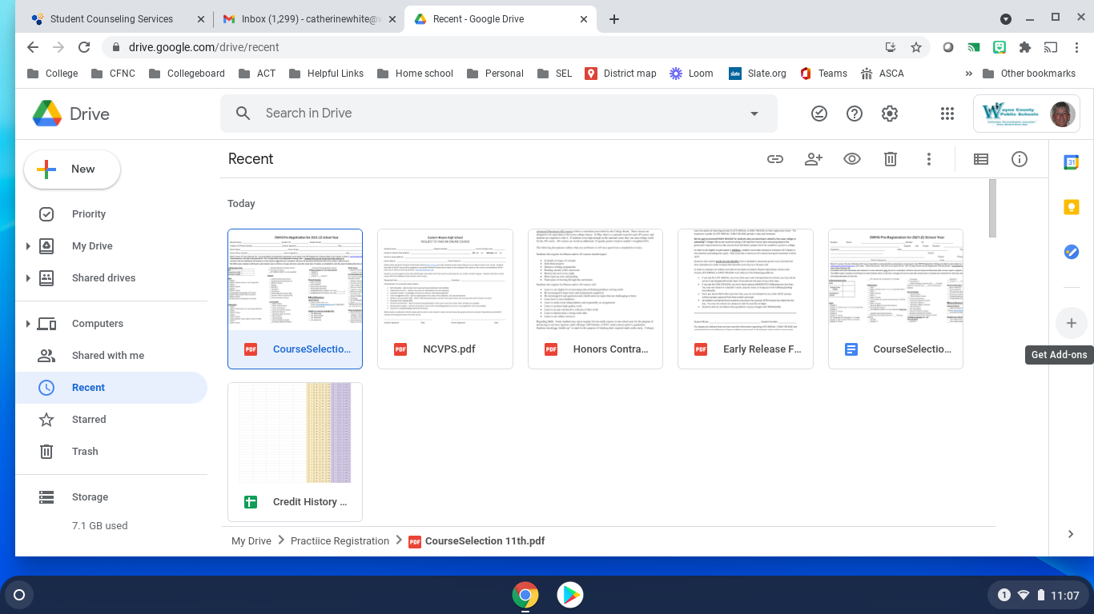

Above your documents you will see a symbol of a person with a + sign, click on that symbol and a new window will open. Type in your counselor's email address and click done to share the saved registration documents with your counselor.

