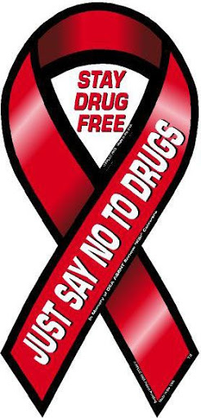
Drugs and Controlled Substances

Research Guide
To get to the library databases:

Go to the Library Schoology course list
Click on the link MackinVia (Databases, ebooks, audiobooks)
At user ID, type in Red Land (2 words with a space – wait -- Red Land High School,
Lewisberry, PA will appear, click on it)
Next screen click on Log-in (you should already be in your wssd.bz account)
Select Databases (on the left side)

** UXL Encyclopedia of Drugs and Addictive Substances
Go to Gale eBooks
Click Open Now
Click on Medicine
In light gray bar, click on Book Index
Pick the letter of the alphabet for the name of the drug you are researching
Click on the link with the link with the biggest page range
Can change view, text size, or listen to it reading (ear buds please)
White bar at the top, click SEND to (paper airplane) to put article in your Google Drive
Click on Cite, MLA 8, Copy and Paste to your Bibliography page

** Sites for Classes

• National Institute on Drug Abuse for Teens
• National Institute on Drug Abuse Easy Facts
• National Institute on Drug Abuse, Commonly Abused Drugs
• Drugs A to Z, American Addiction Centers
• Addiction Center

Author’s last name, first name. (if given) “Article Title.” Publisher, Date of Info. (Day Month Year),
web address (no http://). Accessed (Day Month Year).

Example:
“Vicodin.” National Institute on Drug Abuse, 20 Feb. 2018,
drugabuse.gov/Infofacts/inhalants.html. Accessed 3 Oct. 2020.

Remember to cite the resources you use on your Bibliography page. Give credit for pictures too!

Metcalfe 11-20

