Kindergarten | 1st Grade | 2nd Grade
● Book Bag (without wheels and large enough that binders may be sent home in it)  ● 1 Pair Headphones (No Earbuds)  ● 1 pack of No.2 pencils  ● 4-6 glue sticks  ● 1 pair of children’s scissors (Children’s Fiskar recommended)  ● plastic folder with brads  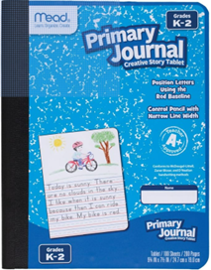  ● 2 primary journal Creative Story Tablet  ● 4 boxes of Crayons 24 count  ● 1 Plastic Pencil Box or bag  ● 1 pack of pink rubber erasers (Pink Pearl)  ● 1 pack of Dry Erase markers  These items are optional but recommended:  ● 1 packages of baby wipes/ Lysol wipes  ● Playdough  ● Germ-X/ Hand Sanitizer  ● 1 pack of markers  ● Boxes of Plastic Ziploc bags (1 Gallon/1 Quart/1 Sandwich)  ● 1 pack of Clear Plastic Sheet Protectors | FOR PERSONAL USE:  -2 folders with pockets (solid colors)  -1 pencil box for supplies  -2 boxes Crayola crayons (no markers)  -1 pair scissors  Over-the-head Headphones (NO Bluetooth or earbuds)  -Reusable water bottle  -3 PRIMARY composition notebooks (see below)  -DUAL: 5 PRIMARY composition notebooks (see below)  TO BE SHARED WITH THE CLASS:  -2 boxes of Kleenex  -1 bottle hand sanitizer  -2 containers of Lysol wipes or baby wipes  Girls – Gallon Ziploc bags  Boys – Quart Ziploc bags  -1 pack Expo dry erase markers  -1 pack large pink erasers  -4-6 glue sticks  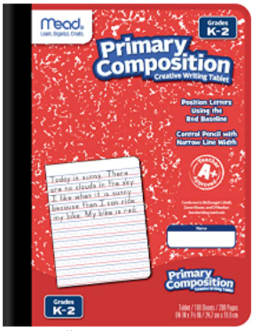  -2 packs of pencils (pre-sharpened preferred) | -1 pack of Ticonderoga pencils  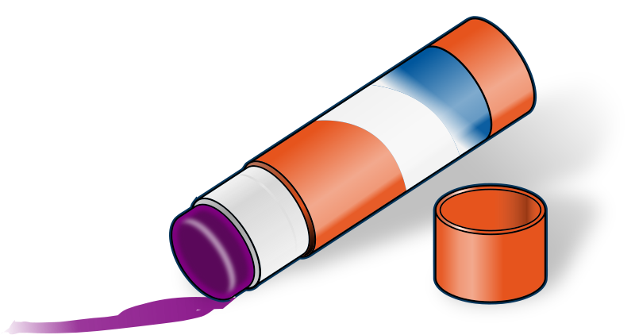  -1 pack of crayons  -8 glue sticks    -4 wide-ruled composition notebooks  (no wires)  -1 pair of scissors (Fiskars) -headphones (No Earbuds)  -2 plastic folders  -Pencil Box  -1 pack Expo dry erase markers  1 pack of large pink erasers  -2 Boxes of Tissues  -Lysol Wipes or Baby Wipes  -1 bottle hand sanitizer  -Ziploc Bags:  Boys – Gallon Bags  Girls – Quart Bags

3rd Grade | 4th Grade | 5th Grade
Pencil box  1 pack of Ticonderoga pencils  2 Composition Notebooks (black/White marble, No spiral)  2 Mead Plastic 2-pocket folder with brads (blue and red)  Box of crayons  Markers  Scissors  4 glue sticks  3 boxes of Kleenex  4 dry erase markers  1 pair of headphones (NO EARBUDS)  2 Lysol wipes  Ziploc Bags (sándwich and gallon sized)  ** No handheld pencil sharpeners**  ** These items are optional but recommended:  Baby Wipes  Wireless Computer Mouse | - 2 boxes of kleenex  - Clorox Wipes  - 2 boxes of Band-aids  - 2 packs of Ticonderoga pencils or mechanical pencils  - Erasers  - Highlighters  - 2 folders (Dual - 1 Red/1 Blue)  - 3 Composition notebooks (Dual - 4)  - Skinny dry Erase Markers  - Headphones (for testing)  - Gluesticks  - Colored pencils or crayons  - Scissors  - Clipboard  - Reusable Water Bottle with Lid  - Cloth pencil pouch (no boxes please) | - 1 pack of Ticonderoga pencils  - 10 pack skinny markers  - 4 glue sticks  - 1-2 highlighters  - scissors  - skinny dry erase markers  - high polymer white eraser  - ruler  - Headphones  - 3 Composition Notebooks (NO SPIRAL) *(Dual will need 6 Composition Notebooks)  - 5 folders with prongs (10 for dual)  - 2 Boxes of Kleenex  - 2 Clorox Wipes  - Pencil Pouch with Zipper

