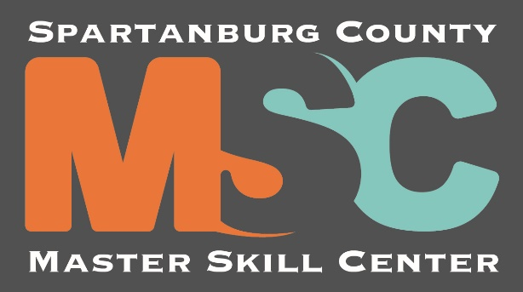
Attention All 10th Graders
Mandatory Barbering Meeting for the
New Spartanburg County Master Skill Center
Dates: January 22, 2020 OR January 23, 2020
Time: 6:00 pm
Place: RD Anderson Multi-Purpose Building
*To be considered for the Barbering program at the new Master Skills Center of Spartanburg County, it is required that you AND a parent/guardian attend one of the above sessions.

**You MUST bring your original signed Social Security card (copies will NOT be accepted)!**

Should you have any questions or concerns, please call Mr. Cedric Miller, RDA Counselor, at 576-5020 Ext. 117

***In case of inclement weather, the make-up meeting will be held
Thursday, January 30, 2020.***

