ATTENTION SOPHOMORES:
Do you have a passion for beauty?
Turn that passion into a career in Cosmetology. Take the first step on the path to your new future.
We will be discussing:
- Prerequisites
- Class Course Guide
- State Requirements
- Program Costs
- Career Opportunities

Join us for the Virtual Daniel Morgan Technology Center Cosmetology Information Meeting

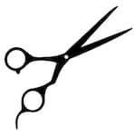
WHEN: March 9, 2021 @ 4:30 PM
HOW: Join our Zoom Meeting
Meeting ID: 814 3613 8074
Passcode: Cosmo

