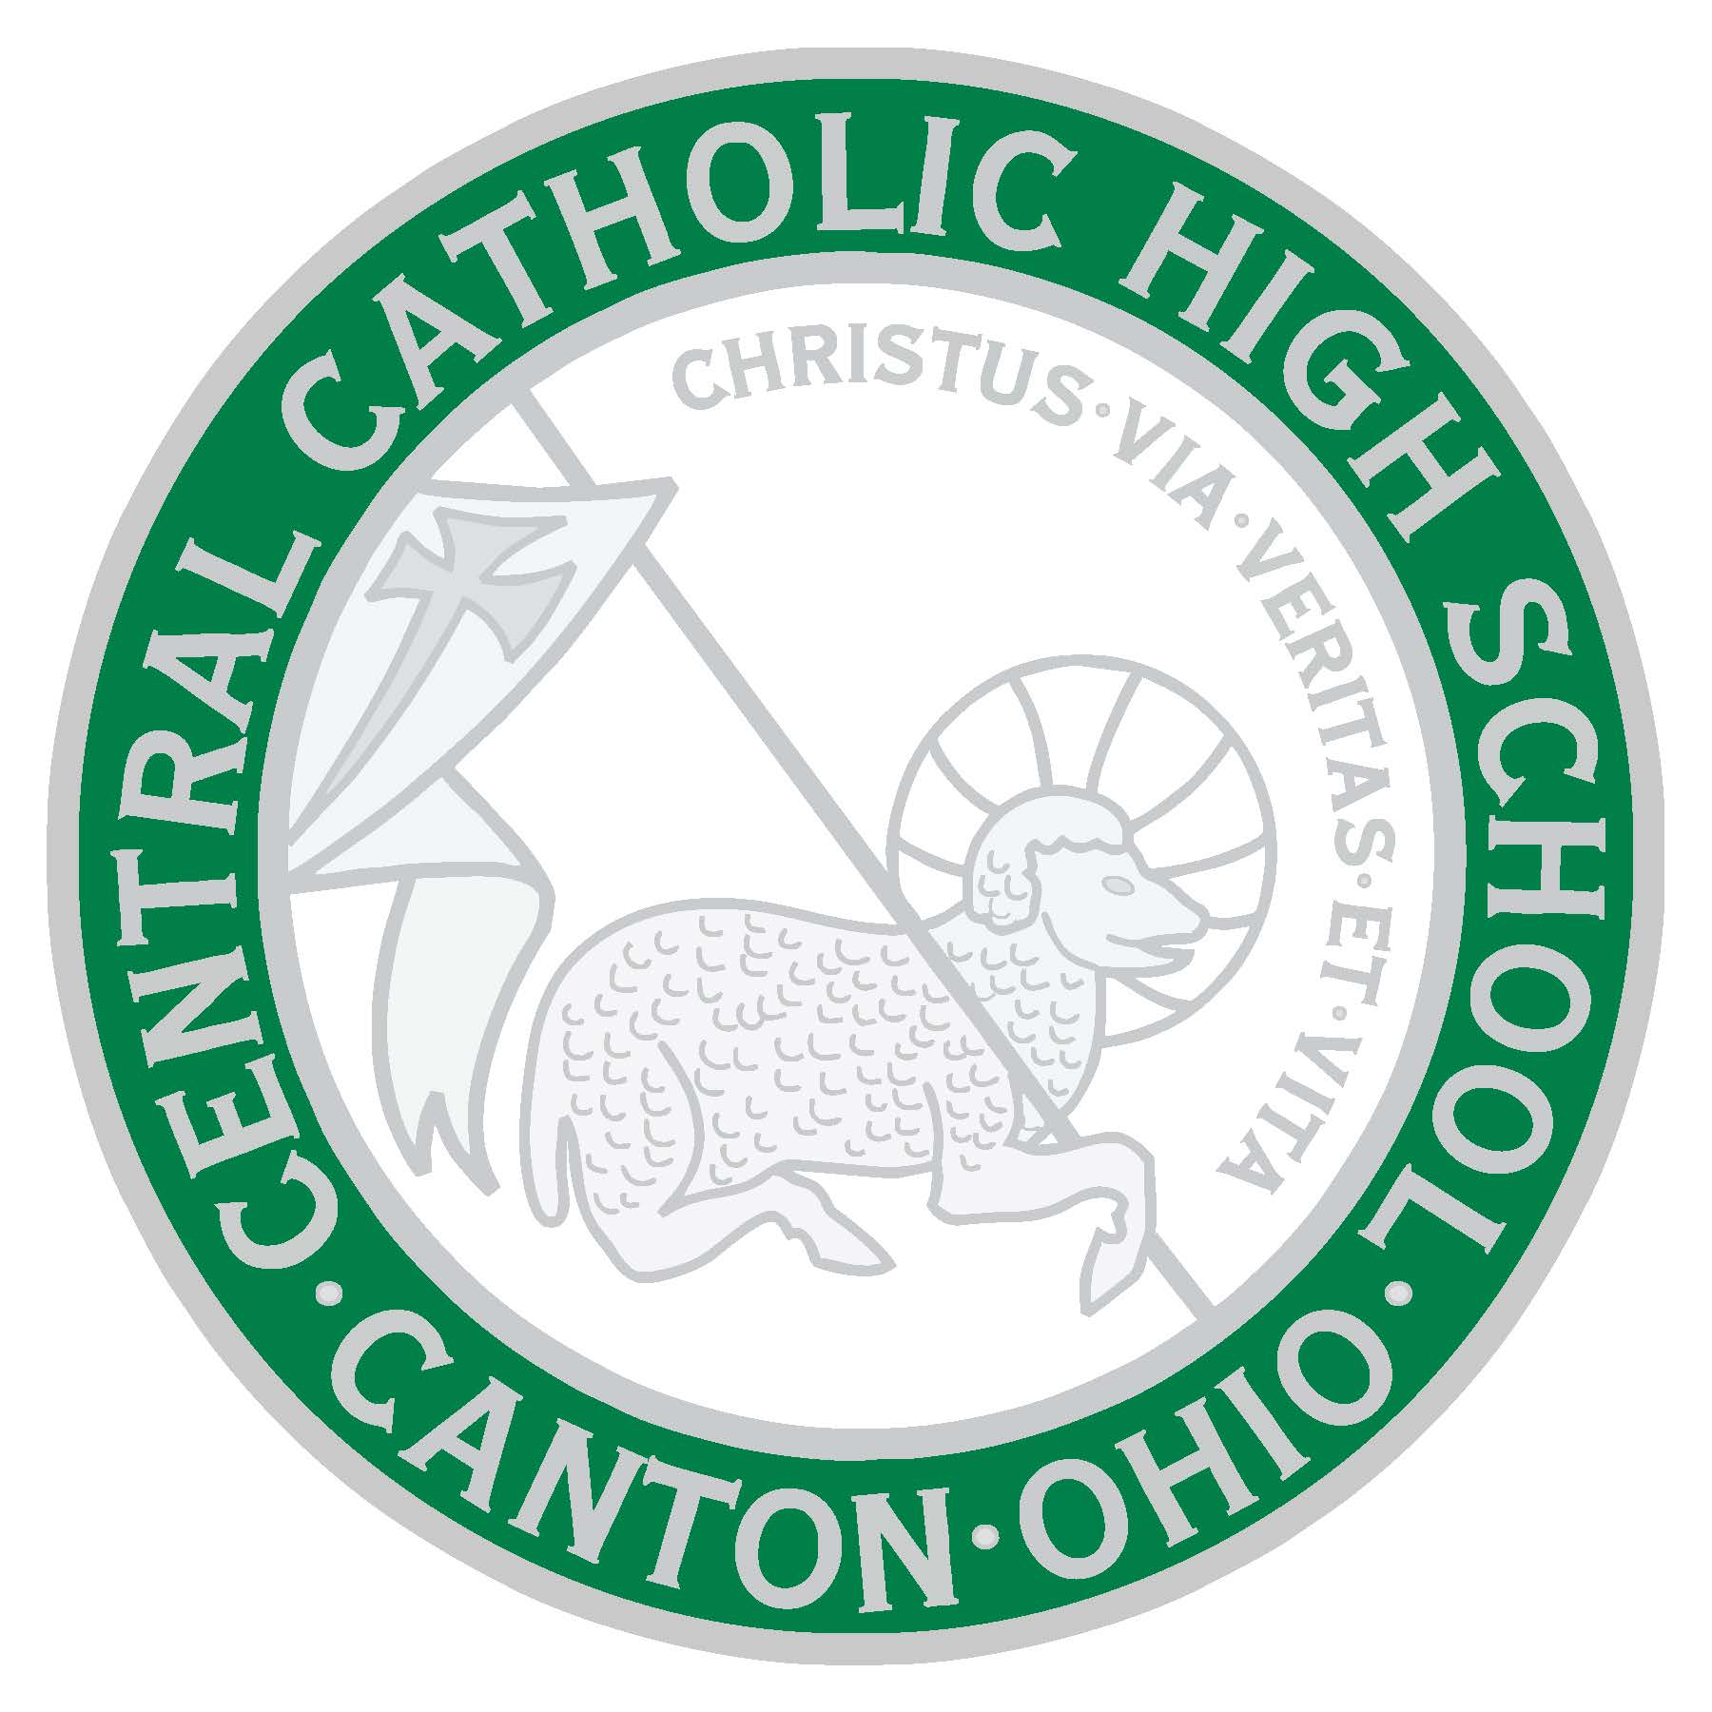
CENTRAL CATHOLIC HIGH SCHOOL

Grades 9 - 12
4824 Tuscarawas St., Canton, OH, 44708 | (330) 478-2131 | CentralCrusaders.org

CENTRAL CATHOLIC HIGH SCHOOL
RESPONSIBLE RETURN TO SCHOOL PLAN

As always, Central Catholic is committed to the health and safety of our students. While we understand that we are in unprecedented times we agree with the conclusion of the Academy of Pediatrics that the reopening of schools with students physically present is important for child and adolescent development and well-being. Therefore, it is our intention to return to school, in person, 5 days a week while following safety guidelines to mitigate the spread of coronavirus (COVID-19).

Our guidelines have been created by considering the recommendations of the Centers for Disease Control (CDC), the American Academy of Pediatrics (AAP), the Responsible Restart Ohio framework from Governor DeWine, the Ohio Department of Health, our local health department, the Diocese of Youngstown’s Return to School Plan, and with input from our parent survey. Thank you for your patience as we crafted these guidelines during this ever-evolving situation.

We appreciate your confidence in our school as we work together to keep our students safe while offering them a positive learning experience that includes steps to mitigate the spread of COVID-19.

Calendar

Central Catholic will begin school on our original start date. Freshmen will report for Orientation on August 17. Everyone else will start on August 18. While some districts have pushed their start dates back, we believe it is important to get our students back to school as soon as possible. In addition, nearly 75 percent of our students are participating in a fall sport that begins on August 1.

Monday, August 17 – Freshmen report to school
Tuesday, August 18 – First day of classes for all students
Learning Options

Central Catholic will be offering five days per week, in-person instruction.

In the event that schools are forced to close by orders of the governor or local health departments, we will transition to remote learning taught by our teachers. We have learned many valuable lessons from this past spring and are ready to begin remotely if needed. Further, Central Catholic is a 1-to-1 school, each student has been given a Chromebook to keep which they can use while physically in school or from home, if remote learning is ordered by the governor or health department.
Health Checks

Parents are to conduct daily health checks of students prior to coming to school. Anyone with a fever over 100 degrees F or exhibiting COVID-19 symptoms must stay home.

Any student that presents symptoms while at school will be sent to a designated quarantine room, parents will be notified, and the student will be sent home. Any area of the building occupied by that person will be thoroughly sanitized.

Please keep in mind that we have a nurse on staff here at Central Catholic.
Masks & Face Coverings

All staff and students are required to wear masks at all times in school and on school transportation. Students may not wear a face shield. Staff may use a face shield if they are in front of the class teaching and socially distanced from students.

Face masks breaks may be given throughout the day when students are socially distanced from each other.

Face masks waivers will require medical documentation and be handled on an individual basis.

All face masks must be a solid color or a Central Catholic mask.

Social Distancing

All classrooms will maximize space to keep students as distanced as possible.

Seating in the cafeteria will be limited at each table.

Students will be expected to maintain as much social distancing as possible in common areas.

Our bell schedule has been adjusted to make sure there is plenty of time between periods for proper sanitization.
Food and Drink

Lunch will be served in the cafeteria with seating altered to allow for spacing. Other areas of the building may also be used to allow for adequate spacing.

Drinking fountains will only be used as a water bottle filling station. Students should bring their own water bottle to school.

Vending machines will not be available.
Cleaning

Students will be encouraged to practice frequent handwashing during the day. Hand sanitizer will be available in all classrooms and throughout the building. Students may bring their own hand sanitizer to use during the day.

High-touch and high traffic areas will be cleaned regularly throughout the day.

The cafeteria will be sanitized after each lunch period.

Additionally, all desks and other touchpoints in the classrooms will be cleaned after each period.

Visitors

While family involvement has always been a cornerstone of a Catholic education, at this time limiting the number of people inside our building protects us all. Visitors and volunteers will not be permitted at this time. If a parent needs to come to school for any reason, they will be met at the door or limited to the office area.

Extracurricular Activities

Athletics, including cheerleading and band, will follow the recommendations of the Ohio High School Athletic Association (OHSAA), the Diocese of Youngstown, and our local department of health.

Other student organizations will be reviewed once the school year begins to determine if it such gatherings allow the ability to maintain social distancing.

There will be no assemblies or field trips during the first semester. Future assemblies and field trips will be evaluated at a later date.
Mass

We intend to hold our opening Liturgies on Monday, August 17 for freshmen and Wednesday, August 26 for sophomores, juniors, and seniors at our outdoor Our Lady of Lourdes Grotto. These Masses are an important part of emphasizing our Catholic identity and noting our first time coming back together as a school community.

Students and staff will be expected to wear masks to and from Mass, as well as during Mass.

We will evaluate our ability to safely hold Masses on a service by service basis depending upon social distancing and the location required to hold the service and in accordance with the guidelines provided by the Diocese of Youngstown.
Parent Communication

This year, more than any other, will require excellent communication from our administration, teachers and from parents/guardians. Please make sure your information is updated with the office to be sure you are receiving emails and parent alerts, to update your information call the main office at 330-478-2131 or you can update your information online on our website at https://www.starkcountycatholicschools.org/updatefamilycontactinformation0878.aspx.

Staff and teachers’ emails can be found on our website under our staff directory found at https://www.starkcountycatholicschools.org/StaffDirectory_CC.aspx.
Parents/guardians will receive emails and phone calls through a parent alert system. All important and emergency information will come via these routes from the school.
Please follow us on Facebook, @Friends of Central Catholic, or download our app, Stark County Catholic Schools and follow our school to receive alerts to your mobile phone. Our free app can be found on the Google Play Store or the Apple App store.
Infection Protocol

Central Catholic will consult and follow the recommendations of the local health department. The health department takes the lead when infections are reported and we must follow their directives.
Frequently Asked Questions:

What should I do if my child has symptoms of COVID-19?
If your child shows symptoms of COVID-19, you should immediately contact your doctor. Your doctor may ask that your child participate in a COVID-19 test. Please alert the attendance office and do not send your child to school.

Students, staff, or any other person present in the building who start to show symptoms or have a temperature above 100 degrees F while at school will be isolated from others in a designated room while they wait to go home. Areas of the building occupied by the person will be thoroughly sanitized.

Individuals who test positive for COVID-19 must experience an improvement in symptoms and isolate for a period of time before returning to school. The local health department will provide a protocol for individuals to follow and work with the school.

My child has COVID-19-like symptoms, but tested negative for COVID-19. When can he or she return to school?
If your child does not have COVID-19, but has another illness, you should keep your child home until the illness’ symptoms disappear. If the child had a fever, he or she must be fever-free without the use of fever reducing medication for 24 hours. The school will require you to provide a negative COVID-19 test and/or a doctor’s note verifying the negative test and clearance before your child can return to school.

What should I do if my child tests positive for COVID-19?
You should immediately contact your doctor for additional instructions. You should contact the attendance office. You should not send your child to school.

When can a student return to school after receiving a positive COVID-19 test?
If a student tests positive for COVID-19, the student must isolate and not return to school until they have met the Center for Disease Control’s criteria to discontinue home isolation and followed the protocols set by the local health department. This includes:
1. Three or more days without a high fever; AND
2. A reduction of other COVID-19 symptoms by at least 75%; AND
3. At least 14 days, or the number designated by the health department, have passed
since symptoms first appeared. A doctor’s note may be required.

What should I do if a member of my household (who is not my child) tests positive for COVID-19?
You should immediately contact the attendance office. The school may ask that you keep your child home for 14 days or whatever is directed by the local health department. If your family member recovers from COVID-19 (through meeting the criteria in the previous question) AND your child shows no COVID-19 symptoms for the designated period, your school will allow your child to return.

What happens if my child’s teacher or another student in the class tests positive for COVID-19?
When a report that a member of the school community has contracted the virus is reported to the administration, the administration or designee will contact the person or the parent of the student to get the details of the situation. The administration will then consult with the local health department regarding the circumstances, and the procedures required by the health department for any student or staff member who has been exposed and the proper communication to those families will be followed.

All school parents will receive email updates to keep them informed of COVID-19 related information. If a person has been exposed, a period of quarantine will most likely be required and follow-up with the person’s doctor recommended. A student or staff member may not return to school until the period of quarantine is completed or has been tested and the negative diagnosis and permission to return to school is given in writing by the person’s physician.

If advised by the health department, a class, part of the school, or school may be shut down for a period to allow for deep cleaning or a possible quarantine. During that time, teachers will provide and support remote instruction. In all cases of exposure to the virus, the administration will follow the direction and advice of the local health department.

Note: Individual names of persons infected or exposed will NOT be shared with the health department. However, when a positive case is reported to the health department through testing results, the Health Department may contact families for contact tracing. Further, we will not release the name of anyone in our school community who has tested positive or displays symptoms of COVID-19.

Could the school be closed down due to COVID-19 this year?
If a COVID-19 surge occurs, we will work closely with state officials to determine if we can continue face-to-face instruction. If the Governor or the local health department issues an order to close schools temporarily, we will comply. Ohio’s county color system may affect the decision to hold face to face instruction or remote learning. We will do our best to ensure a safe and healthy environment. However, if numerous cases appear in our school, resulting in the isolation of multiple classes, we may need to close temporarily. We will follow the protocol given to us by the local health department. If either of the two scenarios above become reality, the school will transition to remote learning for that period of time. Parents will be updated regularly should that need arise.

What if my family needs to travel out of town?
While it is recommended that travel be limited during the pandemic, if it is necessary for your family to travel, please consult the Center for Disease Control’s Travel Guidance found at https://www.cdc.gov/coronavirus/2019-ncov/travelers/travel-in-the-us.html. If you are traveling to an area that is having a surge, please report this to the school and plan to quarantine for 14 days upon your return. If you are traveling from a state officially designated by the Governor, your child must quarantine for 14 days before returning to school.

We will follow guidelines as outlined by the Diocese of Youngstown. More detailed information about the Diocese of Youngstown’s Return to School Plan can be found at https://doy.org/wp-content/uploads/2020/07/Final-Return-to-School-Planning-Guide20200727.pdf

Any changes to these guidelines or if more information becomes available as we learn more about COVID-19, we will communicate those changes or additions to our families as soon as possible. We are in an extremely fluid situation; policies and procedures could change per local, Diocesan, or state orders. Thank you for your patience. For questions or concerns, please feel free to reach out to the school administration at 330-478-2131.

