6th Grade Supply List
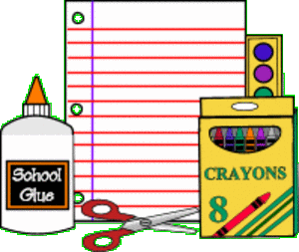
2025-2026
Language Arts:
- 3-Ring Binder with tabbed divider sheets
- Lined Paper
- PENCILS!
- Highlighters (to be used in all classes)
- Expo Dry Erase Markers (to be used in all classes)
- Colored Pencils (to be used in all classes)
- Headphones or Earbuds (to be used in all classes)
Math:
- 3 ring binder
- Filler paper
- Notebook
- Pencils (no pens in math class!!)
- Glue Stick
- Texas Instruments TI-30X IIS Calculator—VERY IMPORTANT!
Science:
- 3 ring binder
- Notebook
- Pocket Folder
- Pencils
Social Studies:
- 3 ring binder
- Notebook
- Pencils!!!!!

**NOTE: The pencils, colored pencils, earbuds (headphones), highlighters, and dry erase markers are for use in all classes. However, the folders, binders, and notebooks should be purchased per individual subject area.

