7th Grade Supply List
2025-2026

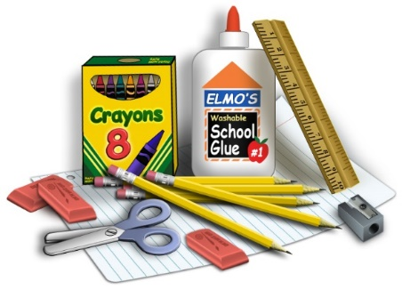

Social Studies (Mr. Caponi):
- 3-ring binder with dividers
- Colored Pencils
- Pencils
- Headphones or Earbuds (to plug into laptop and can be used for all classes)
ELA (Mrs. Faust):
- 3-ring binder with dividers
- Pocket folder
- Highlighters
- Pencils
- Pens
Math (Mr. Rogiero):
- 3-ring binder
- Pencils
- Scientific Calculator – TI-30X IIS (if possible, if not, we have a classroom set)
Science (Mrs. Davis):
- 3-ring binder
- Composition Notebook
- Pencils
- Colored Pencils
- Highlighters
Note: The pencils, colored pencils, highlighters, and headphones (earbuds) are for use in all classes, but the binders and notebooks should be purchased for each individual class.

