Entering Class Report Card Comments
1. Click on Menu --> Gradebook --> Gradesheet
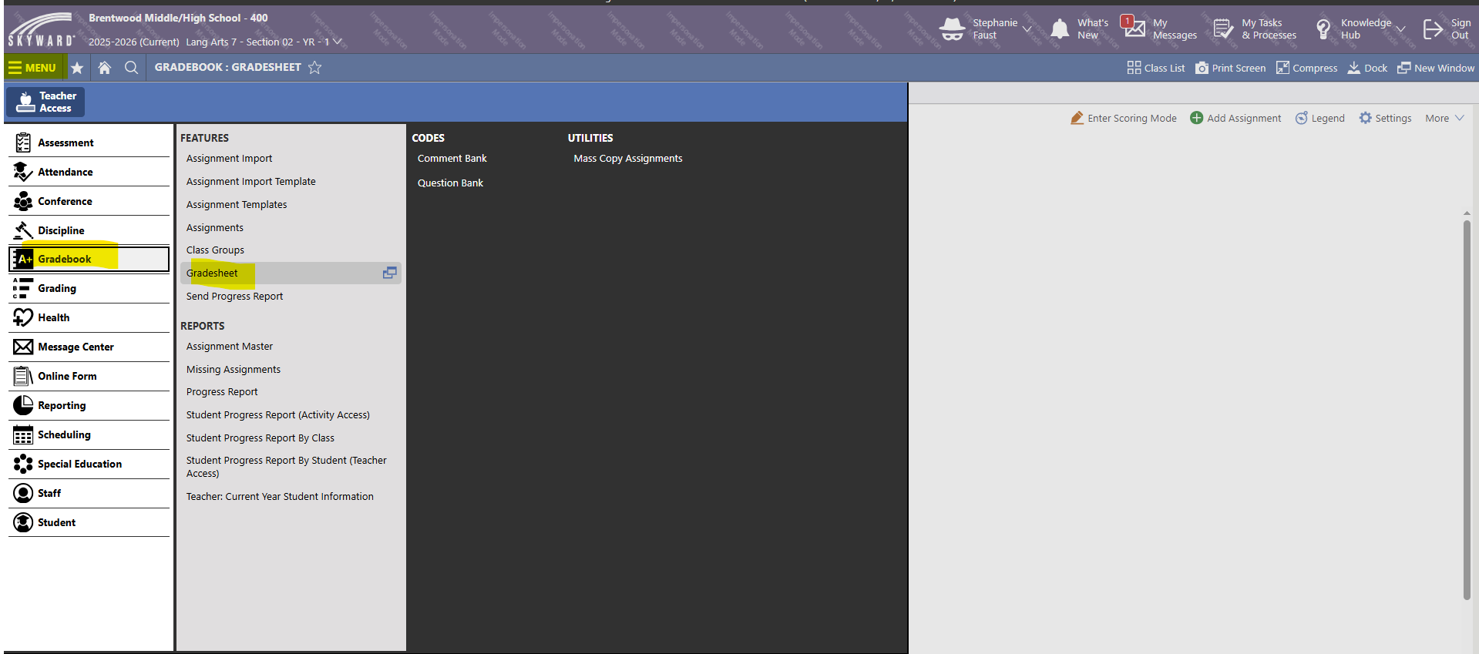

2. Click on the course that you want to add Report Card Comments.
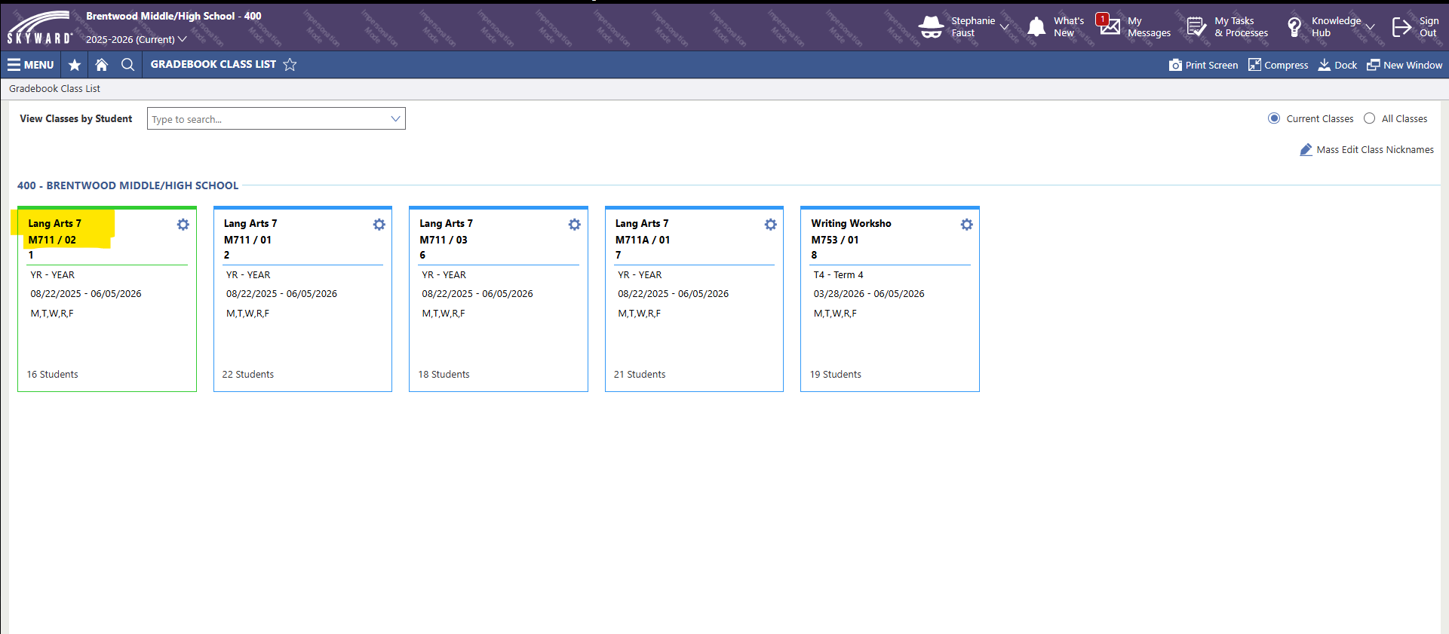

3. Click on the Grade Period Column heading. Click on Add/Edit Comments for Grading Periods. Click Save.
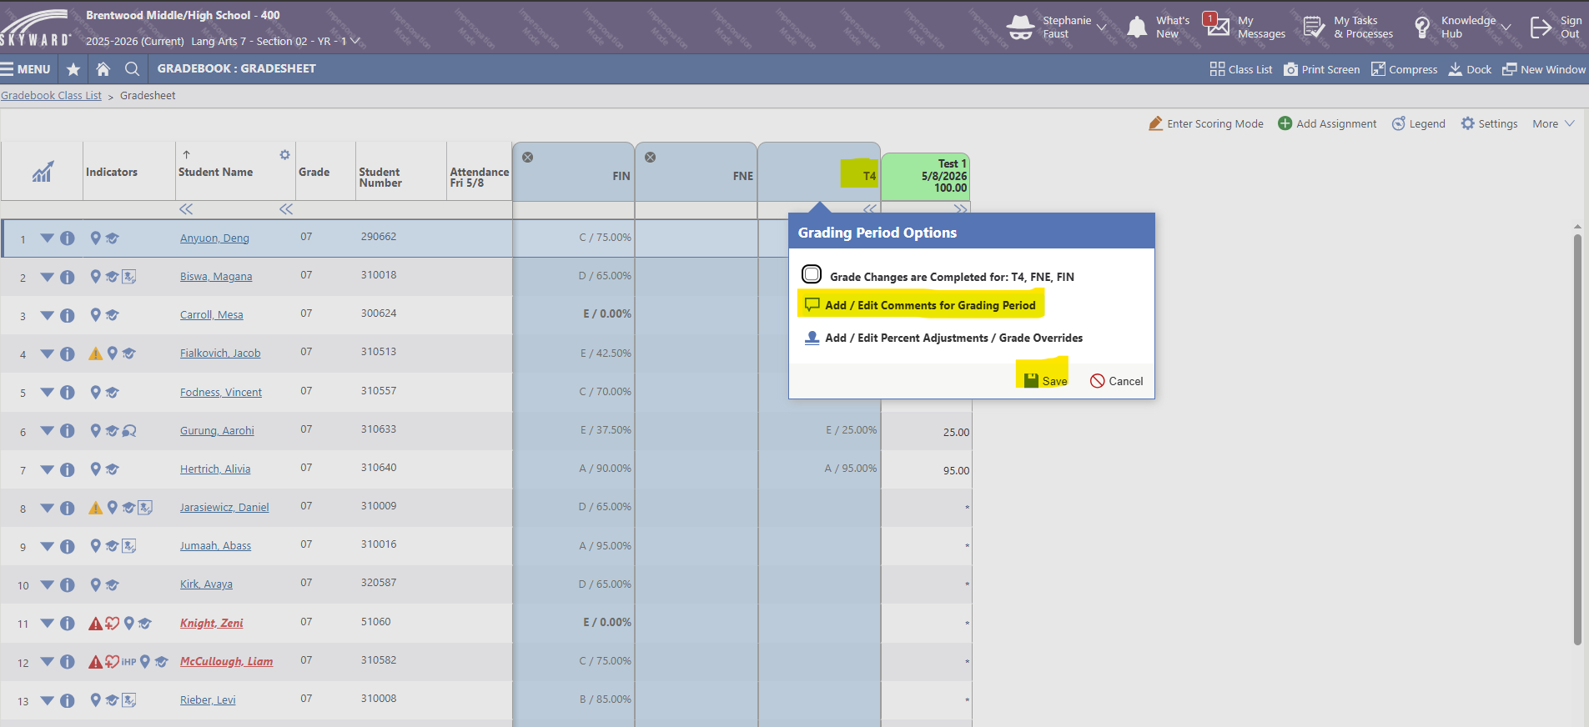

4. Click on the comment column. Enter the Comment Code for each student.
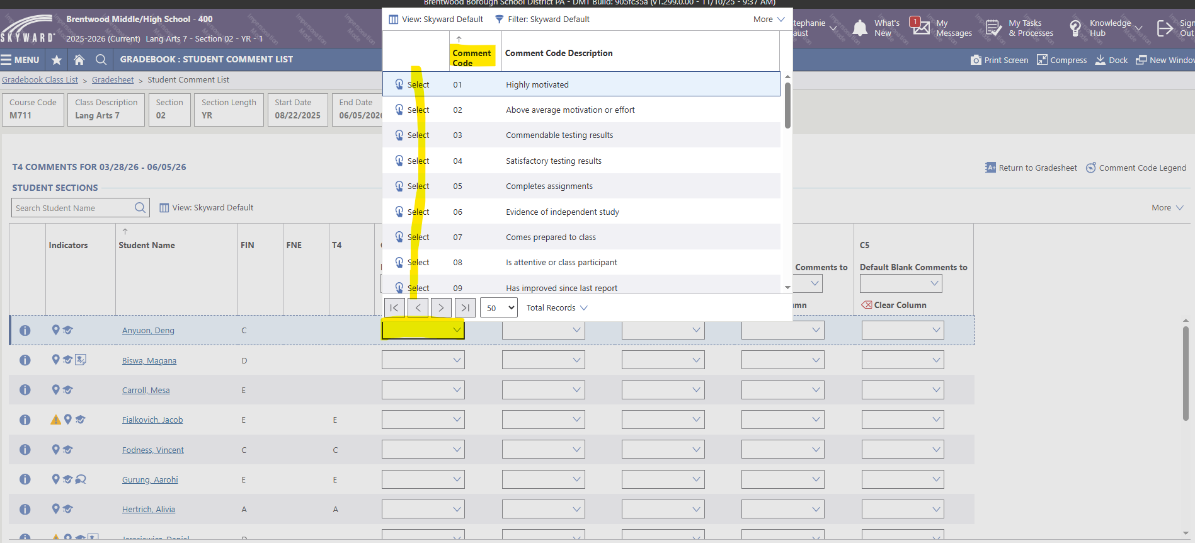

5. Choose the Save option near the top of the screen to save your work after each comment has been entered.
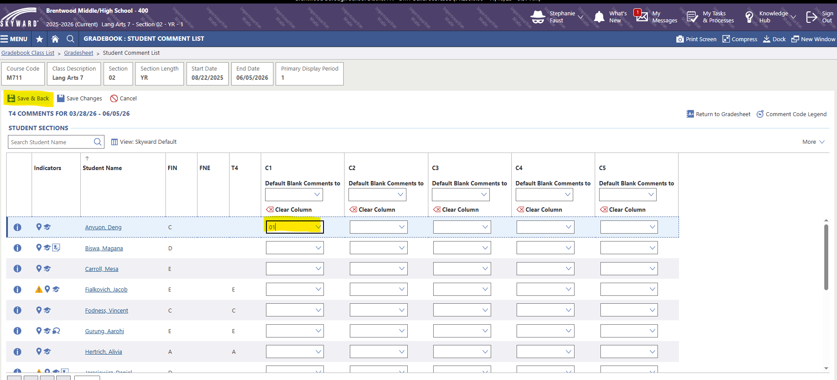

6. To make sure that the comment is correct for each student, click on the conversation icon in the term period column.
