Working with linked text boxes

MMS Mountie News







**DATES TO REMEMBER**

**1-17 No School/MLK Day**

**2-03 2 hr Early Release**

**Parent/Teacher**

**Conferences 2pm – 7pm**

**2-04 No School/Teacher in-**

**Service**

**2-11    Remote Day- Professional Development for staff**

**2-14 Valentine’s Day**

**2-17 Valentine’s Dance**

**2-15 6th Grade Parent Outdoor School meeting @ 6:30pm**

**2-18 Remote Day- Professional Development for staff**

**2-20 2nd payment due/D.C. Trip**

**2-21 No School/President’s Day**

**3-17 3rd payment due/D.C. Trip**

**3-25 End of 3rd Grading Period**

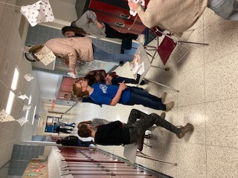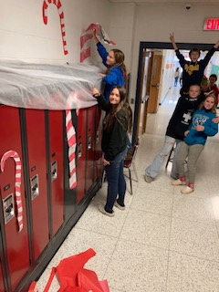

Caption describing picture or graphic.

Middle School Hallway Decorating Contest

Our students were focused on showing how much they care about our school and other classes as they celebrated the season with the “Deck the Halls Contest”. Students had the opportunity to collaborate with other classes to decorate the hallways. Congratulations to the 6th grade hallway winners!





**Canned Food Drive**

We had a middle school canned drive last month and embraced the spirit of giving!  Congratulations to

Mrs. Kaufman’s 1st period class as they brought in the most items! They won a dessert of their choice from Mr. Long!!



Be Ready, Responsible &

Respectful

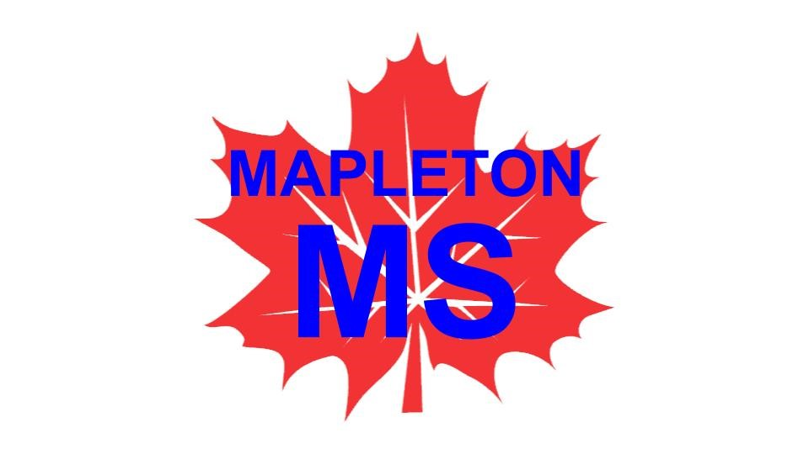

**COMMUNICATION !**

Sign up for important school updates by getting text messages or emails about our school  
 with “Remind”.

**6th Grade- Text 81010 and message @b4ea4f**

**7th Grade- Text 81010 and message @46dbb22**

**8th Grade- Text 81010 and message @2bbkkde**





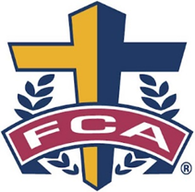

**Congratulations Students of the month!**

**December**

Nicolas McBride- 6th Grade

Cole Kelley- 7th Grade

Isabella Ocheltree- 8th Grade

**November**

Emilee Stolcals- 6th Grade

Layla Perzy- 7th Grade

David Ritenour- 8th Grade

**October**

Jack Sheppard- 6th Grade

Lucy Hartley- 7th Grade

Dalton Mahoney- 8th Grade

**September**

Cody Anderson- 6th Grade

Sara Drake- 7th Grade

Braylon Goon- 8th Grade

# FCA

**Fellowship of Christian Athletes**

**Are you ready and willing to help our school become a better place? Then come on down to Mrs. Kuschel’s room in the 6 grade hallway room 102. With meetings every other Wednesday. Our goal is to help others.**

# PBIS- (Positive Behavior Intervention Supports)

Mapleton Middle School encourages positive behavior with our PBIS plan.  Students that show that they are ready, responsible, and respectful may earn tickets that will enter them into random drawings for prizes or other fun activities!  Also, all students have the opportunity to join our fun quarterly incentive at the end of the grading period when they meet their grade level standards.  Last week we enjoyed nachos and cheese along with some extra game time!



**What do the numbers mean on the report card?**

**Met the Standard (3)**

This is the highest level a student can achieve. Achieving this level indicates that a student can successfully and consistently demonstrate knowledge of the standard.

**Approaching the Standard (2)**

Indicates a student is progressing in his/her knowledge of the standard but may not be successfully and consistently demonstrating knowledge of the standard.

**Developing Knowledge of the Standard (1)**

Students have demonstrated a basic level of knowledge of the standard. Students who are at this level are beginning to develop the knowledge and skills that are necessary to achieve higher levels of understanding.

**What Is Standards Based Assessment?**

Standard based assessment (also known as standards based grading) is built on the idea that grades must have meaning, learning expectations are clearly defined, and students should have multiple opportunities to demonstrate learning. Standards based assessment allows students to learn at their own pace and understands that not every student will succeed on the first try. Homework and other similar items are treated as practice and part of the learning process. Therefore, students are provided descriptive feedback so that a student may improve their practice.  At Mapleton Middle School a student’s learning is gauged on their current level of understanding and application of a particular learning standard. Teachers have identified those standards that are critical to student success for each class and grade level. These critical standards form the basis of teacher instruction and student understanding and application of each standard is assessed based on rubrics and performance level descriptors.



**AFTER SCHOOOL TUTORING!!**

**We will be offering after school tutoring to help students that need extra time on Tuesdays- Thursdays from 3:05-5pm (transportation may be available)**

**Please contact Mr. Erwin for more information.**



**Mapleton Middle School recognizes our students for academic achievement!**

In the standards-based assessment system, students will be recognized using the following categories/criteria from the second quarter report cards:

**Distinguished Scholar Honor Roll-** Performance level of Met the Standard in **ALL** standards.

**Haleigh Mosley**

**Ashton Mulkey**

**Carlee Osborne**

**Joseph Ross**

**Jack Sheppard**

**Emilee Stolcals**

**7th Grade**

**Paige Beattie**

**Emilee Beecheer**

**Maggie Bogner**

**Tia Bryant**

**Sara Drake**

**Lucy Hartley**

**Bailey Hartman**

**Tyler Hartzler**

**Kenzie Hastings**

**6th Grade**

**Cole Bates**

**Brandon Bergosh**

**Kail Callihan**

**Claire Delosh**

**Ethan Dennison**

**Addison Enlow**

**Jack Gove**

**Anna Grundy**

**Kenzie Hellickson**

**Madisyn Henry**

**Addison Hess**

**Reagan Hickey**

**Maddison Hopstetter**

**Kenzee Imhoff**

**Lukus Jenkins**

**Osiris Kover**

**Nicolas McBride**

**Dalton Hildebrandt**

**Gavin Hill**

**Cole Kelley**

**Macy Kerr**

**Elena Peters**

**8th Grade**

**Laila Davidson**

**Braylon Goon**

**Skylar Hopstetter**

**Karl McConnell**

**David Ritenour**

**Leigh-Ann Schmidt**

**Jaiden Simonson**

**Jocelyn Turner**

**Ella White**

**High Honor Roll-** Performance level of Met the Standard and not more than TWO performance levels of Approaching the Standard of any standard.

**8th Grade**

**Garet Garwood**

**Clara Jarosz**

**Christian Nell**

**Mariah Pummell**

**Kyler Leiby**

**Jacob Robinson**

**7th Grade**

**Kaylee Gault**

**Clair Heater**

**Eden McIntosh**

**Aaron Roberts**

**6th Grade**

**Rachel Alkire**

**Amelia Ashley**

**Payton Frye**

**Leo Heyl**

**Cheyenne Jackson**

**Grayden Kerr**

**Dominic Knighton**

|  |  |
| --- | --- |
|  |  |

**Congratulation to our National Junior Honor Society Members!!**

**Last Friday, Mapleton Middle School held its first National Junior Honor Society induction ceremony. National Junior Honor Society is an honor society that focuses on the five qualities of scholarship, service, leadership, character, and citizenship. The following twelve students completed an application process and were inducted into Mapleton's first NJHS: Nevaeh Anderson, Braylon Goon, Emily Katsaris, Owen Sheppard, Maggie Bogner, Sara Drake, Kaylee Gault, Lucy Hartley, Bailey Hartman, Tyler Hartzler, Elena Peters, Addison Roderick. Students were awarded an NJHS pin and certificate.**

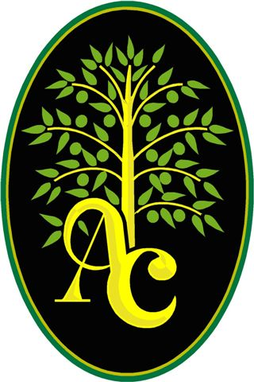**Associated Charities**

Monthly Satellite Food Distribution

**3rd Tuesday of each month**

**@ Polk Fire Station…**

1. **Congress St., Polk OH 44864**

* **January 18th, @** **6 pm until food is gone**
* **February 15th, @ 6 pm until food is gone**
* **March 15th, @6 pm until food is gone**
* **April 19th, @6 pm until food is gone**

**\*\*Serving individuals and families in need residing in Troy, Sullivan, Orange, Jackson and Perry Townships.**

**\*Please bring proper ID to verify address and your own bags**

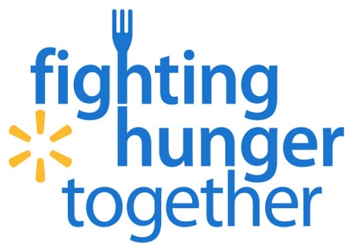

Associated Charities 240 Cleveland Ave. Ashland Ohio 44805 PH: 419.281.6061

Caption describing picture or graphic.

**Conference Sign Ups-**

**PLEASE SIGN UP ONLINE AT THE MAPELTON MIDDLE SCHOOL WEBSITE!**