Instructions for the App

* Bring up Building

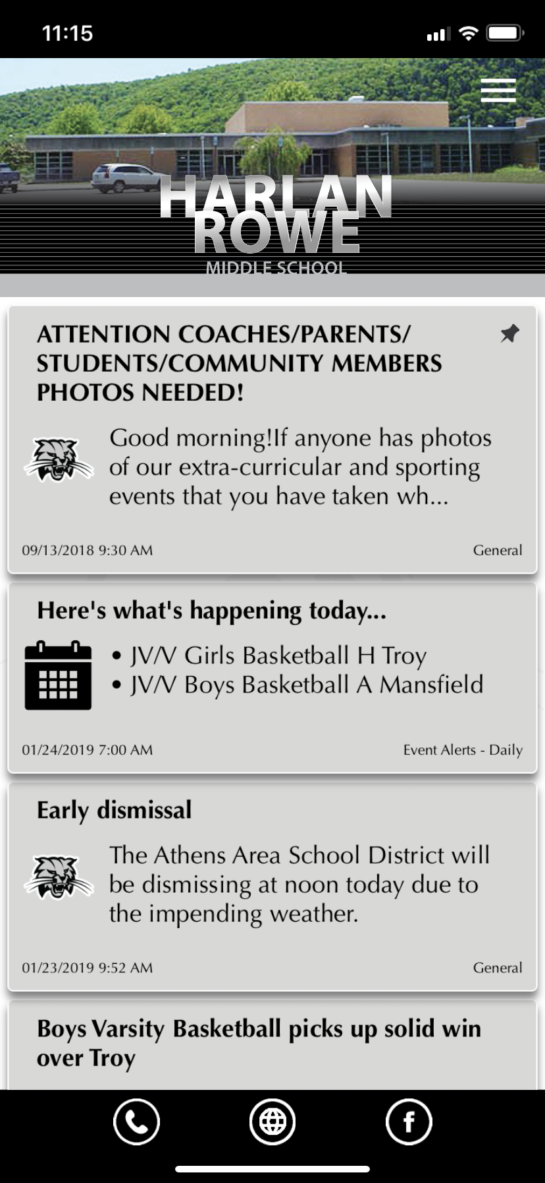

* Click on the Hamburger in the upper right corner and scroll down to “My Alerts”



* Tap the “Person” instead of the building at the bottom.

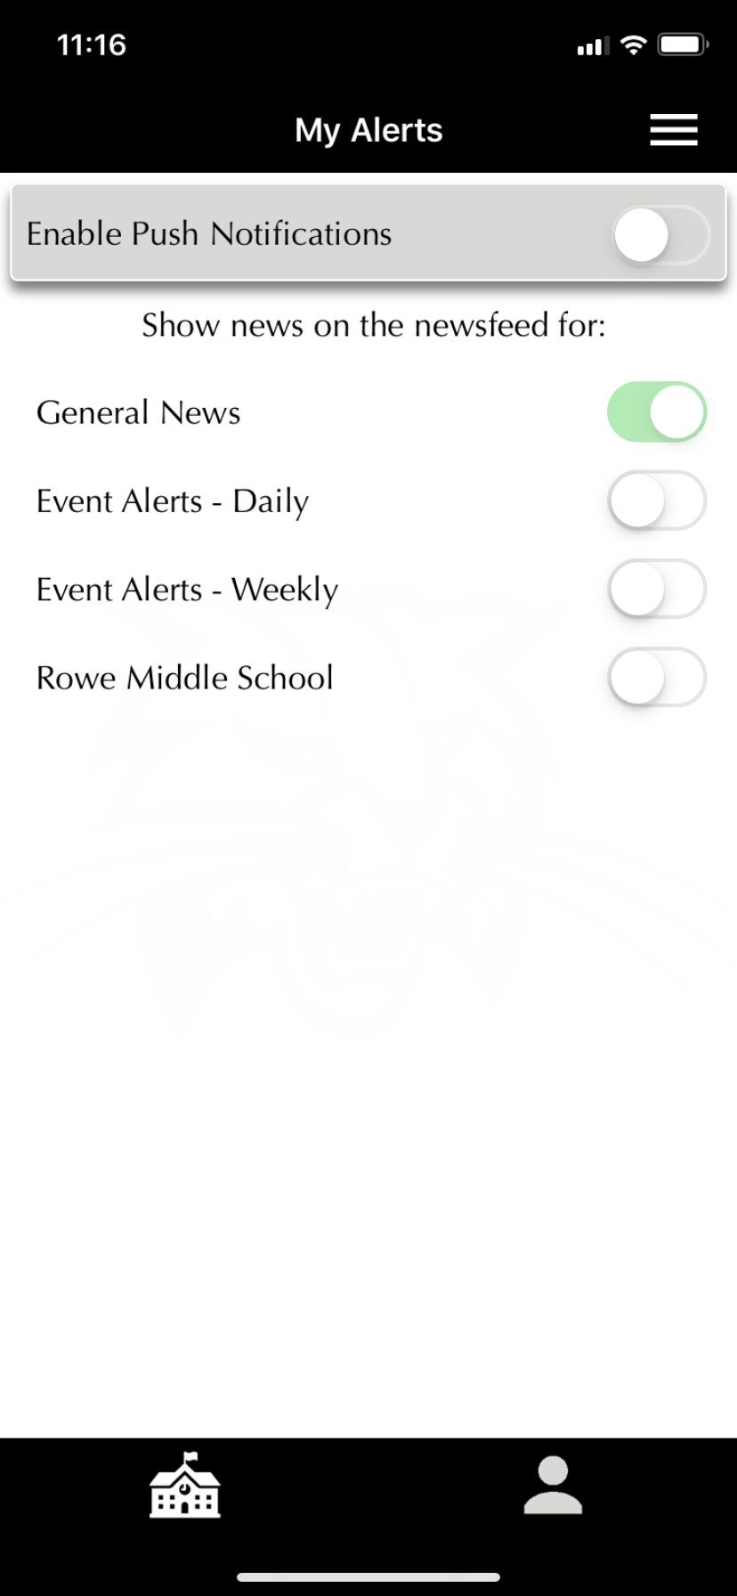

* Scroll down to the person/category you wish to subscribe to and slide the slider to activate.



