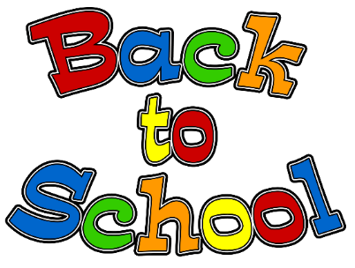

For School:
- Headphones – Please make sure they comfortably fit your child and work well. Also, send them in a gallon bag with your child’s name on it.
- Backpack

* ALL items belonging to your child (headphones, backpack, coats, etc.) must be clearly labeled with his or her first and last name. This is very important!

At Home Items: (We will provide these for your child in school, but it would be good for your child to have these available to use at home.)
- Crayons (24 pack regular)
- Pencils
- Block or pencil-top erasers
- Glue stick
- Scissors

We would gladly take donations of the following for the classroom…
- Individual cans of Play-Doh
- Pack of 12” x 18” construction paper
- Tissue
- Clorox wipes

We will see you soon!

Thank you! - Mrs. Smith and Mr. Wastchak

