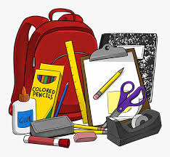

5th Grade Supply List
- 5 single subject notebooks
- Plenty of Pencils
- Highlighter
- Several Dry Erase Markers
- 3 Folders
- Small Pair of Scissors
- Box of Kleenex
- Clorox Wipes
- Crayons
- Glue stick

