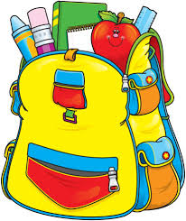
Kindergarten School Supplies 2023-2024

FOR SCHOOL
- Labeled Water Bottle (reusable & easy to refill)
- Backpack – We ask that all Kindergarten students have a backpack. Backpacks should be large enough to fit a standard size folder and not have wheels.
- Headphones – We ask that all students bring his/her own pair of headphones. Ear buds are difficult for Kindergarten students, so please send in headphones.
- Kleenex – box for classroom or individual pack for your child to keep in their desk.

Please label all personal items with your child’s first and last name and room number. This includes lunch boxes, jackets, book bags, etc.

HOME SUPPLIES - DO NOT SEND TO SCHOOL
- Pencils
- Pencil sharpener
- Crayons
- Glue stick
- Scissors (student pair)
- Paper or notebook
- Small dry erase board & marker

We would gladly take any donations of the following for the classroom…
Tissues
Hand Sanitizer
Clorox Wipes
Baby Wipes
Disposable kid size masks
Dry Erase Markers
Play-doh (individual cans)

