Third Graders’ Supply List 2024-25 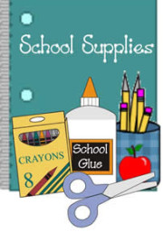

Welcome to 3rd grade! To help families plan and get the 3rd Grades off to a great start, here is a list of items needed for 3rd Grade. We hope that you can use this list to gather school supplies over the summer and within the first week of school. We are looking forward to a great year in 3rd Grade! -The Third Grade Teachers ☺

* **Backpack**
* **Large CANVAS Pencil Pouch**- To hold our pencils, glue sticks, crayons, and other small items. **DO NOT send plastic pencil boxes**, please.
* **Colored Pencils (8 or 12 count)**- Colored pencils will help students complete their class assignments.
* **Thin Colored Crayola Markers (8 or 12 count)**
* **One Pair of FISKERS child scissors**
* **Crayola Crayons (24 count)**- For great opportunities for students to be creative.
* **1 Single Subject Spiral Notebook**
* **1 Water Bottle-** Suitable for refilling and daily use
* **1 pocket folder**
* **Earbuds or headphones**

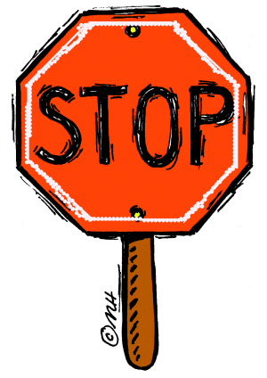PLEASE DO NOT SEND: **\*Post-It Notes or Stickers, *Ink Pens, *Highlighters, *Thick washable or permanent Markers, *Pencil Boxes**

**CLASSROOM DONATION SUPPLIES**: Your donations mean so much….Thank you! We can use the following supplies for our classrooms: ☺Kleenex & Paper Towels, ☺Boxes of No. 2 Pencils, ☺Multipacks of Glue Sticks, ☺Baby Wipes or Clorox Wipes